
INDUSTRY REPORT 44812
Women's Clothing Stores in the US
Wear and tear: Industry competition is expected to rise and hinder industry revenue
Claire O'Connor | December 2020



Contents

COVID-19 (Coronavirus) Impact Update 3
About This Industry 5
Industry Definition 5
Major Players 5
Main Activities 5
Supply Chain 6
Industry at a Glance 7
Executive Summary 9
Industry Performance 10
Key External Drivers 10
Current Performance 11
Industry Outlook 14
Outlook 14
Industry Life Cycle 16
Products & Markets 17
Supply Chain 17
Products & Services 17
Major Markets 18
Business Locations 19
Competitive Landscape 22
Market Share Concentration 22
Key Success Factors 22
Cost Structure Benchmarks 22
Basis of Competition 25
Barriers to Entry 26
Industry Globalization 27
Major Companies 28
Major Players 28
Other Companies 29
Operating Conditions 31
Capital Intensity 31
Technology & Systems 31
Revenue Volatility 33
Regulation & Policy 34
Industry Assistance 34
Key Statistics 36
Industry Data 36
Annual Change 36
Key Ratios 36
Industry Financial Ratios 37
Additional Resources 38
Additional Resources 38
Industry Jargon 38
Glossary 38

COVID-19 (Coronavirus)  Impact Update | IBISWorld's analysts constantly monitor the industry impacts of current events in real-time – here is an update of how this industry is likely to be impacted as a result of the global COVID-19 pandemic:  · Revenue for the Women's Clothing Stores industry has been adjusted to decline an estimated 11.4% in 2020 as many operators had to temporarily close stores and consumers cut back on discretionary spending. For more detail, please see the Current Performance chapter.  · Since many upstream women's apparel products are manufactured in China, the industry's purchase costs are expected to fluctuate as operators contend with supply chain disruptions, leading to unsteady profit. For more detail, please see the Cost Structure Benchmarks chapter.  · Demand for formalwear, such as suits, is anticipated to decline in 2020 as many individuals are working remotely and no longer need to purchase office attire. For more detail, please see the Products and Services chapter.  Note: The content in this report is currently being updated to reflect the trends outlined above.

About IBISWorld
IBISWorld specializes in industry research with coverage on thousands of global industries. Our comprehensive data and in-depth analysis help businesses of all types gain quick and actionable insights on industries around the world. Busy professionals can spend less time researching and preparing for meetings, and more time focused on making strategic business decisions that benefit you, your company and your clients. We offer research on industries in the US, Canada, Australia, New Zealand, Germany, the UK, Ireland, China and Mexico, as well as industries that are truly global in nature.

About This Industry
Industry Definition | This industry comprises establishments that specialize in women's wear, including misses', juniors', plus-size and maternity clothing. Operators in this industry undertake sales and administrative activities, such as customer service, advertising and cash handling. Some stores also offer basic alteration services on-site.
Major Players | Ascena Retail Group
Main Activities | The primary activities of this industry are:  Selling women's shirts, blouses and other tops  Selling women's pants and jeans  Selling skirts and dresses  Selling women's outerwear and suits  Selling maternity wear  The major products and services in this industry are:  Other apparel and accessories  Outerwear  Dresses  Bottoms  Tops

Supply Chain
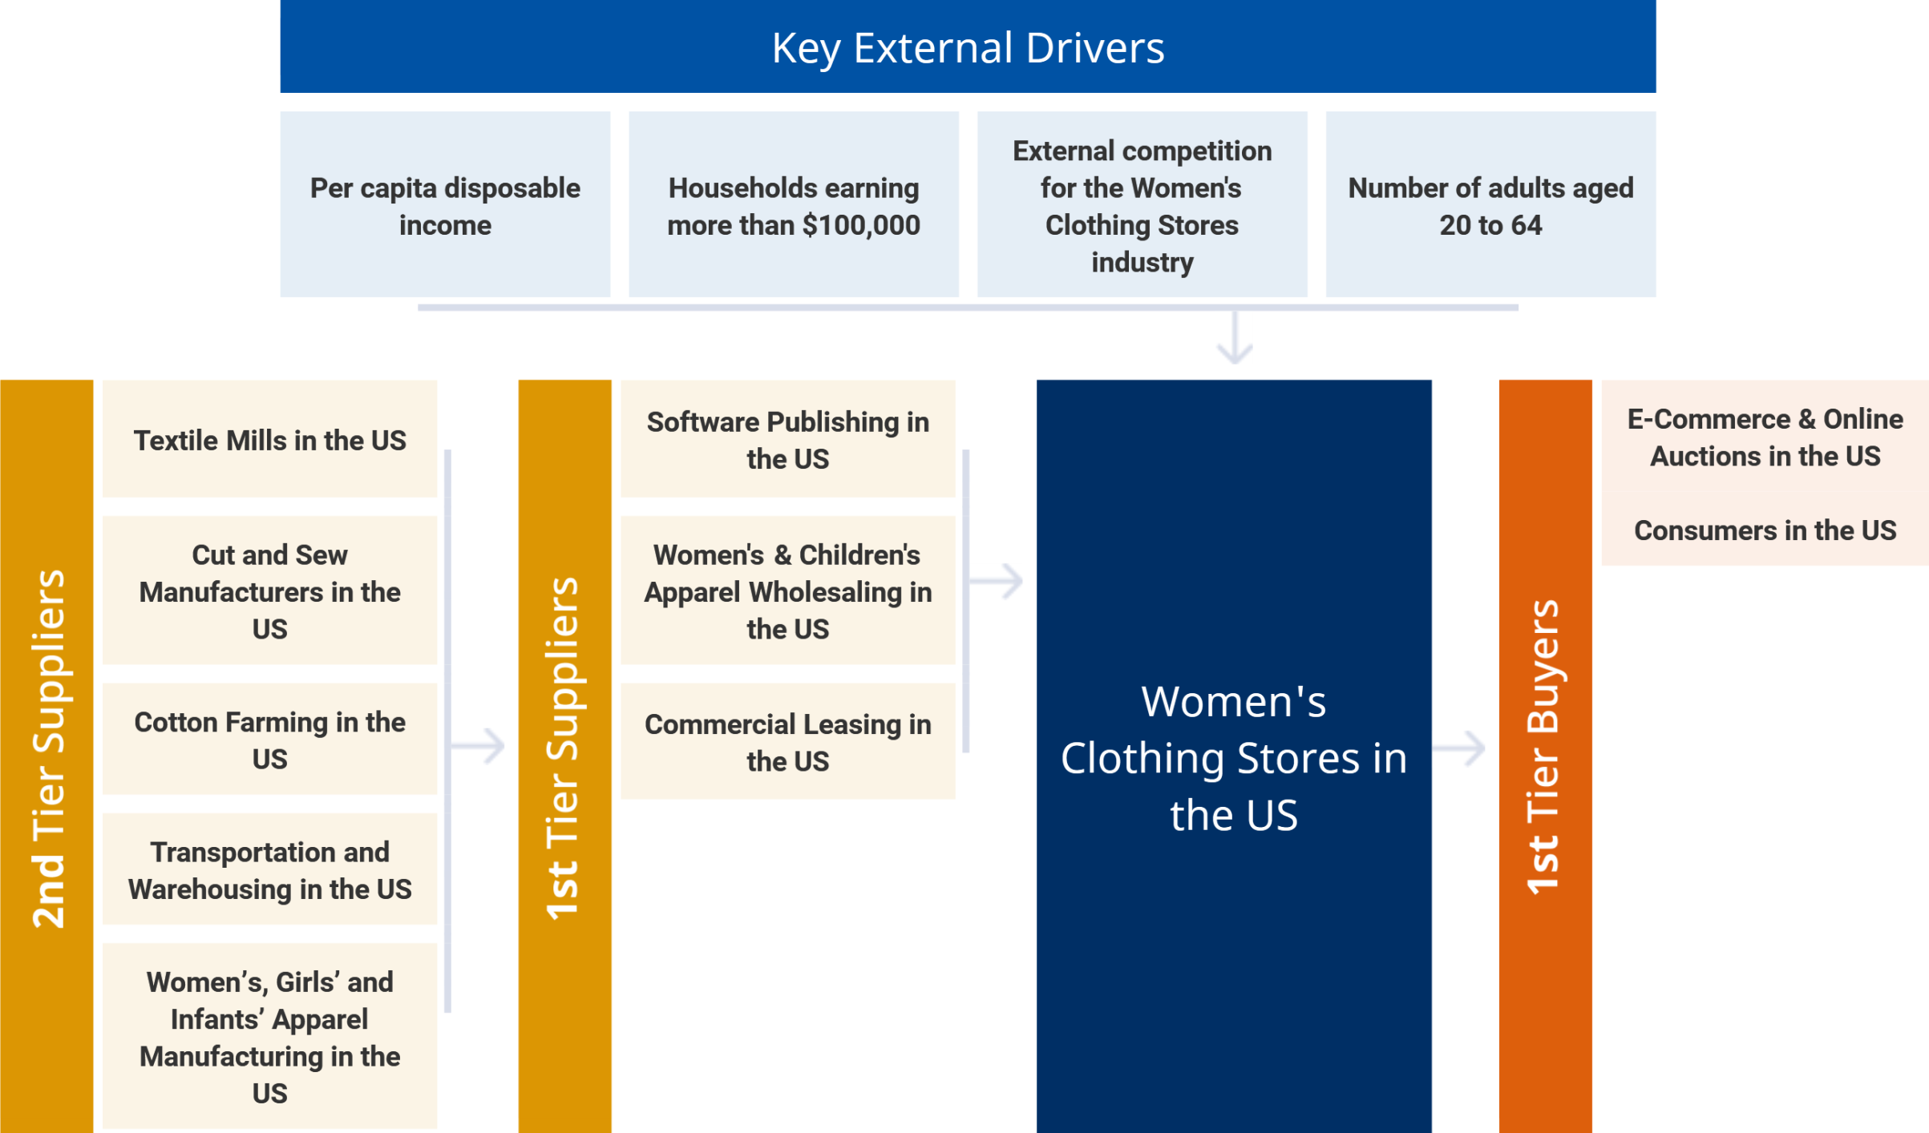

Similar Industries
Women’s, Girls’ and Infants’ Apparel Manufacturing in the US | Family Clothing Stores in the US | Lingerie, Swimwear & Bridal Stores in the US | Department Stores in the US
Used Goods Stores in the US | E-Commerce & Online Auctions in the US | Mail Order in the US | Handbag, Luggage & Accessory Stores in the US

Related International Industries
Clothing Retailing in Australia | Clothing Stores in China | Clothing Retailing in the UK | Plus-Size Women's Clothing Stores in the UK
Online Women's Clothing Retailing in the UK | Women's Clothing Stores in Canada | Clothing Retailing in New Zealand | Clothing Retailing in Ireland

Industry at a Glance
Key Statistics | Industry Structure
   | $36.6bn  Revenue
  Annual Growth  2015–2020  -3.8% | Annual Growth  2020–2025  -0.4% | Annual Growth  2015–2025  
   | $769.3m  Profit
  Annual Growth  2015–2020  -19.1% |  | Annual Growth  2015–2020  
   | 2.1%  Profit Margin
  Annual Growth  2015–2020  -2.9pp |  | Annual Growth  2015–2020  
   | 33,124  Businesses
  Annual Growth  2015–2020  -2.1% | Annual Growth  2020–2025  -1.4% | Annual Growth  2015–2025  
   | 293k  Employment
  Annual Growth  2015–2020  -3.7% | Annual Growth  2020–2025  -1.2% | Annual Growth  2015–2025  
   | $5.1bn  Wages
  Annual Growth  2015–2020  -3.4% | Annual Growth  2020–2025  -1.1% | Annual Growth  2015–2025  
  Key External Drivers | % = 2015–20 Annual Growth
  2.8%  Per capita disposable income | 0.2%  Number of adults aged 20 to 64
  3.1%  Households earning more than $100,000 | N/A  External competition for the Women's Clothing Stores industry
   | Positive Impact
   | Revenue Volatility  Low |  | Capital Intensity  Low
   | Concentration  Low |  | Industry Globalization  Low / Increasing
   | Mixed Impact
   | Life Cycle  Mature |  | Regulation & Policy  Medium / Steady
  Technology Change
  Medium
   | Negative Impact
   | Industry Assistance  Low / Increasing |  | Barriers to Entry  Low / Steady
  Competition
  High / Steady
  Key Trends
  - As with most retailing industries, external competition has been an increasing threat
  - Despite overall revenue decline, the industry has experienced mixed performance
  - The geographic spread of industry stores is concentrated in metropolitan areas
  - Industry revenue growth will likely be generated by premium brands and specialty stores
  - Many industry operators are expected to expand their own factory outlet retail channels
  - The highly saturated nature of the industry will deter many new entrants from setting up shop
  - Many companies that were traditionally store-only businesses have responded to external competition by opening online stores

Products & Services Segmentation
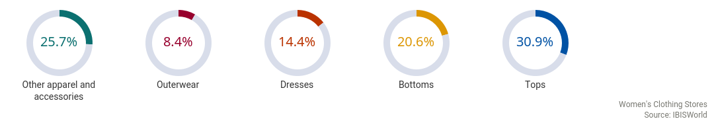

Major Players  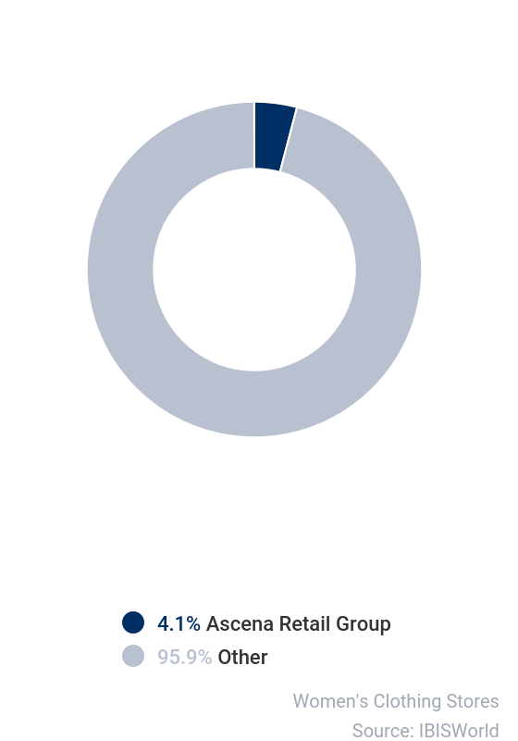 | SWOT
   | Strengths
   | Low & Increasing Level of Assistance
   | Low Volatility
   | Low Imports
   | Low Customer Class Concentration
   | Low Product/Service Concentration
   | Low Capital Requirements
   | Weaknesses
   | Low & Steady Barriers to Entry
   | High Competition
   | Low Profit vs. Sector Average
   | Low Revenue per Employee
   | Opportunities
   | External competition for the Women's Clothing Stores industry
   | Threats
   | Very Low Revenue Growth (2005-2020)
   | Low Revenue Growth (2015-2020)
   | Low Outlier Growth
   | Low Revenue Growth (2020-2025)
   | Low Performance Drivers
   | Number of adults aged 20 to 64

Executive Summary | The market for the Women's Clothing Stores industry is changing.  Due to declining mall traffic and competition from thriving superstore retailers, industry revenue is expected to fall at an annualized rate of 3.8% to $36.6 billion over the five years to 2020. Despite the industry's overall decline, rising disposable income and consumer sentiment during the majority of the five-year period are expected to boost some specialty and high-end retailers. While price-conscious consumers among lower- to middle-income households are important to industry sales, the willingness of higher-income consumers to spend on luxury clothing and accessories has mitigated further declines in the industry.  By definition, this industry only accounts for clothing stores that specialize in women's clothing, which excludes many popular family and unisex retailers that also carry women's clothing, but usually at lower prices. Therefore, many of the largest industry players are high-end or specialty stores that intend to sell to affluent women or niche markets. Many small specialty stores that carry niche products such as eco-friendly clothing or athleisure wear have flourished while staple mall stores have cut down locations to remain profitable. Additionally, overall growth in the number of households earning more than $100,000 is expected to have helped several main industry players outperform low-end retailers that have more customers but less-expensive transactions. However, the number of industry enterprises has decreased at an annualized rate of 2.1% to 33,124 enterprises over the five years to 2020 as companies have exited the industry due to intense competition. Profit has also suffered as a result of price-based competition within the industry. The outbreak of COVID-19 (coronavirus) has further exacerbated negative trends within the industry and created an unfavorable macroeconomic environment. Increasing unemployment has led to falling consumer confidence and consumer spending, triggering consumers to cut back on discretionary spending. Additionally, consumers who are still shopping are doing so online as the majority of brick-and-mortar retail that have re-opened with limited capacity. As a result, industry revenue is anticipated to decline an estimated 11.4% in 2020 alone.  Over the five years to 2025, industry revenue is expected to decline at an annualized rate of 0.4% to total $35.9 billion. Industry competition is expected to rise, as more operators enter the industry and internet sales continue to gain an edge in women's clothing. Many companies that were traditionally store-only businesses have responded to external competition by opening online stores that complement their brick-and-mortar establishments and attracting more customers through social media. The rise of mobile technology is expected to sustain this trend in the future. As consumers experience better financial conditions that favor nonessential purchases, revenue growth for a few existing industry players is expected to continue. However, a slight surge in brick-and-mortar shopping in 2021 is anticipated to mitigate further declines. Since stores were closed at the onset of coronavirus, as they reopen and eventually lift capacity limits, consumers will increasingly shop in-store to support those businesses. However, this trend is not anticipated to last long and online shopping will likely pick back up as the US economy stabilizes.

Industry Performance
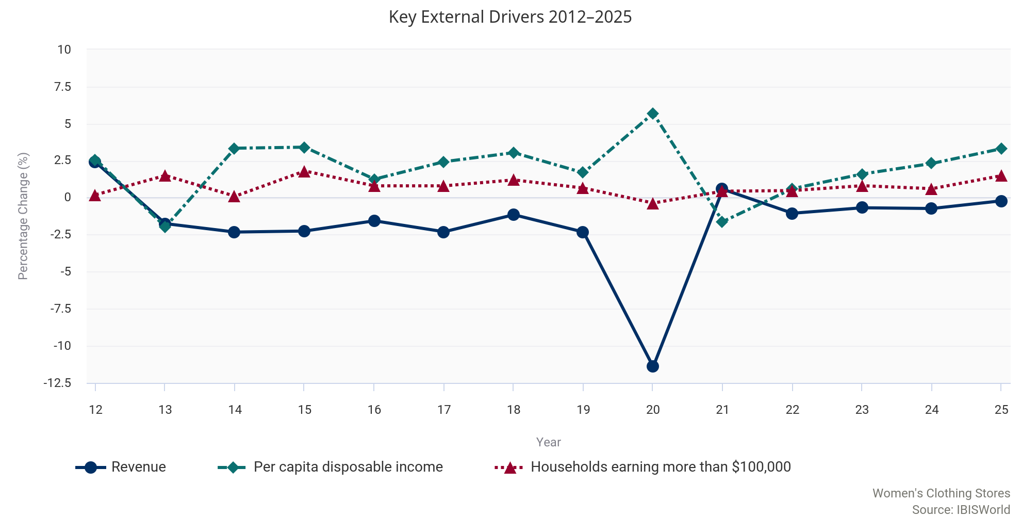

Key External  Drivers | Per capita disposable income  Growth in per capita disposable income affects demand for women's clothing. When household disposable income is high, consumers have more power to purchase discretionary items, such as clothes. Per capita disposable income is expected to increase in 2020 in line with expanded federal unemployment and the one-time stimulus check paid to qualifying taxpayers.  Households earning more than $100,000  Consumers in a higher-income bracket are more likely to shop at specialized women's clothing stores. Many industry participants design their products for affluent women and have clothing lines with high prices. The number of households earning more than $100,000 is expected to fall in 2020.  External competition for the Women's Clothing Stores industry  Discount supercenters and online stores provide clothing at a large discount to consumers. Rising income inequality may cause consumers to seek out cost-saving techniques on items they do not mind being made generically or by a nonluxury brand. External competition for the Women's Clothing Stores industry is expected to rise in 2020, posing a potential threat to the industry.  Number of adults aged 20 to 64  The number of adults in the population, especially females, affects demand for women's clothing. In particular, adults between 20 and 39 years old are a key demographic for women's clothing. The number of adults aged 20 to 64 is expected to slightly increase in 2020, representing a potential opportunity for industry operators.

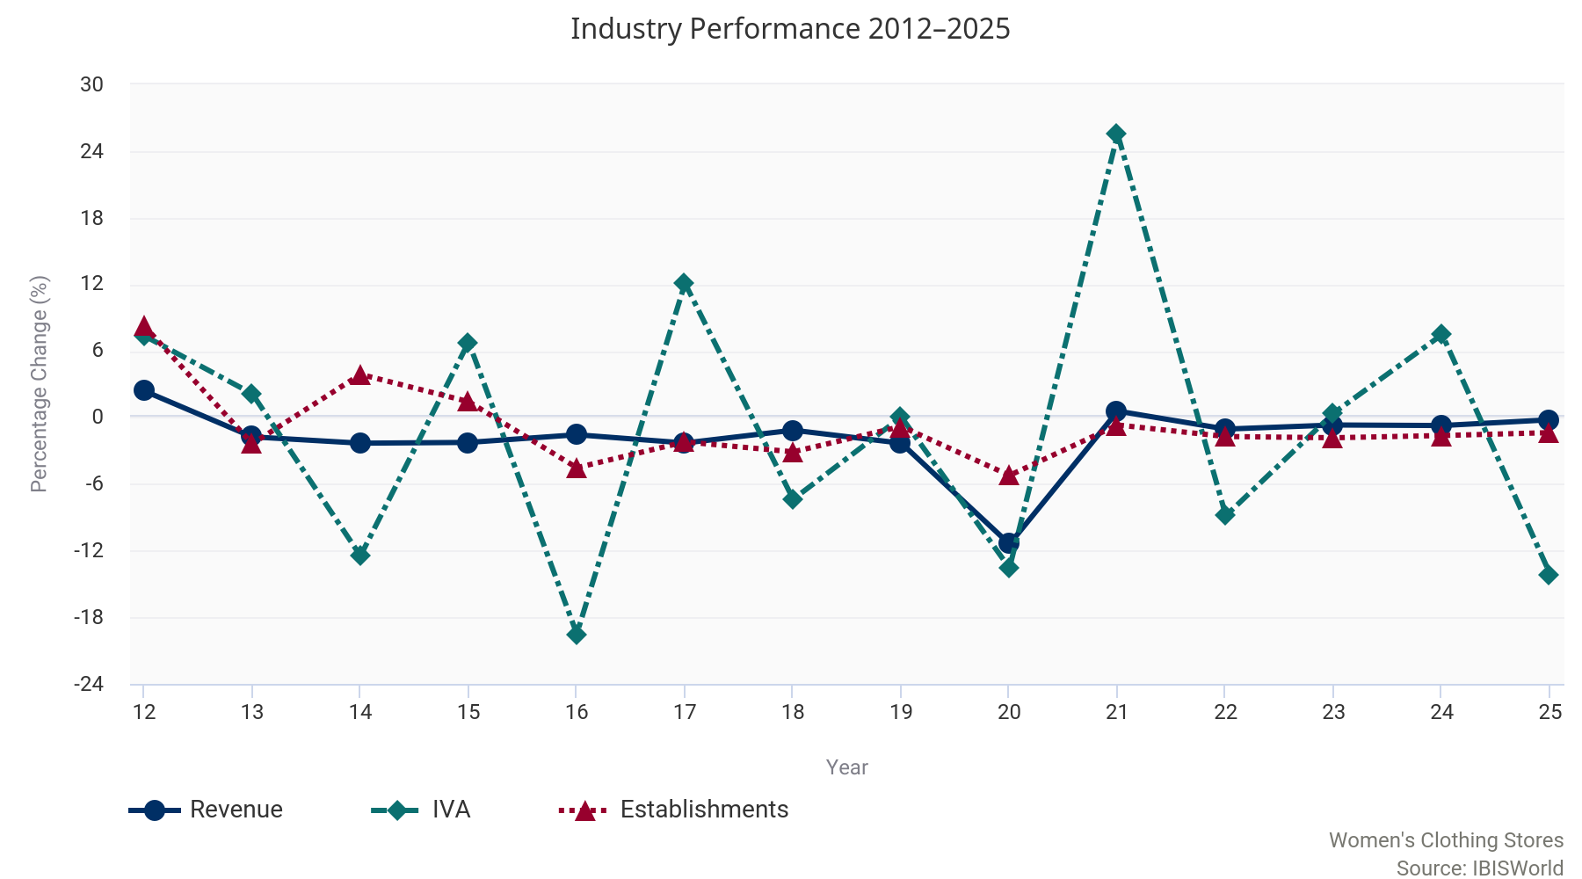

Current  Performance | Over the five years to 2020, the Women's Clothing Stores industry has struggled amid declining mall foot traffic and heightened external competition.  Despite an overall boost in per capita disposable income, more consumers have shifted to fast-fashion clothing stores and online outlets, which have eaten away at demand from industry establishments. Even so, some premium brand and specialty stores have benefited over the five years to 2020 as the upscale market became more pronounced. Despite favorable economic conditions during the majority of the five-year period, intense price competition and thriving external competition have resulted in mixed industry performance. Overall, industry revenue is expected to fall at an annualized rate of 3.8% to $36.6 billion over the five years to 2020.  External competition  As with most retailing industries, external competition has been an increasing threat over the past five years.  Many retailers have struggled to compete with discount department stores and supercenters, along with e-commerce channels. For the Women's Clothing Stores industry, however, external competition comes in even more forms, as numerous other industries retail women's apparel items. These competitors include the Family Clothing Stores industry (IBISWorld report 44814); the Sporting Goods Stores industry (45111); the Lingerie, Swimwear and Bridal Stores industry (44819); and the Used Goods Stores industry (45331). Family clothing stores are a particular threat to women's clothing retailers. These can range from upscale or specialty stores to more generic or discount stores. Family clothing stores sell a variety of men's, children's and women's apparel. These stores retail comparable products to women's clothing stores while benefiting from multiple target audiences. Over recent years, fast-fashion family stores, such as Zara and H&M, have expanded rapidly, further adding to the industry's external competitive environment. These stores offer inexpensive clothing items that are in line with the latest fashion trends. Over the past five years, fast-fashion stores have attracted a large number of women between the ages of 18 and 35, reducing revenue from industry operators that target this age group.  Online retailers have also put increasing competitive pressure on industry operators. Shopping online lets consumers choose from a larger variety of products and compare prices with ease. Over the five years to 2020, as internet traffic volume increased at an annualized rate of 26.4%, shopping online has become increasingly popular. Many online women's clothing stores have entered the retail market, many of which offer extended sizes and loyalty programs. In response to these online retailers, many industry operators have invested heavily into their own e-commerce channel. In 2020 (latest data available), Ascena Retail Group Inc., the industry's largest company, generated 47.0% of total company sales online, up from 19.0% in 2016. Additionally, RTW Retailwinds, previously known as New York & Company Inc., generated 36.0% of its total sales online between February 2019 and February 2020 (latest data available). Although online sales are not included in the industry, many industry operators have increasingly relied on e-commerce to remain competitive.  Mixed performance  Despite overall revenue decline over the past five years, the industry has experienced mixed performance.  Prior to the five-year period, the industry benefited from a growing economy, as consumers purchased clothing and other discretionary items. However, as the economy stabilized and the competitive environment intensified, industry performance became much more volatile. Since 2015, revenue has steadily declined due to discount retailers and online operators outperforming industry stores, especially during the holiday season. In 2020, industry revenue is expected to fall 11.4%.  Over the past five years, as price competition intensified and e-commerce became more widely accepted, many lower-priced brands struggled to compete, hampering industry revenue and profit. Many of these discount brands, including Charlotte Russe and Wet Seal, have been forced to reduce store counts or exit the industry altogether. Conversely, specialty stores and premium brands have bolstered industry revenue, despite a poor performance from lower-scale retailers. Upscale operators, such as Chico's FAS Inc. and Jones New York, and specialty retailers such as Lucy and Athleta, have grown sizably due to their ability to reach their target demographic.  Industry structure  Over the past five years, the number of industry enterprises is expected to decrease an annualized 2.1% to 33,124 operators.  The number of establishments has also decreased at a similar annualized rate of 3.2% to 50,395 locations. This decrease is a result of falling foot traffic in stores and intense competition forcing operators out of the industry. The industry is becoming increasingly dominated by smaller niche players further contributing to the decline in employment. Although the boost in small single-chain stores has created some employment opportunities, these stores require fewer employees to perform day-to-day operations. As a result, the number of industry employees is expected to decline at an annualized rate of 3.7% to 292,895 workers over the five years to 2020.  The geographic spread of industry stores is concentrated in metropolitan areas, particularly within New York and California. Fashion hubs such as New York City and Los Angeles provide specialized clothing stores with the opportunity to network with designers, merchandisers and fellow retailers to gain exposure in the industry. This networking can lead to changes and improvements in a store's supply chain and enable the store to effectively follow trends within the industry. Consumers with higher incomes are also concentrated around these areas, supplying high-end operators with their preferred customer base.  COVID-19  Unfortunately for industry operators, the outbreak of COVID-19 (coronavirus) is anticipated to further drive industry revenue down.  Due to the nonessential nature of the industry, the majority of operators were forced to temporarily close stores beginning in March to remain in compliance with social distancing and shelter-in-place protocols. When stores are closed, operators are unable to generate revenue through in-store sales. The majority of stores have since reopened depending on which state they are located in; however, operators are operating at limited capacity in many places. Additionally, the outbreak has caused unfavorable operating conditions for women's clothing stores as skyrocketing unemployment and falling disposable income has negatively affected consumer spending, which is anticipated to decline 3.8% in 2020. Women's apparel is considered a discretionary item and spending on industry products typically falls during times of economic uncertainty and downturn. All of these factors have contributed to an estimated 11.4% drop in industry revenue in 2020. Furthermore, industry profit, measured as earnings before interest and taxes, is anticipated to decline from 5.0% in 2015 to 2.1% in 2020, as operators are unable to cover fixed costs and inventory purchases due to falling in-store sales. These conditions have led to long-standing retailers exiting the industry. Both RTW Retailwinds and Ascena Retail Group filed for chapter 11 bankruptcy in July 2020. Since then, RTW Retailwinds is in the process of liquidating all inventory in stores through sales and has sold their ecommerce platform. Ascena Retail Group on the other hand has entered into agreements with various companies to purchase their subsidiaries, one of which is notable industry player, Sycamore Partners. In December 2020, Sycamore Partners was approved by a US bankruptcy judge to purchase Ann Taylor, Loft, Lane Bryant and the Lou & Grey Brand from Ascena. Once the transition is complete, it is likely Sycamore Partner's market share will increase somewhat significantly.

Historical Performance Data
Year | Revenue  ($m) | IVA  ($m) | Establishments  (Units) | Enterprises  (Units) | Employment  (Units) | Exports  ($m) | Imports  ($m) | Wages  ($m) | Domestic  Demand  ($m) | Consumer spending  ($b)
2011 | 46,329 | 8,430 | 53,185 | 29,406 | 376,174 | N/A | N/A | 6,206 | N/A | 10,844
2012 | 47,439 | 9,051 | 57,573 | 31,571 | 417,624 | N/A | N/A | 6,869 | N/A | 11,007
2013 | 46,613 | 9,244 | 56,214 | 32,911 | 383,880 | N/A | N/A | 6,400 | N/A | 11,167
2014 | 45,534 | 8,091 | 58,399 | 35,379 | 376,900 | N/A | N/A | 6,224 | N/A | 11,497
2015 | 44,512 | 8,641 | 59,232 | 36,799 | 353,918 | N/A | N/A | 6,104 | N/A | 11,921
2016 | 43,820 | 6,957 | 56,554 | 35,865 | 363,022 | N/A | N/A | 6,036 | N/A | 12,248
2017 | 42,815 | 7,798 | 55,311 | 35,748 | 365,211 | N/A | N/A | 5,871 | N/A | 12,567
2018 | 42,324 | 7,224 | 53,600 | 34,868 | 326,686 | N/A | N/A | 5,770 | N/A | 12,945
2019 | 41,346 | 7,227 | 53,169 | 34,704 | 320,479 | N/A | N/A | 5,656 | N/A | 13,280
2020 | 36,631 | 6,247 | 50,395 | 33,124 | 292,895 | N/A | N/A | 5,138 | N/A | 12,615

Industry Outlook
Outlook | Over the five years to 2025, the Women's Clothing Stores industry is expected to benefit from the rising number of high-income households that demand premium-clothing items.  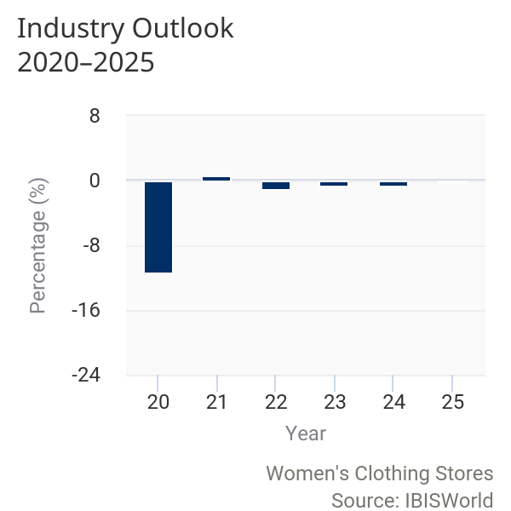  The fashion-forward nature of stores that specialize in only women's clothing convinces customers that the value of specialized products justifies the cost. Still, bargain shopping is popular in any clothing industry and many stores are expected to continue using competitive pricing and sales to lure customers as competition heats up. Competition from online retailers is expected to be particularly intense over the next five years, largely hampering industry revenue growth. IBISWorld projects industry revenue to decline at an annualized rate of 0.4% to $35.9 billion over the five years to 2025.  Specialty growth  Over the next five years, as price competition persists, industry revenue growth is expected to be generated by premium brands and specialty stores.  With rising per capita disposable income, more women will be willing to spend on discretionary high-end apparel items, especially since discretionary spending was stifled in 2020 as a result of COVID-19 (coronavirus). Stores with a niche or specialty offerings are expected to grow particularly rapidly. These include plus-sized stores, premium denim stores, women's athletic apparel stores and eco-clothing stores. Specialty women's clothing stores are usually small in size and serve a fairly homogenous target market. Having a specific target customer base enables these store operators to locate themselves close to key markets, focus promotional activity and enhance customer loyalty through community engagement. These shops are anticipated to fare well in 2021 as consumers opt to shop in brick-and-mortar stores to support local businesses after many operators had to temporarily close their stores at the onset of coronavirus. As a result, industry revenue is anticipated to increase an estimated 0.6% in 2021 as physical retail is expected to regain some of its share of total retail sales, resulting in a slower growth rate than normal for e-commerce sales. However, as the US economy normalizes, e-commerce sales will continue to grow and once again outpace revenue generated from transactions in brick-and-mortar locations. Although many online specialty retailers have flooded the market, the local appeal of these stores is expected to help them stay competitive. Furthermore, retailers will focus on creating more of an in-store experience to try and attract customers in store, such as in-store only promotions, pop-up shops and exclusive collaborations with celebrities and social media influencers.  Online disruptors  Over the next five years, online retailers are expected to pose an increasing threat to industry operators.  During the previous five-year period, rising e-commerce sales were particularly harmful to lower-priced stores with general product lines. However, over the next five years, premium-priced brands are also expected to experience the competitive pressure from online stores, as more specialty e-tailers enter the market. Although many premium brands will expand their online offering, off-price online retailers are expected to dominate the virtual market. Companies such as Rue Gilt Groupe, which operates Rue Lala and Gilt, and 6pm offer heavy discounts on highly sought-after name brand items, appealing to consumers who are both brand conscious and value driven. Even as disposable income increases, the wide appeal of off-price designer e-commerce sites will absorb a significant portion of demand for industry goods and make premium operators more price competitive.  In response to these off-price sites, many industry operators are expected to expand their own factory outlet retail channels. This store format focuses on the sale of excess or out-of-season inventory at a sizable discount. These discount outlets can operate both through traditional brick-and-mortar stores and through e-commerce sites. Industry companies including Coldwater Creek, Bebe, Chico's FAS Inc. and BCBG have already experimented with this strategy, and many more are expected to follow suit over the next five years. The shift toward off-price retailing will likely keep profit stagnant over the coming years, even as premium brand sales rise.  Industry landscape  Over the five years to 2025, establishment counts are anticipated to decline, decreasing an annualized 1.4% to 46,868 locations.  Even as premium brand sales increase, the highly saturated nature of the industry will deter many new entrants from setting up shop. Additionally, consolidation of national level chains is expected to continue, as more independent brands get purchased by larger chains or private equity firms such as Brentwood Associates and Sycamore Partners Management LLC. Additionally, as operators attempt to save profit, employment and wages are expected to fall slightly as operators cut costs. Over the five years to 2025, the number of employees in the industry is expected to decline 1.2% to 275,379 people. Total industry wages are projected to also decline at an annualized rate of 1.1% to $4.9 billion during the same period.
Performance Outlook Data
Year | Revenue  ($m) | IVA  ($m) | Establishments  (Units) | Enterprises  (Units) | Employment  (Units) | Exports  ($m) | Imports  ($m) | Wages  ($m) | Domestic  Demand  ($m) | Consumer spending ($b)
2020 | 36,631 | 6,247 | 50,395 | 33,124 | 292,895 | N/A | N/A | 5,138 | N/A | 12,615
2021 | 36,841 | 7,841 | 50,056 | 32,929 | 291,350 | N/A | N/A | 5,122 | N/A | 13,024
2022 | 36,456 | 7,148 | 49,199 | 32,389 | 286,485 | N/A | N/A | 5,043 | N/A | 13,563
2023 | 36,212 | 7,178 | 48,299 | 31,798 | 282,640 | N/A | N/A | 4,982 | N/A | 14,057
2024 | 35,949 | 7,715 | 47,516 | 31,280 | 278,559 | N/A | N/A | 4,917 | N/A | 14,498
2025 | 35,875 | 6,623 | 46,868 | 30,837 | 275,379 | N/A | N/A | 4,870 | N/A | 14,881
2026 | 35,904 | 7,541 | 46,352 | 30,478 | 273,597 | N/A | N/A | 4,846 | N/A | 15,227

Industry Life Cycle | The life cycle stage of this industry is Mature  LIFE CYCLE REASONS  The industry's contribution to the economy is forecast to be slower than US GDP growth over the 10 years to 2025  Growth in the number of new operators will slow following store closures and mergers  Technological change in the industry is expected to be limited

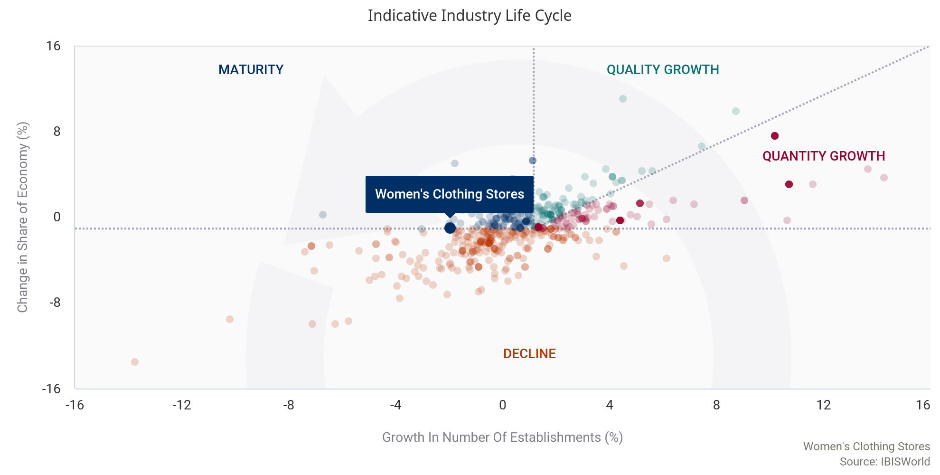

Industry value added (IVA), or the Women's Clothing Stores industry's contribution to the overall economy, is expected to decline an annualized 2.6% over the 10 years to 2025, while US GDP is estimated grow an annualized 1.9% during the same period. IVA growth below GDP usually indicates a declining industry; however, the Women's Clothing Stores industry exhibits characteristics typical of a mature industry. Women's clothing stores have a wholehearted market acceptance, as proven by their recovery from the short lapse in sales, but many of the major players are merging in the wake of weak mall sales. External competition has also plagued industry operators, and continues to hamper sales.
Moreover, the number of industry enterprises is declining at a steady pace and is expected to continue in this fashion over the five years to 2025. Over the 10 years to 2025, the number of companies operating brick-and-mortar women's clothing stores is forecast to decrease at an annualized rate of 1.8% to 30,837 companies. This steady growth is indicative of the stable demand for women's apparel.
Technology use has slowed within stores over the five years to 2020, limited to point-of-sale (POS) systems and online marketing. Unlike other retailers such as grocery stores and supercenters, clothing stores typically do not have self-checkout systems that reduce the number of necessary employees in a store, for customer service and security reasons.

Products & Markets
Supply Chain
  Key Buying Industries
  1st Tier
  E-Commerce & Online Auctions in the US
  Consumers in the US
  Key Selling Industries
  1st Tier
  Software Publishing in the US
  Women's & Children's Apparel Wholesaling in the US
  Commercial Leasing in the US
  2nd Tier
  Textile Mills in the US
  Cut and Sew Manufacturers in the US
  Cotton Farming in the US
  Transportation and Warehousing in the US
  Women’s, Girls’ and Infants’ Apparel Manufacturing in the US

Products & Services | 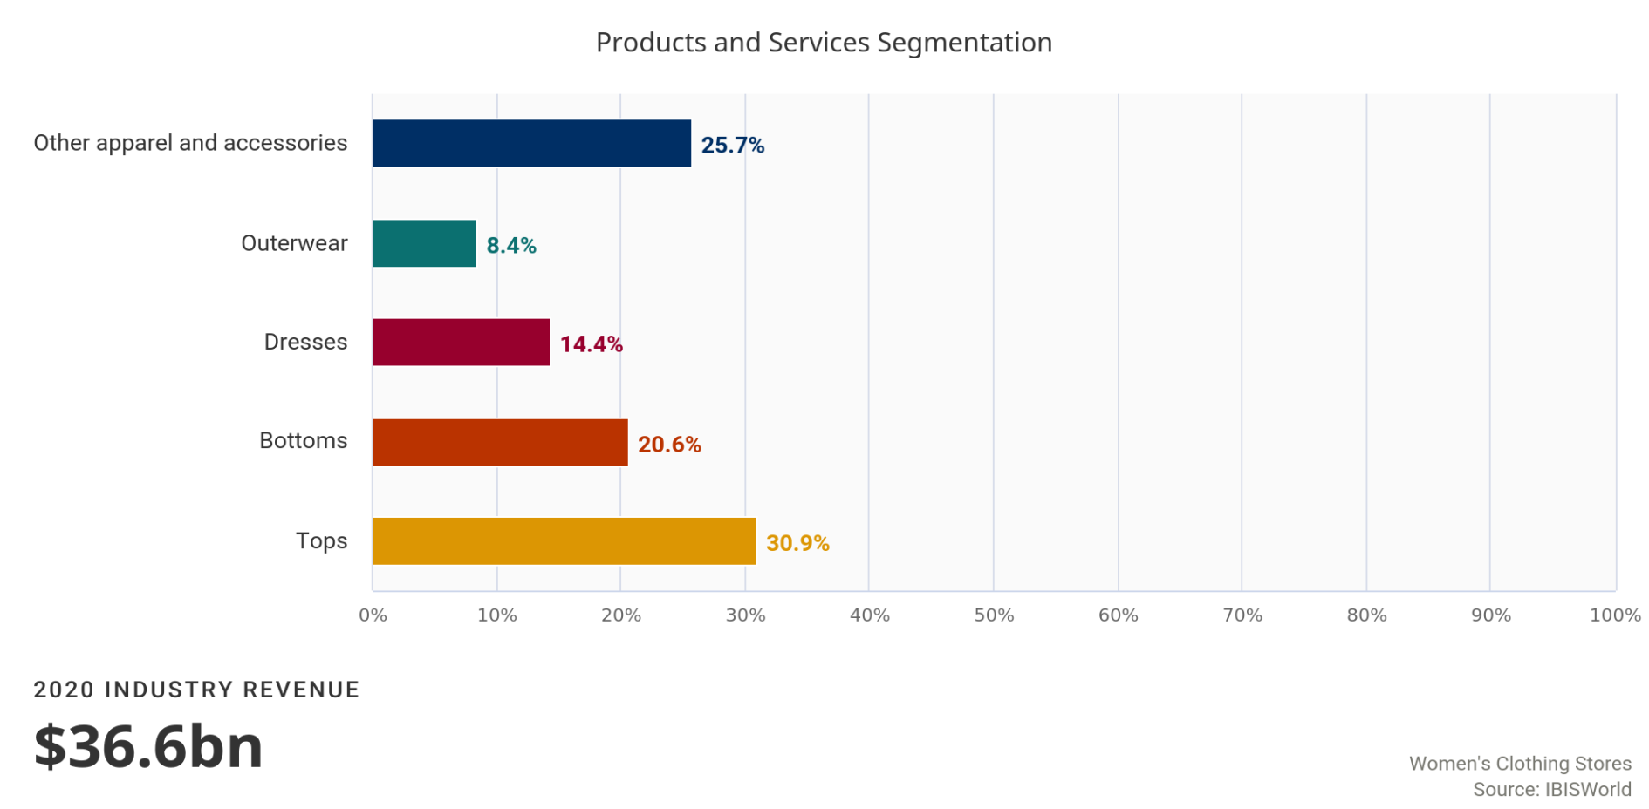
The product segments for the Women's Clothing Stores industry are relatively stable, although fluctuations exist due to climate and fashion changes.

Retailers are increasingly enhancing their product selections to include wider ranges of apparel to capture a larger market set.
Tops
Items that fall into this category include blouses, T-shirts, sweaters and cardigans.

This segment accounts for an estimated 30.9% of industry revenue in 2020. Most women own more tops than dresses or pants; generally, bottoms are more versatile and can be worn with several top combinations. Conversely, tops wear more quickly because they tend to be made of softer fabric (e.g. denim tops are not commonplace). Moreover, tops are generally less expensive than bottoms, which lets women purchase more of them. When discretionary spending on apparel declines, this segment's share of revenue increases slightly due to its relative affordability compared with other, higher-priced clothing items. Over the five years to 2020, revenue from this segment has remained steady.
Bottoms
Jeans, pants, skirts and shorts constitute the bottoms product category.

Growth in one subsegment occurs at the expense of another. For example, growth in demand for jeans offsets demand for skirts. Over the past five years, the pants segment has grown because more women are opting for jeans for office and casual wear. Additionally, the continuous rise of premium denim (i.e. branded denim that offers flattering and presumably high-quality characteristics) has caused this segment to expand more rapidly. Premium denim tends to carry a higher price to reflect its premium features, which also pushes up the segment's revenue. In 2020, IBISWorld estimates that this product segment accounts for 20.6% of industry revenue.
Dresses
Dresses account for an estimated 14.4% of revenue in 2020.

Demand for this segment is seasonal, increasing during warmer months and declining during winter months. Styles for dresses also change with fashion trends, which creates an incentive for consumers to buy new ones each year. However, this segment has declined over the five-year period, mainly due to a steep decrease in 2020 amid the outbreak of COVID-19 (coronavirus), which limited the need to purchases more formal items like dresses.
Outerwear
This product segment consists of jackets, coats and suits.

Demand for outerwear is cyclical, rising during the winter months and declining during the summer months. It is also regional, with demand in the northern parts of the country being stronger for a longer duration of the year due to colder climates. Over the past five years, this segment's share of revenue has declined slightly as growth in demand for other products has outpaced demand for outerwear. Moreover, the move toward casual work environments continues to limit demand for suits and sportscoats. Additionally, remote working among the majority of corporate America amid the outbreak of COVID-19 (coronavirus) has further dampened demand for suits and sportscoats. IBISWorld estimates that this segment accounts for 8.4% of industry revenue in 2020.
All other items
Undergarments, including lingerie, underwear, bras and sleepwear, and active apparel account for a combined 25.7% of industry revenue in 2020.

The growth of high-end active apparel brands has pushed this segment's share of revenue up slightly over the past five years. Additionally, as many individuals are working from home due to many offices being closed as a result of coronavirus, demand for sportswear has increased. Other products sold by this industry segment include accessories such as scarves and hats, wallets and handbags and footwear. Revenue from miscellaneous goods have increased over the past five years, more operators have attempted to diversify their product offering to boost revenue.
Major Markets | 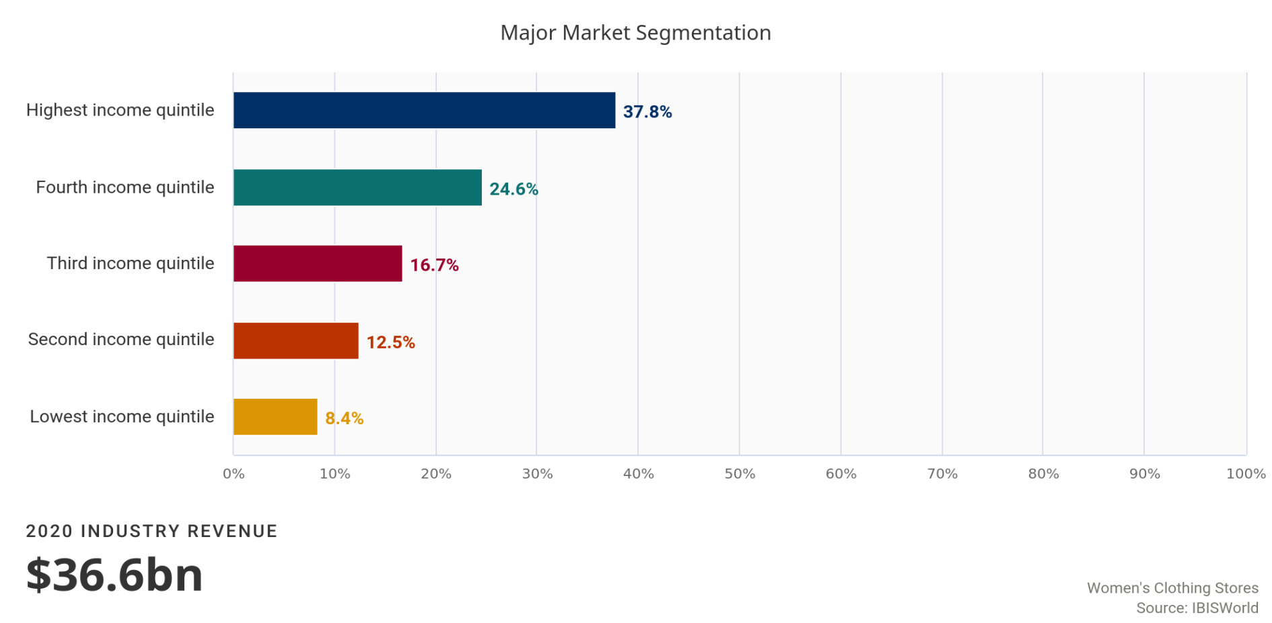
 | Although adult women are not always the purchasers of Women's Clothing Stores industry items, they are the intended market and are typically the recipient of women's clothing.
The following are household income brackets and their proportion of women's clothing expenditures from Bureau of Labor Statistics in 2019 (latest data available). These reflect all retailers, including businesses outside the industry. As a result of COVID-19 (coronavirus), demand from individuals in all income quintiles is anticipated to decline as discretionary spending on apparel is cut back.
Lowest and second income quintile
The lowest and second income quintiles are expected to account for 8.4% and 12.5% of industry revenue, respectively.

Consumers in this category are price conscious and often purchase industry goods on an as needed basis. Members of this segment will shop at industry retailers on occasion, but are likely to seek better prices for apparel at alternative retailers for the majority of clothing purchases. Over the five years to 2025, this segment's share of revenue is expected to decrease slightly, as more consumers shopped at discount department stores.
Third and fourth income quintile
The third and fourth income quintiles are anticipated to comprise 16.7% and 24.6% of industry revenue in 2020, respectively.

Such consumers benefit from higher disposable income, leading to stronger demand. Revenue from these segments is anticipated to expand over the five years to 2020 as unemployment falls and consumers within these quintiles return to work. Despite rising demand from these consumers, this segment's share of revenue is expected to increase slightly as more shoppers turn to premium retailers as per capita disposable income increases. Additionally, the emergence of fast fashion stores has enabled these consumers to make more frequent and unplanned purchases. However, over the next five years revenue from this segment will likely decline as many shopped for comparable goods online.
Highest income quintile
This segment of consumers accounts for the largest proportion of the market at an estimated 37.8% in 2020.

Many of the consumers within this bracket are 35 and up, which is the intended age group for customers of the industry's major players. These customers have grown up valuing brand recognition and spend a high proportion of their income on discretionary clothing and accessories. This segment is expected to increase within the greater economy, and will continue to provide revenue growth for this industry.
Exports in this industry are Low and Steady
Imports in this industry are Low and Steady
Women's Clothing Stores industry operators do not directly participate in trade, but the industry is affected by trade and sourcing in upstream industries. By convention, trade figures are accounted for at the manufacturing level. In this case, the Women's and Girls' Apparel Manufacturing industry (IBISWorld report 31523) accounts for all trade affecting women's clothing retailers.

Business Locations | 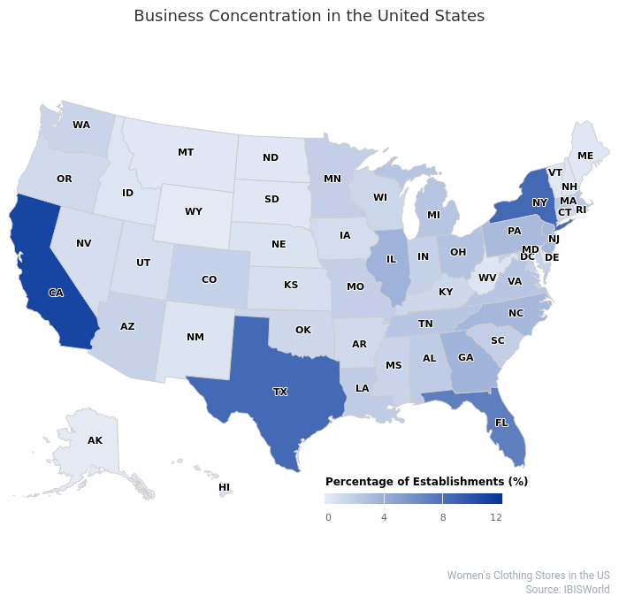
Similar to many other retail industries, the locations of Women's Clothing Stores industry operators in the United States follow population concentration trends. This pattern holds true in terms of region, but state by state this pattern has some exceptions. For example, New York accounts for 8.5% of all industry establishments, but population accounts for a lower 6.0% of the entire nation. Major metropolitan areas such as New York City, Miami and Los Angeles are highly commercialized and have wealthy populations to drive any clothing industry's demand for luxury brands. Consequently, the regions with the highest number of establishments are the Southeast, the Mid-Atlantic and the West.
The Southeast region is expected to account for the largest share of industry establishments in 2020 at 29.2%, while also having the largest portion of the US population, 25.8%. This synchronicity also indicates that consumers of all income levels feel comfortable enough to spend on women's clothing from industry stores rather than department stores.
The Mid-Atlantic region accounts for the second-largest share of industry establishments at an estimated 17.3%. This is proportionally higher than the region's share of the US population, which is 15.0%. IBISWorld attributes this disparity to the area's above-average annual incomes. While the national average income is $68,703 in 2018 (latest data available), according to the US Census Bureau, the average American living in the Mid-Atlantic region earns over $72,000. This income difference appeals to industry players seeking to capture the profitability that comes from selling products at a premium to wealthier consumers.
The Western region accounts for an expected 15.1% in 2020, in line with its US population proportion of 17.2%. California is the state with the highest amount of industry establishments, 10.8%, clearly carrying the region's share of the industry. California has several wealthy and metropolitan areas, some of which are known to be fashion hubs. Los Angeles, San Francisco, San Diego and others. Smaller women's clothing boutiques often showcase and sell the work of both well-known and new fashion designers, many of whom are located in cities of California that provide artistic and educational environments.
 | 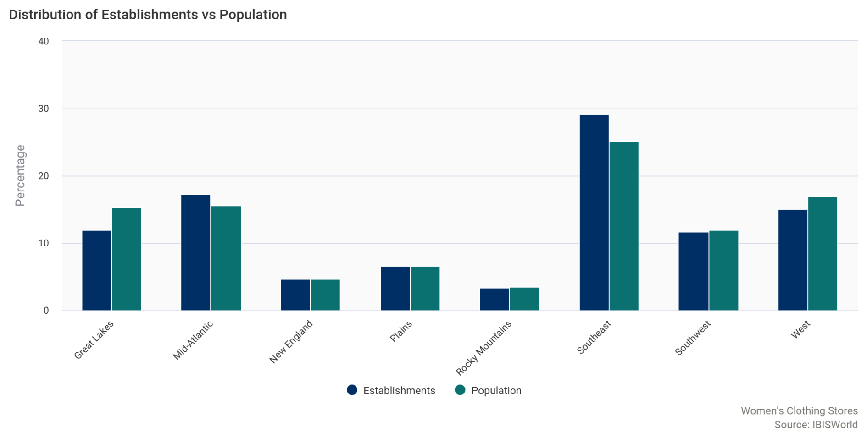

Competitive Landscape
Market Share Concentration | Concentration in this industry is Low  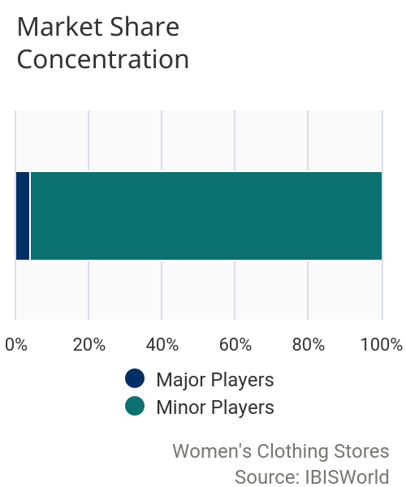  The Women's Clothing Stores industry is highly fragmented, with the majority of operators operating on a local or regional scale. In 2020, the top four industry companies are expected to account for 10.1% of industry revenue. Despite increased merger and acquisition activity during the period, market share concentration has decreased as operators are losing market share to e-commerce platforms. However, as retail sales struggled and profit remained depressed, many small brands were picked up by private equity firms such as Sycamore Partners Management LLC, Brentwood Associates and OpCapita. Additionally, due to struggles relating to COVID-19 (coronavirus), many retailers felt mounting pressure and filed for bankruptcy, including Ascena Retail Group and RTW Retailwinds. Both players have begun winding down operations, with Ascena Retail Group selling the majority of their brands to Sycamore Partners and RTW Retailwinds deciding to close down stores and sell their e-commerce platform. Over the five years to 2025, while merger and acquisition activity is expected to continue, market share is anticipated to decline due to the rising popularity and dominance of online retailers.
Key Success  Factors | IBISWorld identifies 250 Key Success Factors for a business. The most important for this industry are:  Attractive product presentation:  A logical store layout improves the shopping experience for customers. Having an attractive product display encourages product purchases and can strengthen the company's image.  Establishment of brand names:  Many shoppers are guided by the status of brands. Women's clothing stores that establish brand recognition will entice customer attention and encourage shopping.  Strong cash reserves:  It is imperative operators have strong cash reserves to keep the business afloat as many industry establishments remain closed amid the outbreak of COVID-19 (coronavirus).  Experienced work force:  The quality of staff is becoming increasingly important because customers demand superior customer service and product quality. Companies that have staff undergo extensive customer service training will have an advantage.  Proximity to key markets:  The store needs to be located where there is a high volume of passing traffic. Being in proximity to target customers will benefit a company because purchasing women's clothing is a very visual activity.  Production of goods currently favored by up-to-date fashion trends:  Women's and girls' clothing pieces stocked by a company have to be consistent with fashion trends and well suited to the fashion tastes of its target market.
Cost Structure  Benchmarks | 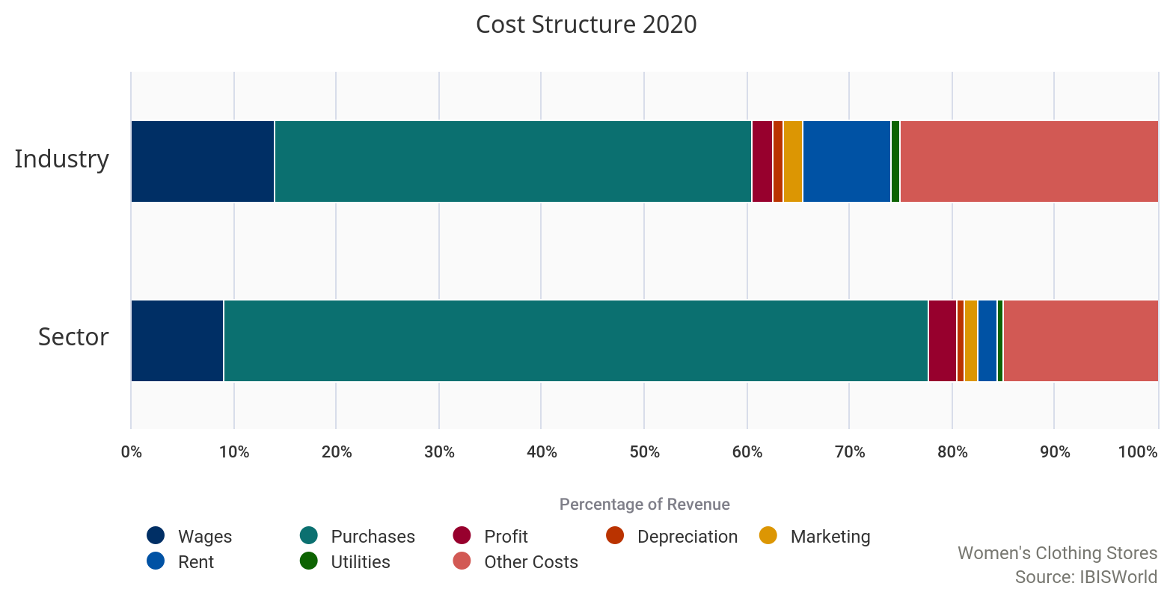
 | Profit  Due to the wide assortment of operators in the industry, profit often varies significantly between operators. Successful premium level stores often earn higher profit than generic stores selling less expensive merchandise. Overall, women's clothing retailers are estimated to achieve average profit, measured as earnings before interest and taxes, of 2.1% of revenue in 2020. Profit has decreased from 5.0% in 2015 as online shopping has become a larger force within the retail landscape, forcing operators to compete heavily on the basis of price to drive foot traffic into stores. COVID-19 (coronavirus) has put further pressure on profit as many operators were forced to temporarily close stores and contend with supply chain disruptions. Additionally, even as stores re-opened, many operators enforced capacity limits, mitigating their ability to generate enough revenue to cover losses incurred earlier in the year. | 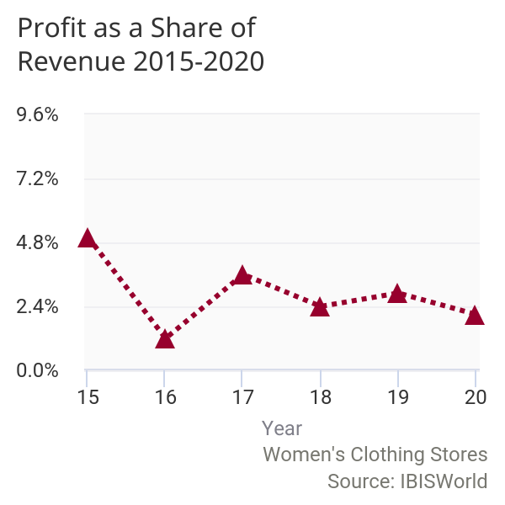

 | Wages  Wages are estimated to account for 14.0% of industry revenue in 2020. This share has remained relatively stable over the five years to 2020, increasing slightly from 13.7% in 2015 only because wages is declining at a slightly slower pace as revenue. In an attempt to salvage profit, many operators have relied more heavily on part time workers who are less costly to hire than full time staff. The fall in average wage is also due to declining employment in the industry. Over the past five years more operators have implemented technology such as inventory tracking systems and point-of-sale (POS) systems which reduce the need for lower-skilled employees. Furthermore, many operators furloughed workforces as stores were shut down and demand fell amid the outbreak of coronavirus. Since many stores had to enforce capacity limits, operators were able to keep staff counts lower than normal, further contributing to the overall decline in employment and wages in 2020. | 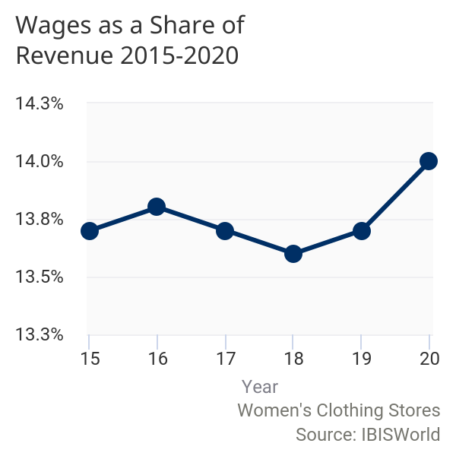

 | 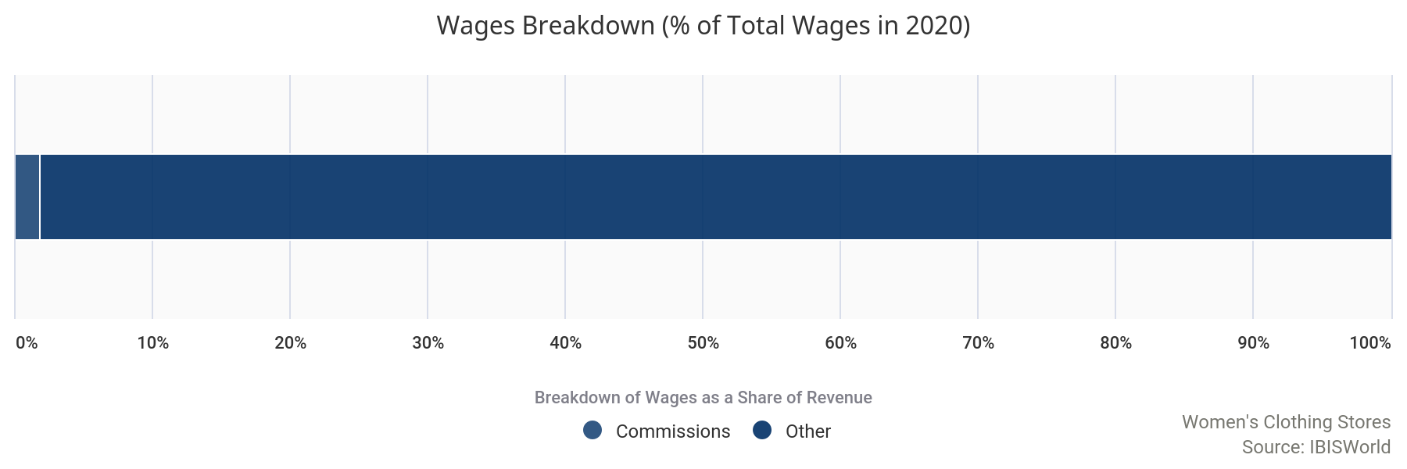
 | Purchases  Purchases are typically the largest cost for participants in the retail sector. Within the Women's Clothing Stores industry, purchases are estimated to account for 46.5% of industry revenue in 2020. This proportion will vary greatly among retailers of different sizes. Over the past five years, the portion of clothes sourced from low-cost overseas producers has increased significantly, keeping purchase costs lower than they would be if they were domestic. As said, the prices of cotton and alternative fibers have fluctuated drastically over the past five years due to adverse weather conditions damaging the supply chain, affecting purchase costs greatly. | 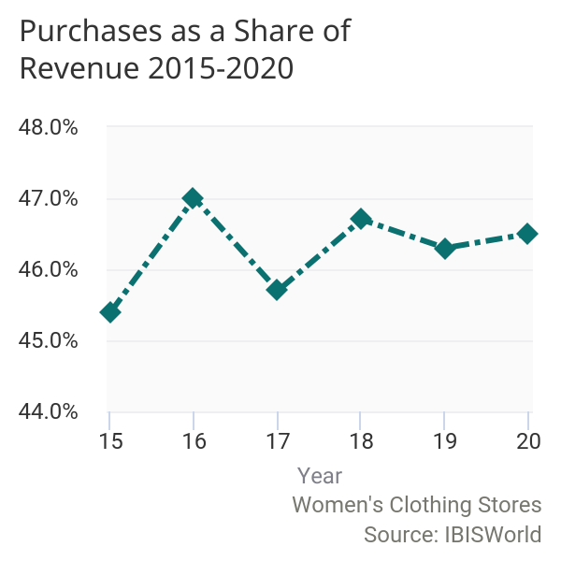

 | 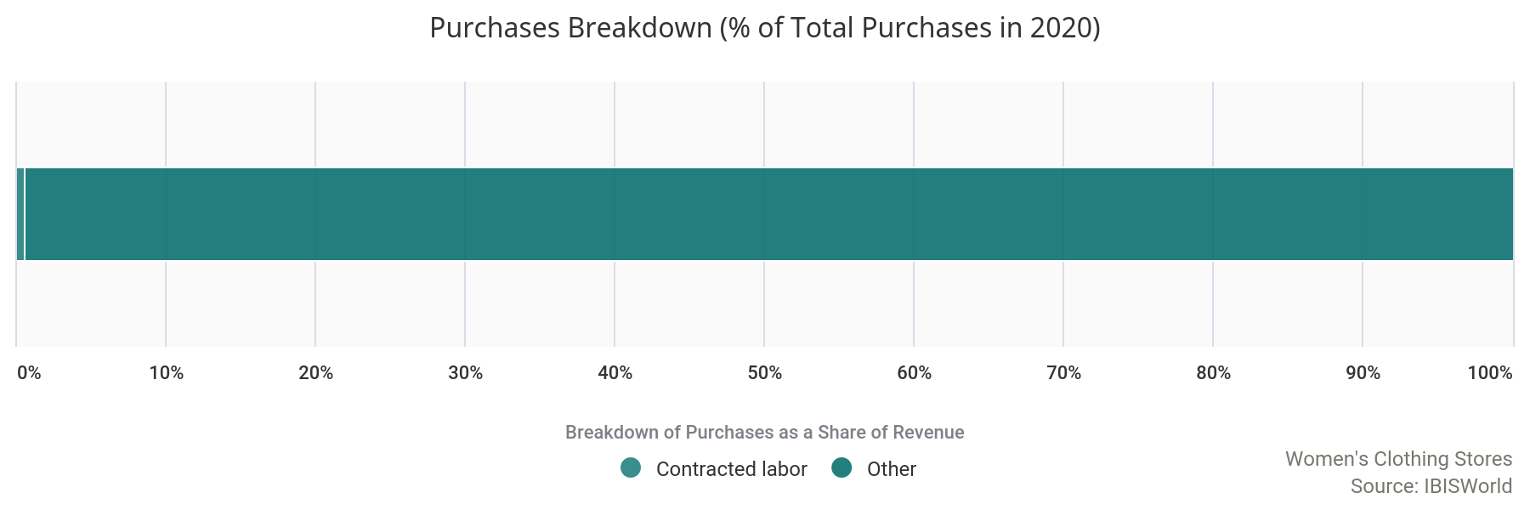
 | Marketing  In 2020, marketing expenditures are expected to make up 2.0% of industry revenue. To generate foot traffic, many operators rely on print, TV and online advertisements. Over the past five years, industry operators have allocated more resources to marketing campaigns to retain customers. | 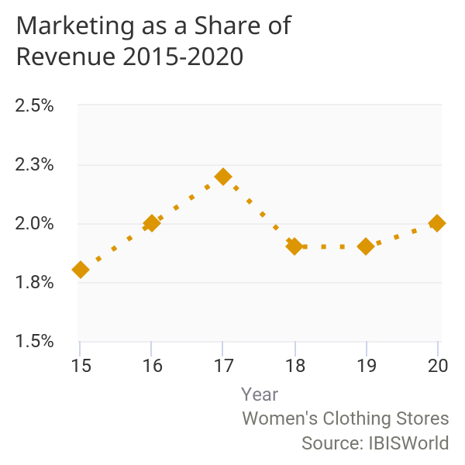

 | Depreciation  Depreciation expenses are low for industry operators, accounting for a mere 0.9% of revenue in 2020. Costs in this category include the depreciation of fixtures, inventory management software and POS systems. | 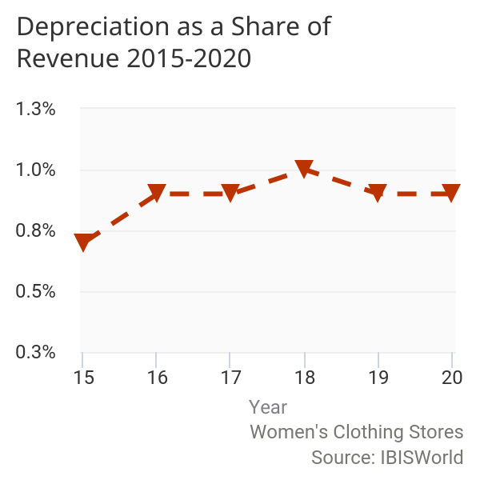

 | Rent  Rent expenses account for a total of 8.5% of industry revenue in 2020, increasing from 8.4% in 2015. Many women's clothing stores lease their establishment locations rather than own, increasing the amount industry participants spend on rent. Additionally, overall rental prices have increased alongside inflation. | 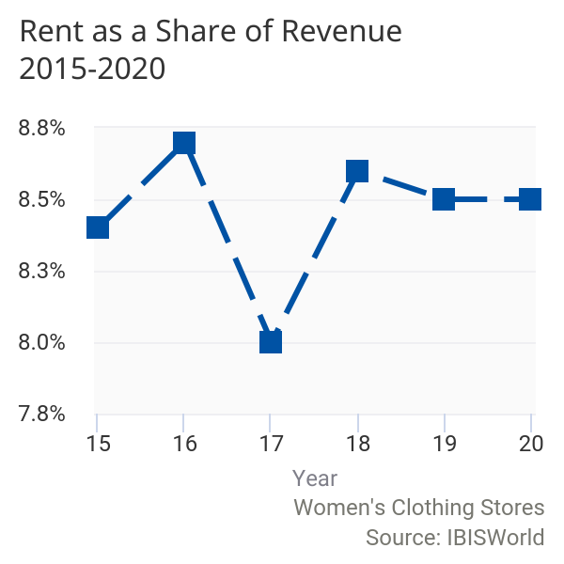

 | 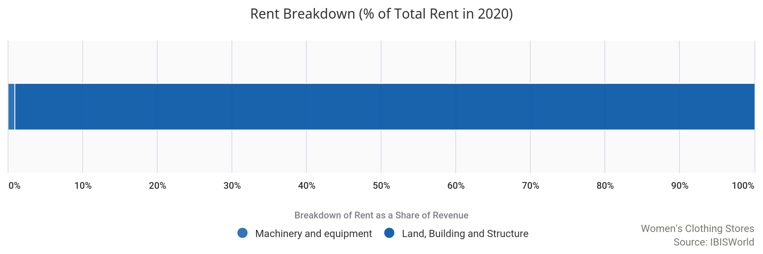
 | Utilities  Electricity is a large expenditure for stores, for both lighting for the store, and for displays. As a result, utilities account for an estimated 0.9% of industry revenue in 2020. | 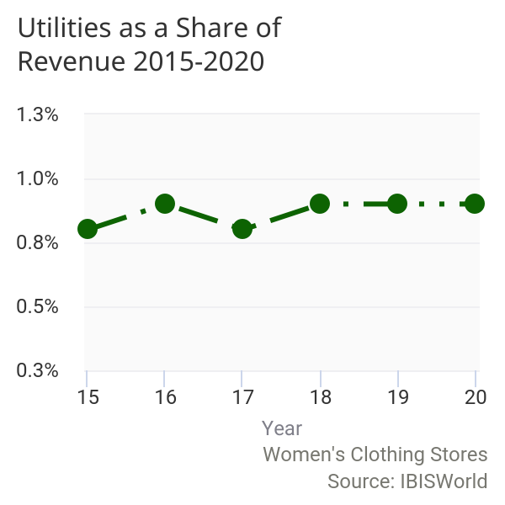

 | Other Costs  Other expenses include general administrative costs, repairs and maintenance, warehousing services and technical services. The increase in e-commerce for women's clothing is an increasing cost for both large and small retailers that choose to conduct additional business online. The cost of maintaining a website can be minimal, but is likely higher for large retailers with many clothing departments, and a higher volume of online customers. Besides POS systems, there is minimal in-store technology that needs maintenance and frequent repair. This segment of the industry's cost structure accounts for an estimated 25.1%. | 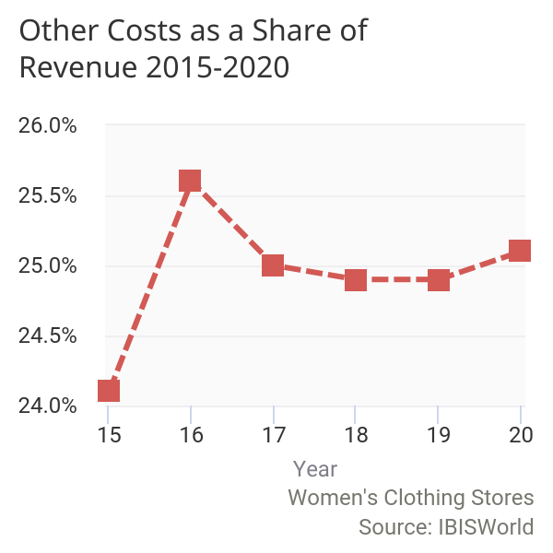

 | 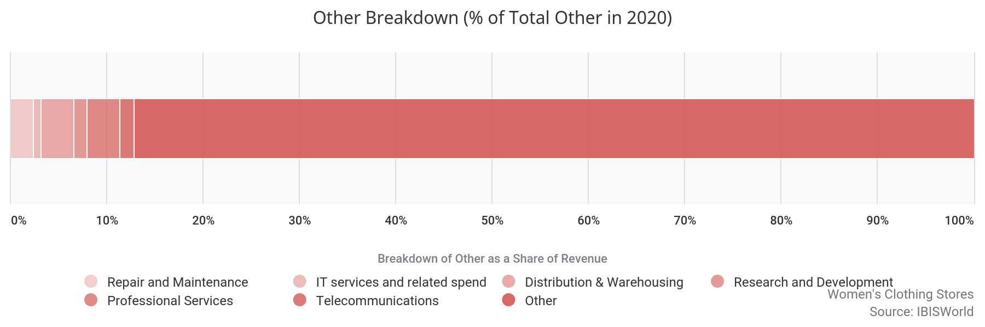
Basis of  Competition | Competition in this industry is High and the trend is Steady
The Women's Clothing Stores industry is highly competitive.

Competition for the industry exists both internally (among women's clothing stores) and externally (between the Women's Clothing Stores industry and other industries).
Internal competition
Industry participants compete with each other on the basis of brand image, marketing, fashion design, quality, price, customer service and store location.

Major players in this industry invest considerable resources in brand awareness and advertising promotions. Retailing well-recognized brands is important in this industry, where strong brand names help define consumer preferences and fashion choices. Industry participants need to offer customers a selection of merchandise with a style, quality and fit appropriate to their target market. For example, over the past few years, many women's retailers have expanded into plus-size fashion to build a customer base in that market segment. Some retailers in this industry target more affluent, professional women and charge premium prices for their higher-quality products. Other retailers target lower- to middle-income women and offer low prices. Price is only a basis of competition among retailers that have the same target market. Customer service and store location are also important to retailers in this industry because customers return to stores that provide professional and friendly service. Shoppers will also frequent a store that is conveniently located near them. Additionally, operators are now likely going to compete on the basis of adequate measures taken to ensure safety in their stores amid COVID-19 (coronavirus). These precautions include limited capacity, spaced out clothing racks and dressing rooms and dividers at cash registers.
External competition
The main industries competing with women's clothing stores are the Department Stores industry (IBISWorld report 45211), the Warehouse Clubs and Supercenters industry (45291), which includes off-price retailers such as Walmart Inc., and the E-Commerce and Online Auctions industry (45411a).

The one-stop-shop format of department stores enables women to purchase clothes for themselves while also shopping for their entire families. Discount stores offer price-competitive products to women who may be more conscious of their expenditure on apparel. Online retailers provide a platform for price comparison among many retailers and often give promotional offers and free shipping to return customers.

Barriers to  Entry | Barriers to Entry in this industry are Low and the trend is Steady
 | The capital costs associated with establishing a women's clothing store are relatively low, and the only real barriers to entry in the Women's Clothing Stores industry relate to brand awareness and competition. The long-term process of establishing a solid brand reputation can be considered a deterrent to entering the industry. Existing players have already established brand names in their respective product fields, so new entrants will have to invest money and time to sway consumers into making the shift from strong existing brand names to the garments of relatively new brands.  With a large number of smaller players, competition within the industry is strong. There is also a high level of external competition, particularly from the Department Stores industry. However, there are opportunities for retailers to compete in niche markets, such as plus-size, petites, casual clothing or evening wear. This industry is highly fragmented and comprises a large number of smaller players. The top four industry players have a collective industry share of an estimated 10.1%, which indicates low industry concentration.  Additionally, finding a retail space in a prime location with a lot of foot traffic can be a barrier to entry because it is often costly and not readily available. However, there are no regulatory or licensing requirements to set up a women's clothing store establishment, which is another factor contributing to the industry's low barriers to entry.
  Barriers to Entry Checklist
  Competition | High
  Concentration | Low
  Life Cycle Stage | Mature
  Technology Change | Medium
  Regulation & Policy | Medium
  Industry Assistance | Low

Industry Globalization | Globalization in this industry is Low and the trend is Increasing
 | The Women's Clothing Stores industry has a low level of globalization. Major players of the industry have facilities and stores in other countries besides the United States, but most of their stores are still domestic. Industry stores do not engage in international trade, although the majority of women's apparel is sourced internationally. Industry participants are affected by changes in the US dollar's value only marginally, as most changes are adjusted at the manufacturing and wholesale levels. However, significant shocks to commodity prices can determine women's clothing stores' merchandise prices. For example, this was the case in 2010 and 2011, when the world price of cotton skyrocketed and trickled down to retailers in the form of higher purchasing costs. Some retailers were able to pass on the increased prices to consumers, helping them generate higher revenue, while others had to absorb the cost and incur lower profit (or losses).

Major Companies
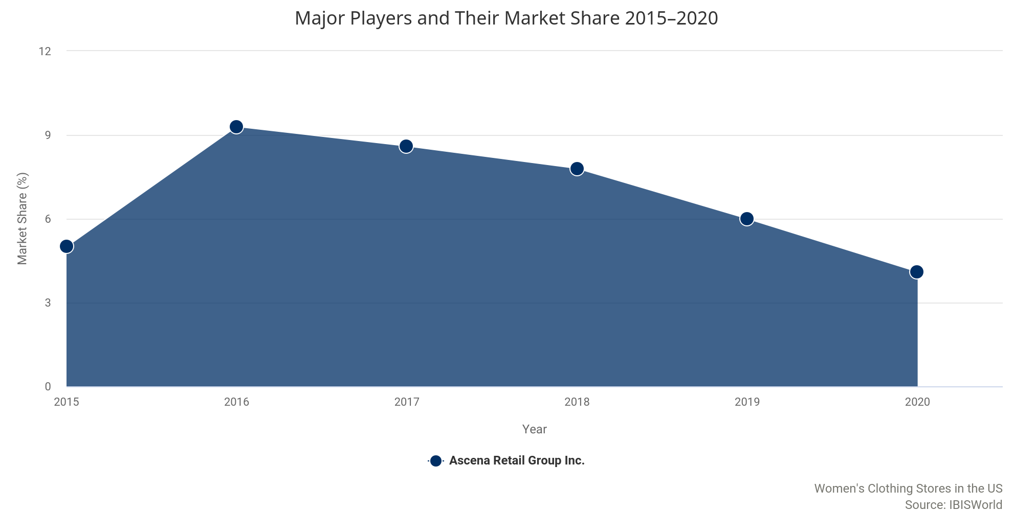

Major Players | 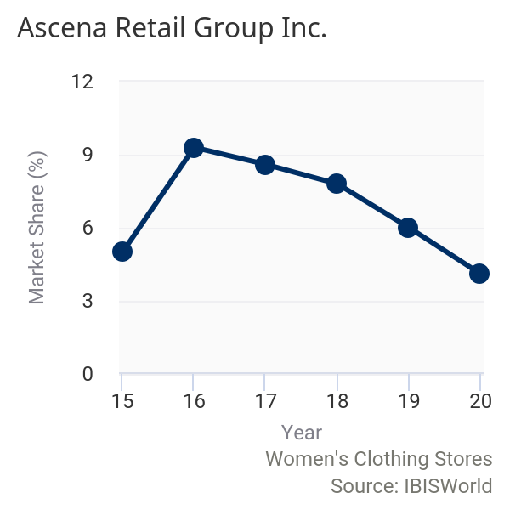  Ascena Retail Group Inc.  Market Share: 4.1%  Brand Names Lane Bryant, Maurices, Dressbarn, Catherines, Ann Taylor, Loft  Headquartered in Mahwah, NJ, Ascena Retail Group Inc. (Ascena) stores offer women's clothing, shoes and accessories through several brands, including Ann Taylor, Loft, Lane Bryant, Maurices, Dressbarn and Catherines. The company has 2,500 stores in the United States, Puerto Rico and Canada. Ascena currently participates in the Women's Clothing Stores industry through each of its brands except Justice, which is targeted toward the seven- to 14-year-old female demographic. Ascena's retail stores are located in shopping centers and outlet malls.  The group's Lane Bryant segment operates 637 retail locations, along with an e-commerce site, and sells plus-size fashions. Products in the segment range in sizes from 14 to 28 and include items such as lingerie, casual apparel, social occasion apparel and footwear. The Catherines segment operates 255 stores and an online retail platform; this segment caters to plus-size females ranging in sizes from 16 to 34 and 28 to 34, while also offering casual and career apparel and accessories. In August 2015, the company acquired Ann Inc., adding 894 Loft and Ann Taylor store locations to the company's portfolio. However, in March 2019, Ascena completed the sale of Maurices, a previous industry-relevant brand, to OpCapita LLP. Additionally, Ascena completed the sale of Dressbarn in December 2019. As of August 2020, Premium and Plus size fashion accounted for 78.0% of total company revenue, with the remaining revenue being generated through the Kids segment which is not industry relevant. In July 2020, Ascena filed for chapter 11 bankruptcy and plans to close 1,600 stores. Since then, the company has sold off Justice to Bluestar Alliance and have entered into an agreement to sell Catherines' to City Chic. On December 10, 2020, a US bankruptcy judge approved Ascena's sale of Ann Taylor, Loft, Lane Bryant and the Lou & Grey brands to Sycamore Partners for $540.0 million. Currently, all of the majority of the deals still need to be finalized and therefore, for the fiscal 2020 year, Ascena Retail Group is still considered the parent company of Catherines, Ann Taylor, Loft and Lane Bryant.  Financial performance  Over the five years to fiscal 2020 (year-end August), IBISWorld projects that Ascena's US industry-specific revenue will decline at an annualized rate of 6.0% to $1.5 billion. Moderate pricing has given Ascena an advantage over other specialty stores, attracting consumers who are seeking fashion on a budget; however, the industry-relevant revenue has been steadily declining since fiscal 2017 due to increased competition and proliferation of online sales. Additionally, the company completed its plans of winding down Dressbarn operations beginning in 2020, which has contributed to a further decline in industry relevant revenue. Furthermore, due to the outbreak of COVID-19 (coronavirus), the company temporarily closed all stores in March 2020, limiting the company's ability to generate in-store revenue, which accounts 53.0% of total sales in fiscal 2020. As stores began to reopen, there were limitations put in place, including a lower capacity for customers, health safety checks for employees and adjusting cash registers, clothing racks and fitting rooms to comply with social distancing. As a result, industry-relevant company revenue is anticipated to decline an estimated 38.9% in fiscal 2020 alone.  Operating income has fluctuated during the five-year period due to suppressed mall sales and the company's adjustment to acquisitions. In fiscal 2016, the company acquired Ann Inc., which sizably increased industry-relevant revenue an estimated 84.4%. Despite significant growth in the beginning of the five-year period, the company is expected to continue closing retail locations to streamline operations and elevate profit. The company has been able to mitigate some losses by adjusting inventory, which was down an estimated 20.0% as of May 2020 compared with the same period in the previous year. However, the adjustments have not been enough to salvage profit, so much so that the company filed for chapter 11 bankruptcy in July, with plans to close down 1,600 of its 2,500 stores. Since then, the company has entered in various agreements to sell its subsidiaries to different buyers. However, this has yet to be finalized, but if it is it will likely change the landscape of the industry.
Ascena Retail Group Inc. (US industry-specific segment) - financial performance*
Year** | Revenue  ($m) | Growth  (% change) | Operating Income  ($m) | Growth  (% change)
2014-15 | 2,061.4 | N/A | -226.5 | N/A
2015-16 | 3,800.6 | 84.4 | -52.2 | 77.0
2016-17 | 3,495.2 | -8.0 | -830.2 | -1,691.6
2017-18 | 3,224.5 | -7.7 | -51.5 | 93.8
2018-19 | 2,471.9 | -23.3 | -333.2 | -747.1
2019-20 | 1,510.7 | -38.9 | -452.5 | -235.8
Source: Annual report and IBISWorld
Note: *Estimates; **Year-end August

Other Companies | Chico’s FAS Inc.
 | Market Share: 2.6%
Established in 1983, Chico's FAS Inc. (Chico's) began business on Sanibel Island, FL, selling folk art specialty (FAS) items and custom-made furniture. The owners soon started selling sweaters and other specialty clothing from Mexico and determined enough potential in the segment to focus the business on women's apparel and accessories. The company is currently headquartered in Fort Myers, FL, and employs 17,100 workers across 1,341 stores in 46 states, Puerto Rico, the US Virgin Islands and Canada. Additionally, Chico's has opened 70 franchise locations in Mexico.
Chico's brands include Chico's and White House Black Market, each geared toward women aged 30 and older. The company completed the sale of Boston Proper and closed all Boston Proper stores as of 2015. As a result, the company's industry-specific revenue is expected to decrease in 2020. Furthermore, ChicosOffTheRack.com online outlet launched in 2017, taking away from the sales generated in brick-and-mortar locations. As a result, the company has closed more stores than it has opened every year in the five-year period, including 2019 in which the company closed 83 store locations and opened six. This trend has further been exacerbated as Chico's was forced to temporarily close all stores in March due to the outbreak of coronavirus, limiting the ability to generate revenue through in-store sales. However, in July the company had reopened the majority of store locations, but as the situation develops Chico's has had to re-close some stores and implement further restrictions such as reduced hours and staff, as well as stricter capacity limitations. Overall, IBISWorld projects industry-specific revenue to total $947.1 billion in 2020, declining at an annualized rate of 13.7% over the five years to 2020.
 | Sycamore Partners Management LLC
 | Market Share: 2.1%
 | Sycamore Partners Management LLC (Sycamore) is a private equity firm based in New York City that specializes in apparel retail investments. The company was founded in 2011 and has acquired several brands that operate within the Women's Clothing Stores industry, including Torrid, Talbots and Coldwater Creek. Some of the company's other retail brands carry women's apparel, but do not have stores that specialize in women's clothing. In April 2015, the company sold Jones New York to Authentic Brands group. Over the five years to 2020, Sycamore has both purchased and divested multiple women's clothing store brands, making the company's contribution to the industry variable. Torrid, Talbots and Coldwater Creek stores were temporarily closed beginning in March due to coronavirus, although that majority have since been re-opened depending on their location and various circumstances related to store hours, staff capabilities and capacity limits. The different brands have also stated that they have extended their return policy and have warned customers that there may be shipping delays. Additionally, in December 2020, Sycamore received approval from a US Bankruptcy court judge to purchase Ann Taylor, the Loft, Lane Bryant and Lou & Grey brands for $540.0 million from Ascena retail group. Once the transaction and transition is complete, it is likely Sycamore Partner's market share will increase. Although the company does not release financial statements to the public, IBISWorld expects Sycamore's industry-specific revenue to reach $782.9 million in 2020.
 | RTW Retailwinds
 | Market Share: 1.3%
 | RTW Retailwinds, previously known as New York & Company Inc. (New York & Company), is a specialty woman's retailer operating under the New York & Company brands. New York & Company rebranded in November 2018 and currently operates over 400 retail and outlet locations in 35 states. The company sells stylish and office-friendly pieces targeted at women between ages 25 and 45. In February 2018, New York & Company acquired certain assets of Fashion to Figure, a plus-sized fashion retailer based in the United States. Furthermore, in 2018, the company announced a partnership with Kate Hudson, who will create her own ready-to-wear brand. Like many industry operators, New York & Company has reduced its store count over the past five years, to save profit as mall traffic declined. In March 2020, the company stated that it would close between 150 stores over the next 18 months as the company transitions to a digital-focused brand. As a result, the company's online channel has increased from 33.0% of total sales in February 2019 to 38.0% of total sales in February 2020. Similar to other industry operators, all New York & Company stores were temporarily closed in March 2020 as a result of coronavirus. Following this, RTW Retailwinds filed for Chapter 11 Bankruptcy with plans to close down most, if not all stores. Currently, liquidation sales are going on at all store locations that remain open. Furthermore, in August 2020, Saadia Group purchased RTW's e-commerce business for $40.0 million. In 2020, IBISWorld estimates that the company's industry-specific revenue will fall to $473.8 million. However, if all store locations permately close, RTW Retailwinds will no longer operate in the industry.

Operating Conditions
 | 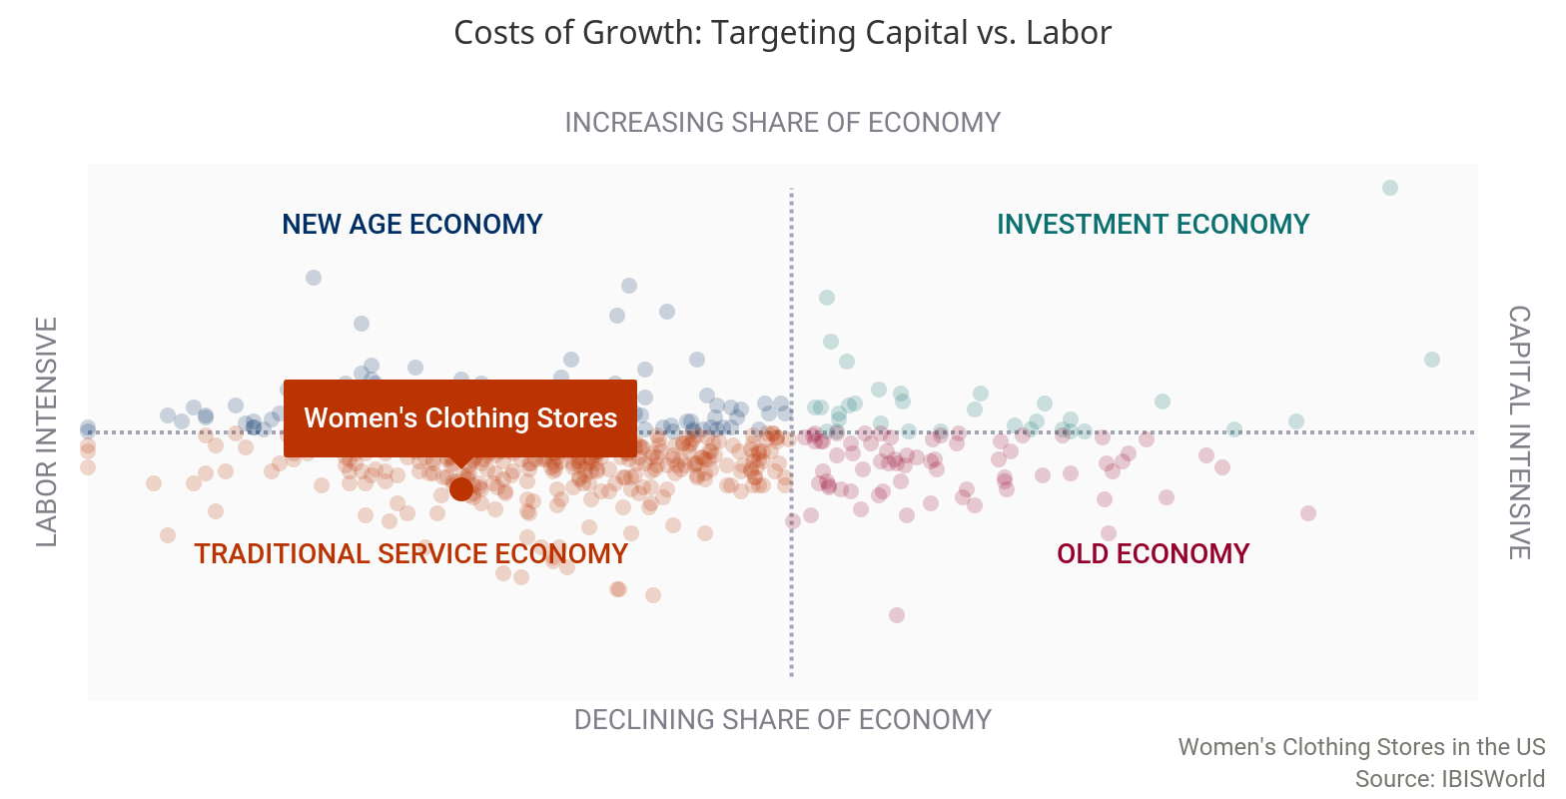
Capital Intensity | The level of capital intensity is Low
  In determining the level of capital intensity within the Women's Clothing Stores industry in the United States, IBISWorld uses wage costs as a proxy for labor, and depreciation as a proxy for capital investment. For every $1.00 absorbed by wages, an estimated $0.07 will be allocated toward capital investment in 2020. This ratio indicates a low level of capital intensity. Retail industries have typically been labor-intensive. Women's clothing stores require staff to provide high levels of customer service. Staff members are also required for merchandising tasks and processing sales. Capital costs include cash registers, computer systems and fixtures and fittings, typically incurred at the beginning of starting a business and not often incurred after. | 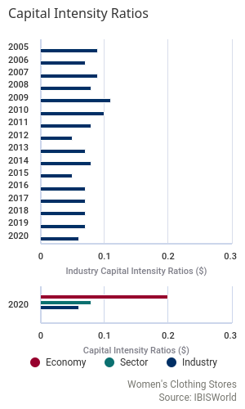
Technology & Systems | Potential Disruptive Innovation: Factors Driving Threat of Change
Level |  | Factor | Disruptive Effect | Description
 | Medium | Rate of Innovation | Potential | A ranked measure for the number of patents assigned to an industry. A faster rate of new patent additions to the industry increases the likelihood of a disruptive innovation occurring.
 | High | Innovation Concentration | Likely | A measure for the mix of patent classes assigned to the industry. A greater concentration of patents in one area increases the likelihood of technological disruption of incumbent operators.
 | High | Ease of Entry | Likely | A qualitative measure of barriers to entry. Fewer barriers to entry increases the likelihood that new entrants can disrupt incumbents by putting new technologies to use.
 | Low | Rate of Entry | Unlikely | Annualized growth in the number of enterprises in the industry, ranked against all other industries. A greater intensity of companies entering an industry increases the pool of potential disruptors.
 | Low | Market Concentration | Unlikely | A ranked measure of the largest core market for the industry. Concentrated core markets present a low-end market or new market entry point for disruptive technologies to capture market share.

The industry is adding new patent technologies at a rate in line with the average across all industries, which suggests a stable addition of technology. However, the concentration of technologies is high. This creates the potential for innovation outside the focus of industry leaders to gain traction.
The technological factors supporting the disruptive innovation potential are connected to an industry structure that is accommodative to new entrants. The relative ease of entry into the industry magnifies the threat of disruption regardless of other factors as one-off occurrences are more likely to succeed. However, the current rate of new entrants is low, suggesting that there is a limited number of new companies that are potential innovators within the industry.
Major market segments for industry operators are relatively diversified. The spread of market segments suggests that there are limited entry points other than those already served my incumbent operators.
There are several disruptive forces in the Women's Clothing Stores industry that have given consumers an alternative way to shop.

Operators have been able to implement technological change through e-commerce websites and mobile phone applications, making shopping easier and more convenient to consumers. However, some operators have capitalized on the convenience desired by consumers and have offered the ability to rent clothing and deliver curated boxes based on preferences and budget. For example, Rent the Runway is an online service that provides consumers with designer clothing and accessory rentals. Individuals can either choose from a subscription or a one-off rental, and must return the item at the end of the rental period. Furthermore, subscription box companies have also been gaining popularity. For example, Stitch Fix sends out boxes of clothing curated by in-house stylists based on the consumers preference, size, style and budget. Additionally, consumers only pay for a styling fee, which is credited back if the consumer purchases any item from the box. Both of these shopping experiences are disrupting the industry.
The level of technology change is Medium
Technological advances include the use of electronic barcode scanners, automated warehouse equipment and electronic surveillance.

Stock control, profitability and customer experience are all anticipated to feel the effects of the technological change occurring in the Women's Clothing Stores industry. Electronic barcode scanning systems enable efficient customer checkouts and returns, store-based inventory management and rapid order replenishment. On January 1, 2005, the 12-digit barcode retailers traditionally used to identify products went to 13-digits due to a shortage of 12-digit numbers.
Various industry participants have adopted e-commerce as an alternative sales medium and marketing tool. E-commerce offers consumers the ability to browse and purchase products from the comfort of their homes while giving women's clothing stores the opportunity to sell outside their prime market areas. The penetration of e-commerce technology is expected to increase, as is its usage among consumers. Additionally, with stock loss and theft affecting the industry's profitability, retailers regularly invest in systems and procedures that aim to limit these losses. Loss prevention technology includes closed-circuit TV cameras (CCTV), source tagging, signature-capture technology used at the point-of-sale (POS) terminal for credit card transactions, and fingerprint scanning systems that verify customer identities with the purpose of combating check fraud.
The key technology for women's clothing stores is radio frequency identification (RFID), which is presently implemented to monitor and replenish inventories more efficiently. RFID tags can either be passive or active, although both kinds respond to radio frequencies that are sent from a transceiver. Passive tags have no internal power supply, which means they emit limited information and are applied or embedded into a garment. Costs for RFID vary depending on the functionality of the product. Very short-range passive tags cost up to $0.06, while two-way active RFID tags with a long range can cost up to $25.00 each. IBISWorld anticipates the use of RFID to increase over the five years to 2025. The major benefits for retailers are identifying stock levels and monitoring inventory. Stock theft and stock loss can also be reduced, which would provide additional savings to retailers. Labor use will also improve because stock counting at a distribution level could be minimized and automatically calculated as needed.
Despite the adoption of RFID technology throughout the supply chain, it is not expected to gain significant traction at a retail level in the near future, given the low concentration of industry operators. However, this technology will significantly change key industry characteristics beyond the next five years. Some major clothing retailers could eventually have automatic checkouts, which calculate items in a customer's basket, confirm the price and process the payment through a unique POS system. Such technological integration has the potential to significantly alter the industry's labor costs.
Revenue Volatility | The level of volatility is Low
 | 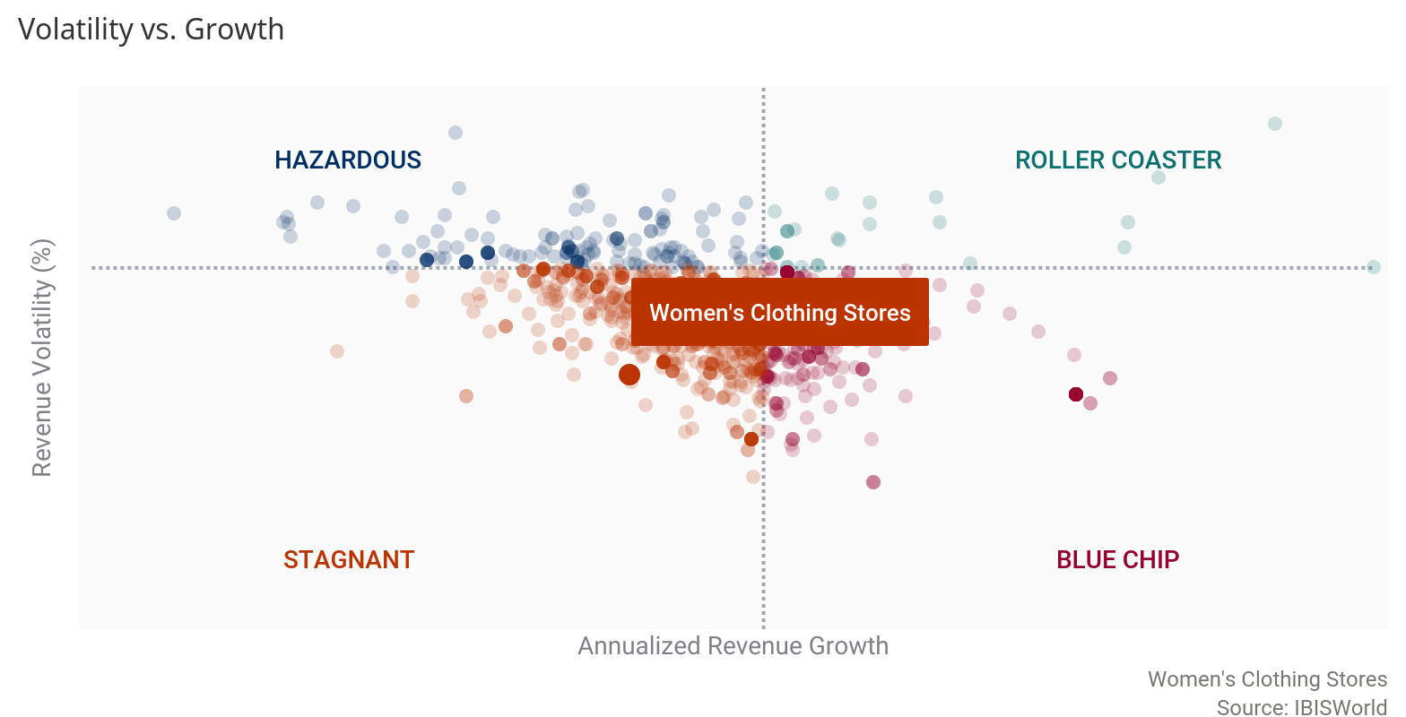
The Women's Clothing Stores industry has exhibited low revenue volatility over the five years to 2020.

Generally, as incomes rise, demand for discretionary apparel does as well. Despite an overall rise in consumer spending during the five-year period, industry revenue has not exhibited the same trend. Industry revenue has declined as little as 1.1% in 2018 and as much as 11.4% in 2020. Rising external competition from online outlets and alternative retailers has plagued industry operators, often forcing them to compete based on price. As operators continue to use promotional pricing to generate foot traffic, industry revenue is adversely affected if sales volumes remain at a similar level. Furthermore, the outbreak of COVID-19 (coronavirus) forced many operators to temporarily close beginning in mid-March and even as they have re-opened, capacity limits are enforced to ensure social distancing.
Regulation & Policy | The level of regulation is Medium and the trend is Steady  Regulations relevant to the Women's Clothing Stores industry vary by state.  Congress and individual states enact trade regulations with the aim of maintaining a free and competitive economy. Congress has passed the Sherman Act, the Wilson Act, the Clayton Act and the Robinson-Patman Act regarding unfair competition. Together these make up US federal antitrust law. The Sherman Act (1890) prohibits the formation of monopolies that hinder competition. The Wilson Act (1895) prohibits conspiracies that restrain import trade. The Clayton Act (1914) bans certain forms of price discrimination. Finally, the Robinson-Patman Act (1936) provides some protection to small independent retailers and their suppliers from unfair competition from vertically integrated, multilocation chain stores. States have enacted their own antitrust laws to ensure that the public is provided with the best prices, quality and competition among businesses, including women's clothing stores.  The laws that affect credit programs offered by retailers include the Federal Consumer Credit Protection Act (Truth in Lending), which specifies written disclosure of information relating to financing. For example, creditors must notify consumers of their annual percentage rate. The Federal Fair Credit Reporting Act specifies that consumer credit information can be used to approve or deny credit to that individual. The Federal Equal Credit Opportunity Act prohibits discriminating against any credit applicants based on gender, age, ethnicity and sexuality. The Fair Debt Collection Practices Act regulates how payments are collected on credit accounts. Finally, the Gramm-Leach-Bliley Act requires retailers to disclose their privacy policy as it relates to customers' nonpublic personal information  COVID-19  Due to the outbreak of COVID-19 (coronavirus) in late 2019 and early 2020, social distancing measures and nonessential business closures were enacted by all states to varying degrees.  Industry operators are considered non-essential and therefore, the majority of establishments were temporarily closed at the onset of the pandemic. However, most states have begun to re-open businesses and therefore, operators must ensure social distancing guidelines are maintained within their establishments by ensuring consumers and employees have space to maintain social distancing protocols (six feet apart). While the extent of these regulations varies depending on the state, with many easing restrictions in mid-2020, all operators have been affected. Adapting has involved delineating six-foot markers near registers in establishments, enforcing a face mask policy for customers and employees while in the establishment or limiting consumer counts for smaller or more heavily trafficked establishments. The situation is ongoing and virus cases are increasing across the US, meaning that operators may have to close or enforce stricter capacity limits depending on how the specific state that they are located in proceeds.
Industry Assistance | The level of industry assistance is Low and the trend is Increasing  Trade in apparel is not accounted for at the retail level, so there are no direct tariffs that apply to the Women's Clothing Stores industry.  However, tariffs applied to manufacturers and wholesalers ultimately affect the prices paid by women's clothing retailers.  This industry typically does not receive any major government subsidies or grants. However, due to the outbreak of COVID-19 (coronavirus) and the negative effects for many individuals and businesses as a result of the pandemic, the federal government passed the Coronavirus Aid, Relief, and Economic Security (CARES) Act. Part of the $2.0 trillion stimulus package is the Paycheck Protection Program (PPP), which provides funding for eligible businesses that employ fewer than 500 individuals to receive funding to pay for rent and utilities and keep employees on the payroll. As of August 8, 2020, the Retail Trade sector accounted for just over 7.7% of all approved PPP loans. Given the fact that nonemployers account for 62.2% of all companies within this industry, it is likely many operators will benefit from increased federal funding in 2020. However, PPP funding has since run out, limiting future funding for industry operators.  Additionally, various retail-encompassing associations and councils exist to protect women's clothing businesses. The National Retail Federation is the world's largest retail trade association and conducts programs and services in research, education, training, information technology and government affairs to protect and advance the interests of the retail sector, of which women's clothing stores are a part. The American Apparel and Footwear Association (AAFA) is the national trade association representing apparel, footwear and other sewn products companies. AAFA's mission is to promote and enhance its members' competitiveness, productivity and profitability in the global market by minimizing regulatory, legal, commercial, political and trade restraints.

Key Statistics

Industry Data
Year | Revenue  ($m) | IVA  ($m) | Establishments  (Units) | Enterprises  (Units) | Employment  (Units) | Exports  ($m) | Imports  ($m) | Wages  ($m) | Domestic  Demand  ($m) | Consumer spending ($b)
2011 | 46,329 | 8,430 | 53,185 | 29,406 | 376,174 | N/A | N/A | 6,206 | N/A | 10,844
2012 | 47,439 | 9,051 | 57,573 | 31,571 | 417,624 | N/A | N/A | 6,869 | N/A | 11,007
2013 | 46,613 | 9,244 | 56,214 | 32,911 | 383,880 | N/A | N/A | 6,400 | N/A | 11,167
2014 | 45,534 | 8,091 | 58,399 | 35,379 | 376,900 | N/A | N/A | 6,224 | N/A | 11,497
2015 | 44,512 | 8,641 | 59,232 | 36,799 | 353,918 | N/A | N/A | 6,104 | N/A | 11,921
2016 | 43,820 | 6,957 | 56,554 | 35,865 | 363,022 | N/A | N/A | 6,036 | N/A | 12,248
2017 | 42,815 | 7,798 | 55,311 | 35,748 | 365,211 | N/A | N/A | 5,871 | N/A | 12,567
2018 | 42,324 | 7,224 | 53,600 | 34,868 | 326,686 | N/A | N/A | 5,770 | N/A | 12,945
2019 | 41,346 | 7,227 | 53,169 | 34,704 | 320,479 | N/A | N/A | 5,656 | N/A | 13,280
2020 | 36,631 | 6,247 | 50,395 | 33,124 | 292,895 | N/A | N/A | 5,138 | N/A | 12,615
2021 | 36,841 | 7,841 | 50,056 | 32,929 | 291,350 | N/A | N/A | 5,122 | N/A | 13,024
2022 | 36,456 | 7,148 | 49,199 | 32,389 | 286,485 | N/A | N/A | 5,043 | N/A | 13,563
2023 | 36,212 | 7,178 | 48,299 | 31,798 | 282,640 | N/A | N/A | 4,982 | N/A | 14,057
2024 | 35,949 | 7,715 | 47,516 | 31,280 | 278,559 | N/A | N/A | 4,917 | N/A | 14,498
2025 | 35,875 | 6,623 | 46,868 | 30,837 | 275,379 | N/A | N/A | 4,870 | N/A | 14,881

Annual Change
Year | Revenue  (%) | IVA  (%) | Establishments  (%) | Enterprises  (%) | Employment  (%) | Exports  (%) | Imports  (%) | Wages  (%) | Domestic  Demand  (%) | Consumer spending (%)
2011 | 4.08 | -2.28 | 2.78 | 2.30 | 14.9 | N/A | N/A | 5.78 | N/A | 1.88
2012 | 2.39 | 7.36 | 8.25 | 7.36 | 11.0 | N/A | N/A | 10.7 | N/A | 1.50
2013 | -1.75 | 2.13 | -2.37 | 4.24 | -8.08 | N/A | N/A | -6.82 | N/A | 1.45
2014 | -2.32 | -12.5 | 3.88 | 7.49 | -1.82 | N/A | N/A | -2.75 | N/A | 2.95
2015 | -2.25 | 6.79 | 1.42 | 4.01 | -6.10 | N/A | N/A | -1.94 | N/A | 3.68
2016 | -1.56 | -19.5 | -4.53 | -2.54 | 2.57 | N/A | N/A | -1.11 | N/A | 2.73
2017 | -2.30 | 12.1 | -2.20 | -0.33 | 0.60 | N/A | N/A | -2.75 | N/A | 2.60
2018 | -1.15 | -7.37 | -3.10 | -2.47 | -10.6 | N/A | N/A | -1.72 | N/A | 3.00
2019 | -2.32 | 0.04 | -0.81 | -0.48 | -1.90 | N/A | N/A | -1.99 | N/A | 2.59
2020 | -11.4 | -13.6 | -5.22 | -4.56 | -8.61 | N/A | N/A | -9.17 | N/A | -5.02
2021 | 0.57 | 25.5 | -0.68 | -0.59 | -0.53 | N/A | N/A | -0.31 | N/A | 3.24
2022 | -1.05 | -8.85 | -1.72 | -1.64 | -1.67 | N/A | N/A | -1.55 | N/A | 4.13
2023 | -0.68 | 0.42 | -1.83 | -1.83 | -1.35 | N/A | N/A | -1.21 | N/A | 3.64
2024 | -0.73 | 7.47 | -1.63 | -1.63 | -1.45 | N/A | N/A | -1.30 | N/A | 3.13
2025 | -0.21 | -14.2 | -1.37 | -1.42 | -1.15 | N/A | N/A | -0.96 | N/A | 2.64

Key Ratios
Year | IVA/Revenue  (%) | Imports/  Demand  (%) | Exports/  Revenue  (%) | Revenue per  Employee  ($'000) | Wages/  Revenue  (%) | Employees per  estab.  (Units) | Average Wage ($)
2011 | 18.2 | N/A | N/A | 123 | 13.4 | 7.07 | 16,497
2012 | 19.1 | N/A | N/A | 114 | 14.5 | 7.25 | 16,447
2013 | 19.8 | N/A | N/A | 121 | 13.7 | 6.83 | 16,673
2014 | 17.8 | N/A | N/A | 121 | 13.7 | 6.45 | 16,515
2015 | 19.4 | N/A | N/A | 126 | 13.7 | 5.98 | 17,246
2016 | 15.9 | N/A | N/A | 121 | 13.8 | 6.42 | 16,628
2017 | 18.2 | N/A | N/A | 117 | 13.7 | 6.60 | 16,075
2018 | 17.1 | N/A | N/A | 130 | 13.6 | 6.09 | 17,663
2019 | 17.5 | N/A | N/A | 129 | 13.7 | 6.03 | 17,649
2020 | 17.1 | N/A | N/A | 125 | 14.0 | 5.81 | 17,541
2021 | 21.3 | N/A | N/A | 126 | 13.9 | 5.82 | 17,580
2022 | 19.6 | N/A | N/A | 127 | 13.8 | 5.82 | 17,602
2023 | 19.8 | N/A | N/A | 128 | 13.8 | 5.85 | 17,626
2024 | 21.5 | N/A | N/A | 129 | 13.7 | 5.86 | 17,652
2025 | 18.5 | N/A | N/A | 130 | 13.6 | 5.88 | 17,685

Industry Financial Ratios
April 2019 - March 2020
by company revenue
Liquidity Ratios | Apr 16 -  Mar 17 | Apr 17 -  Mar 18 | Apr 18 -  Mar 19 | Apr 19 -  Mar 20 | Small  (<$10m) | Medium  ($10-$50m) | Large  (>$50m)
Current Ratio | 1.7 | 1.7 | 1.5 | 1.3 | 1.6 | 2.1 | 0.9
Quick Ratio | 0.3 | 0.4 | 0.5 | 0.5 | 0.4 | 0.9 | 0.1
Sales / Receivables (Trade Receivables Turnover) | N/A | N/A | 999.8 | 248.6 | N/C | 47.3 | 212.4
Days' Receivables | 0.4 | 0.4 | 0.4 | 1.5 | N/A | 7.7 | 1.7
Cost of Sales / Inventory (Inventory Turnover) | 4.4 | 4.3 | 3.3 | 3.4 | 3.5 | 2.6 | 5.0
Days' Inventory | 83.0 | 84.9 | 110.6 | 107.4 | 104.3 | 140.4 | 73.0
Cost of Sales / Payables (Payables Turnover) | 14.8 | 16.6 | 11.8 | 11.5 | 22.4 | 6.7 | 9.3
Days' Payables | 24.7 | 22.0 | 30.9 | 31.7 | 16.3 | 54.5 | 39.2
Sales / Working Capital | 12.3 | 15.1 | 13.5 | 17.4 | 21.3 | 6.6 | -65.7

Coverage Ratios
Earnings Before Interest & Taxes (EBIT) / Interest | 1.5 | 4.0 | 3.2 | 2.4 | 3.6 | 4.8 | -1.3
Net Profit + Dep., Depletion, Amort. / Current Maturities LT Debt | 4.5 | N/A | N/A | N/A | N/A | N/A | N/A

Leverage Ratios
Fixed Assets / Net Worth | 0.6 | 0.7 | 1.0 | 0.7 | 0.6 | 0.2 | -39.7
Debt / Net Worth | 1.9 | 1.7 | 3.0 | 2.8 | 2.9 | 1.0 | -174.6
Tangible Net Worth | 18.4 | 26.6 | 13.9 | 21.9 | 15.6 | 54.2 | -1.6

Operating Ratios
Profit before Taxes / Net Worth, % | 16.6 | 25.0 | 27.4 | 12.8 | 15.6 | 13.4 | N/A
Profit before Taxes / Total Assets, % | 3.3 | 7.2 | 5.4 | 3.5 | 4.2 | 5.6 | -4.6
Sales / Net Fixed Assets | 18.9 | 23.5 | 18.3 | 18.4 | 30.3 | 20.6 | 12.0
Sales / Total Assets (Asset Turnover) | 3.0 | 2.8 | 2.7 | 2.6 | 3.1 | 2.6 | 1.8

Cash Flow & Debt Service Ratios (% of sales)
Cash from Trading | 45.4 | 45.8 | 48.9 | 46.3 | 49.4 | 46.5 | N/A
Cash after Operations | 2.6 | 4.4 | 3.5 | 3.8 | 4.2 | 0.9 | N/A
Net Cash after Operations | 2.3 | 4.5 | 3.3 | 3.0 | 4.0 | 2.2 | N/A
Cash after Debt Amortization | 0.0 | 1.1 | -0.3 | -0.5 | -0.6 | 0.2 | N/A
Debt Service P&I Coverage | 1.8 | 3.2 | 2.5 | 1.9 | 1.9 | 3.9 | N/A
Interest Coverage (Operating Cash) | 3.7 | 3.7 | 4.2 | 2.6 | 1.9 | 9.0 | N/A

Assets, %
Cash & Equivalents | 15.4 | 16.1 | 14.9 | 15.5 | 17.5 | 18.1 | 6.7
Trade Receivables (net) | 4.7 | 5.2 | 5.5 | 5.6 | 3.2 | 10.6 | 5.8
Inventory | 44.1 | 40.8 | 41.8 | 45.4 | 48.9 | 48.1 | 32.9
All Other Current Assets | 2.5 | 2.9 | 4.3 | 2.5 | 2.2 | 1.0 | 4.9
Total Current Assets | 66.8 | 65.0 | 66.5 | 69.0 | 71.9 | 77.8 | 50.3
Fixed Assets (net) | 20.3 | 22.1 | 21.8 | 19.3 | 19.7 | 14.4 | 24.6
Intangibles (net) | 6.4 | 5.6 | 6.2 | 5.8 | 5.2 | 0.5 | 14.0
All Other Non-Current Assets | 6.6 | 7.3 | 5.5 | 5.9 | 3.2 | 7.3 | 11.1
Total Assets | 100.0 | 100.0 | 100.0 | 100.0 | 100.0 | 100.0 | 100.0
Total Assets ($m) | 2,802.2 | 2,913.5 | 2,843.5 | 2,194.5 | 56.1 | 216.2 | 1,922.2

Liabilities, %
Notes Payable-Short Term | 17.9 | 11.4 | 16.7 | 12.4 | 13.9 | 9.6 | 11.7
Current Maturities L/T/D | 1.6 | 1.1 | 1.4 | 2.6 | 2.2 | 0.2 | 6.8
Trade Payables | 16.1 | 15.3 | 16.2 | 17.3 | 16.3 | 18.9 | 17.9
Income Taxes Payable | 0.2 | 0.1 | 0.2 | 0.0 | 0.0 | 0.0 | 0.0
All Other Current Liabilities | 17.3 | 16.6 | 15.8 | 17.4 | 22.6 | 7.7 | 15.6
Total Current Liabilities | 53.0 | 44.5 | 50.2 | 49.7 | 54.9 | 36.4 | 52.1
Long Term Debt | 13.4 | 16.3 | 17.3 | 14.7 | 21.5 | 0.8 | 13.8
Deferred Taxes | 0.0 | 0.2 | 0.1 | 0.0 | 0.0 | 0.0 | 0.1
All Other Non-Current Liabilities | 8.8 | 6.8 | 12.3 | 7.9 | 2.8 | 8.0 | 21.6
Net Worth | 24.8 | 32.2 | 20.1 | 27.7 | 20.8 | 54.7 | 12.4
Total Liabilities & Net Worth ($m) | 2,802.2 | 2,913.5 | 2,843.5 | 2,194.5 | 56.1 | 216.2 | 1,922.2

Maximum No. of Statements Used | 96.0 | 96.0 | 75.0 | 59.0 | 32.0 | 15.0 | 12.0
Source: RMA Annual Statement Studies, rmahq.org.  RMA data for all industries is derived directly from more than 260,000 statements of member financial institution's borrowers and prospects |  |  |  |  | 

Additional Resources
Additional Resources | US Bureau of Labor Statistics  http://www.bls.gov  National Retail Federation  http://www.nrf.com  American Apparel and Footwear Association  http://www.aafaglobal.org

Industry Jargon | BABY BOOMERS  The demographic of Americans born between 1946 and 1964, accounting for a major proportion of the population.  BRICK-AND-MORTAR  A store that has a physical presence and location, as opposed to an online retailer.  COMPARABLE STORE SALES  A retail measure used to assess the true performance of retail outlets by taking out the effect of new store openings and only studying at sales growth of existing stores.  E-TAILER  A retailer that primarily sells goods and services via the internet. Many of these companies do not have brick-and-mortar locations.  FAST FASHION  Clothing collections based on the most recent runway shows.  GENERATION X  The demographic of Americans born between 1960 and 1980, who follow the baby boomer generation.  GENERATION Y  The demographic of Americans born from 1980 through the 1990s, who are born to baby boomers and follow Generation X.  LOOKBOOK  A collection of photographs that showcase a fashion line for a specific season.  MISSES  A retail clothing segment targeted at fashion-conscious teen girls with relatively high levels of disposable income.  RADIO FREQUENCY IDENTIFICATION (RFID)  A technology that tracks products from the time they leave the assembly line to the time they leave the store by releasing continuous signals from a chip.

Glossary | BARRIERS TO ENTRY  High barriers to entry mean that new companies struggle to enter an industry, while low barriers mean it is easy for new companies to enter an industry.  CAPITAL INTENSITY  Compares the amount of money spent on capital (plant, machinery and equipment) with that spent on labor. IBISWorld uses the ratio of depreciation to wages as a proxy for capital intensity. High capital intensity is more than $0.333 of capital to $1 of labor; medium is $0.125 to $0.333 of capital to $1 of labor; low is less than $0.125 of capital for every $1 of labor.  CONSTANT PRICES  The dollar figures in the Key Statistics table, including forecasts, are adjusted for inflation using the current year (i.e. year published) as the base year. This removes the impact of changes in the purchasing power of the dollar, leaving only the "real" growth or decline in industry metrics. The inflation adjustments in IBISWorld’s reports are made using the US Bureau of Economic Analysis’ implicit GDP price deflator.  DOMESTIC DEMAND  Spending on industry goods and services within the United States, regardless of their country of origin. It is derived by adding imports to industry revenue, and then subtracting exports.  EMPLOYMENT  The number of permanent, part-time, temporary and seasonal employees, working proprietors, partners, managers and executives within the industry.  ENTERPRISE  A division that is separately managed and keeps management accounts. Each enterprise consists of one or more establishments that are under common ownership or control.  ESTABLISHMENT  The smallest type of accounting unit within an enterprise, an establishment is a single physical location where business is conducted or where services or industrial operations are performed. Multiple establishments under common control make up an enterprise.  EXPORTS  Total value of industry goods and services sold by US companies to customers abroad.  IMPORTS  Total value of industry goods and services brought in from foreign countries to be sold in the United States.  INDUSTRY CONCENTRATION  An indicator of the dominance of the top four players in an industry. Concentration is considered high if the top players account for more than 70% of industry revenue. Medium is 40% to 70% of industry revenue. Low is less than 40%.  INDUSTRY REVENUE  The total sales of industry goods and services (exclusive of excise and sales tax); subsidies on production; all other operating income from outside the firm (such as commission income, repair and service income, and rent, leasing and hiring income); and capital work done by rental or lease. Receipts from interest royalties, dividends and the sale of fixed tangible assets are excluded.  INDUSTRY VALUE ADDED (IVA)  The market value of goods and services produced by the industry minus the cost of goods and services used in production. IVA is also described as the industry's contribution to GDP, or profit plus wages and depreciation.  INTERNATIONAL TRADE  The level of international trade is determined by ratios of exports to revenue and imports to domestic demand. For exports/revenue: low is less than 5%, medium is 5% to 20%, and high is more than 20%. Imports/domestic demand: low is less than 5%, medium is 5% to 35%, and high is more than 35%.  LIFE CYCLE  All industries go through periods of growth, maturity and decline. IBISWorld determines an industry's life cycle by considering its growth rate (measured by IVA) compared with GDP; the growth rate of the number of establishments; the amount of change the industry's products are undergoing; the rate of technological change; and the level of customer acceptance of industry products and services.  NONEMPLOYING ESTABLISHMENT  Businesses with no paid employment or payroll, also known as nonemployers. These are mostly set up by self-employed individuals.  PROFIT  IBISWorld uses earnings before interest and tax (EBIT) as an indicator of a company’s profitability. It is calculated as revenue minus expenses, excluding interest and tax.  REGIONS  West | CA, NV, OR, WA, HI, AK  Great Lakes | OH, IN, IL, WI, MI  Mid-Atlantic | NY, NJ, PA, DE, MD  New England | ME, NH, VT, MA, CT, RI  Plains | MN, IA, MO, KS, NE, SD, ND  Rocky Mountains | CO, UT, WY, ID, MT  Southeast | VA, WV, KY, TN, AR, LA, MS, AL, GA, FL, SC, NC  Southwest | OK, TX, NM, AZ  VOLATILITY  The level of volatility is determined by averaging the absolute change in revenue in each of the past five years. Volatility levels: very high is more than ±20%; high volatility is ±10% to ±20%; moderate volatility is ±3% to ±10%; and low volatility is less than ±3%.  WAGES  The gross total wages and salaries of all employees in the industry.

IBISWorld helps you find the industry information you need – fast.
With our trusted research covering thousands of global industries, you’ll get a quick and intelligent overview of any industry so you can get up to speed in minutes. In every report, you’ll find actionable insights, comprehensive data and in-depth analysis to help you make smarter, faster business decisions. If you’re not yet a member of IBISWorld, contact us at 1-800-330-3772 or info@ibisworld.com to learn more.
DISCLAIMER
This product has been supplied by IBISWorld Inc. (‘IBISWorld’) solely for use by its authorized licenses strictly in accordance with their license agreements with IBISWorld. IBISWorld makes no representation to any other person with regard to the completeness or accuracy of the data or information contained herein, and it accepts no responsibility and disclaims all liability (save for liability which cannot be lawfully disclaimed) for loss or damage whatsoever suffered or incurred by any other person resulting from the use of, or reliance upon, the data or information contained herein. Copyright in this publication is owned by IBISWorld Inc. The publication is sold on the basis that the purchaser agrees not to copy the material contained within it for other than the purchasers own purposes. In the event that the purchaser uses or quotes from the material in this publication – in papers, reports, or opinions prepared for any other person – it is agreed that it will be sourced to: IBISWorld Inc.

Copyright 2020 IBISWorld Inc.



