
INDUSTRY REPORT 44811
Men's Clothing Stores in the US
Dressing up: a decreasing unemployment rate will boost industry revenue growth
Claire O'Connor | November 2020



Contents

COVID-19 (Coronavirus) Impact Update 3
About This Industry 5
Industry Definition 5
Major Players 5
Main Activities 5
Supply Chain 6
Industry at a Glance 7
Executive Summary 9
Industry Performance 10
Key External Drivers 10
Current Performance 11
Industry Outlook 14
Outlook 14
Industry Life Cycle 15
Products & Markets 17
Supply Chain 17
Products & Services 17
Major Markets 18
Business Locations 19
Competitive Landscape 21
Market Share Concentration 21
Key Success Factors 21
Cost Structure Benchmarks 21
Basis of Competition 24
Barriers to Entry 25
Industry Globalization 26
Major Companies 27
Major Players 27
Other Companies 28
Operating Conditions 29
Capital Intensity 29
Technology & Systems 29
Revenue Volatility 31
Regulation & Policy 31
Industry Assistance 32
Key Statistics 33
Industry Data 33
Annual Change 33
Key Ratios 33
Industry Financial Ratios 34
Additional Resources 35
Additional Resources 35
Industry Jargon 35
Glossary 35

COVID-19 (Coronavirus)  Impact Update | IBISWorld's analysts constantly monitor the industry impacts of current events in real-time – here is an update of how this industry is likely to be impacted as a result of the global COVID-19 pandemic:  • Revenue for the Men's Clothing Stores industry has been adjusted to a decline of 15.7% in 2020 due to falling demand and limited revenue streams as a result of store closures. For more detail, see the Current Performance chapter.  • Since the majority of men's clothing is manufactured abroad, the industry's purchase costs are expected to fluctuate, leading to unsteady profit. For more detail, see the Cost Structure Benchmarks chapter.  • Demand for office and formal wear, such as suits, is anticipated to decline as unemployment increases. For more detail, see the Products and Services chapter.  Note: The content in this report is currently being updated to reflect the trends outlined above.

About IBISWorld
IBISWorld specializes in industry research with coverage on thousands of global industries. Our comprehensive data and in-depth analysis help businesses of all types gain quick and actionable insights on industries around the world. Busy professionals can spend less time researching and preparing for meetings, and more time focused on making strategic business decisions that benefit you, your company and your clients. We offer research on industries in the US, Canada, Australia, New Zealand, Germany, the UK, Ireland, China and Mexico, as well as industries that are truly global in nature.

About This Industry
Industry Definition | Men's clothing stores retail a variety of men's and boys' suits, formal wear, shirts, t-shirts, casual slacks, jeans, sport coats, blazers, sports apparel, sweaters, overcoats, raincoats and accessories. Operators may also offer custom suits and other clothing through alterations such as hemming, taking in or letting out seams and lengthening or shortening sleeves.
Major Players | Tailored Brands
Main Activities | The primary activities of this industry are:  Men's and boys' clothing retailing  Men's and boys' clothing accessories retailing  Men's and boys' undergarments retailing, including socks and undershirts  Altering men's and boys' clothing  The major products and services in this industry are:  Suits and formal wear  Casual wear  Office wear  Sport coats and blazers  Overcoats and raincoats  Accessories  Other

Supply Chain
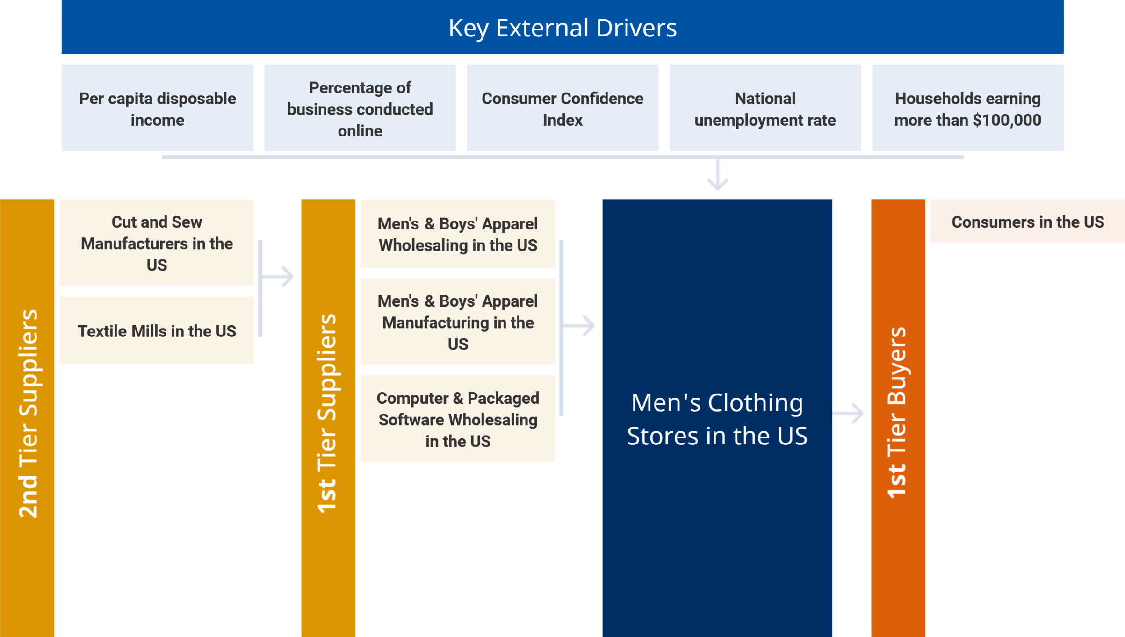

Similar Industries
Men's & Boys' Apparel Manufacturing in the US | Family Clothing Stores in the US | Department Stores in the US | E-Commerce & Online Auctions in the US

Related International Industries
Clothing Retailing in Australia | Clothing Stores in China | Clothing Retailing in the UK | Men's Clothing Stores in Canada
Clothing Retailing in New Zealand | Clothing Retailing in Ireland

Industry at a Glance
Key Statistics | Industry Structure
   | $7.0bn  Revenue
  Annual Growth  2015–2020  -5.9% | Annual Growth  2020–2025  1.1% | Annual Growth  2015–2025  
   | $63.3m  Profit
  Annual Growth  2015–2020  -24.5% |  | Annual Growth  2015–2020  
   | 0.9%  Profit Margin
  Annual Growth  2015–2020  -1.8pp |  | Annual Growth  2015–2020  
   | 8,012  Businesses
  Annual Growth  2015–2020  -1.9% | Annual Growth  2020–2025  -0.4% | Annual Growth  2015–2025  
   | 50,322  Employment
  Annual Growth  2015–2020  -2.7% | Annual Growth  2020–2025  0.3% | Annual Growth  2015–2025  
   | $1.4bn  Wages
  Annual Growth  2015–2020  -3.2% | Annual Growth  2020–2025  0.4% | Annual Growth  2015–2025  
  Key External Drivers | % = 2015–20 Annual Growth
  3.0%  National unemployment rate | 0.8%  Consumer confidence index
  2.8%  Per capita disposable income | 3.1%  Households earning more than $100,000
  8.2%
  Percentage of business conducted online
   | Positive Impact
   | Capital Intensity  Low |  | Concentration  Low
  Industry Globalization
  Low / Increasing
   | Mixed Impact
   | Life Cycle  Mature |  | Revenue Volatility  Medium
   | Regulation & Policy  Medium / Steady |  | Technology Change  Medium
  Barriers to Entry
  Medium / Steady
   | Negative Impact
   | Industry Assistance  Low / Steady |  | Competition  High / Steady
  Key Trends
  - Demand has been pressured in recent years from high levels of external competition
  - Competition from online-only retailers has pushed industry revenue into a slow decline
  - The majority of nonessential businesses have closed in mid-March
  - The industry is projected to experience growth as economic trends, such as consumer confidence, increase
  - Companies are anticipated to continue merger and acquisition
  - A growing number of companies are permitting their employees to dress casually
  - This brick-and-mortar industry will likely continue to feel pressure from external competitors

Products & Services Segmentation
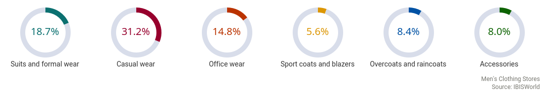

Major Players  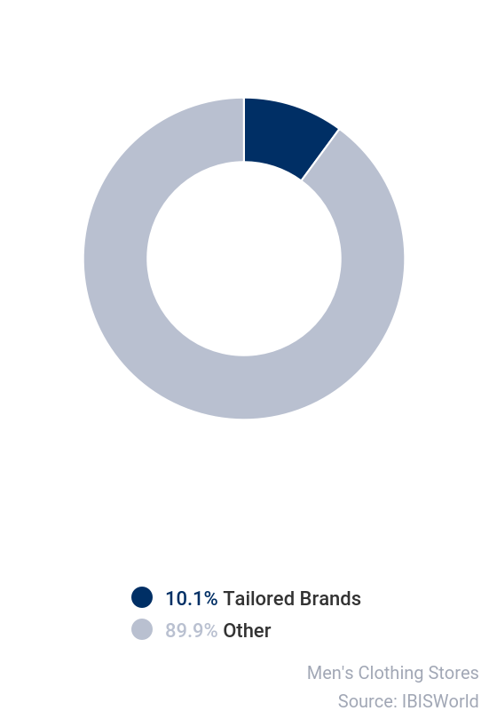 | SWOT
   | Strengths
   | Low Imports
   | Low Customer Class Concentration
   | Low Product/Service Concentration
   | Low Capital Requirements
   | Weaknesses
   | Low & Steady Level of Assistance
   | High Competition
   | Low Profit vs. Sector Average
   | Low Revenue per Employee
   | Opportunities
   | Percentage of business conducted online
   | Threats
   | Very Low Revenue Growth (2005-2020)
   | Low Revenue Growth (2015-2020)
   | Low Outlier Growth
   | Low Revenue Growth (2020-2025)
   | Low Performance Drivers
   | Consumer confidence index

Executive Summary | The Men's Clothing Stores industry has contracted over the five years to 2020 as more male consumers turned to the internet for their clothing.  As the percentage of business conducted online grew at an annualized rate of 6.7% during the period, demand for brick-and-mortar establishments that operate in this industry fell. As a result, IBISWorld estimates that total industry revenue is expected to decline an annualized 5.9% to $7.0 billion over the five years to 2020. This trend was further exacerbated by the outbreak of COVID-19 (coronavirus), which resulted in nonessential businesses, such as Men's Clothing Stores industry operators, to shut down beginning in March for the foreseeable future. While each state is on a different timeline as to when businesses can reopen, the shutdown halted all foot traffic and revenue generated from in-store sales. As a result, industry revenue is anticipated to fall 15.7% in 2020 alone.  Despite pressure from online-based retailers, industry demand has been driven by positive macroeconomic conditions for the majority of the five-year period. Demand for new men's apparel is at its highest when employment rates are strong because men often require new office attire for work. Although the national unemployment rate declined for the majority of the five-year period, industry declines were slightly tempered by such customers. Furthermore, as a result of the high employment rate, disposable income levels shifted upward between 2015 and 2019, providing consumers with more funds to spend. Still, the industry's brick-and-mortar establishments have not been able to compete with online retailers effectively, hampering profit. Additionally, sharply increasing unemployment and falling disposable income in 2020, as a result of the coronavirus, are anticipated to pose a threat to industry operators.  Over the five years to 2025, IBISWorld expects that industry revenue will recover slightly. As the percentage of services conducted online continues to grow, this brick-and-mortar industry will likely continue to feel pressure from external competitors. However, macroeconomic trends that furthered industry losses in 2020 are expected to reverse in the coming years; for example, the unemployment rate is expected to decrease at an annualized rate of 14.0% over the next five years, expanding the number of consumers who need new work apparel. Similarly, the Consumer Confidence Index is expected to reverse its previous trend, growing at an annualized rate of 4.0%, and thus, boosting the amount of money consumers spend on industry goods. As a result, IBISWorld expects industry revenue to increase at an annualized rate of 1.1% over the five years to 2025 to $7.4 billion, as discretionary spending picks up as the economy rebounds from the coronavirus pandemic, mitigating further declines.

Industry Performance
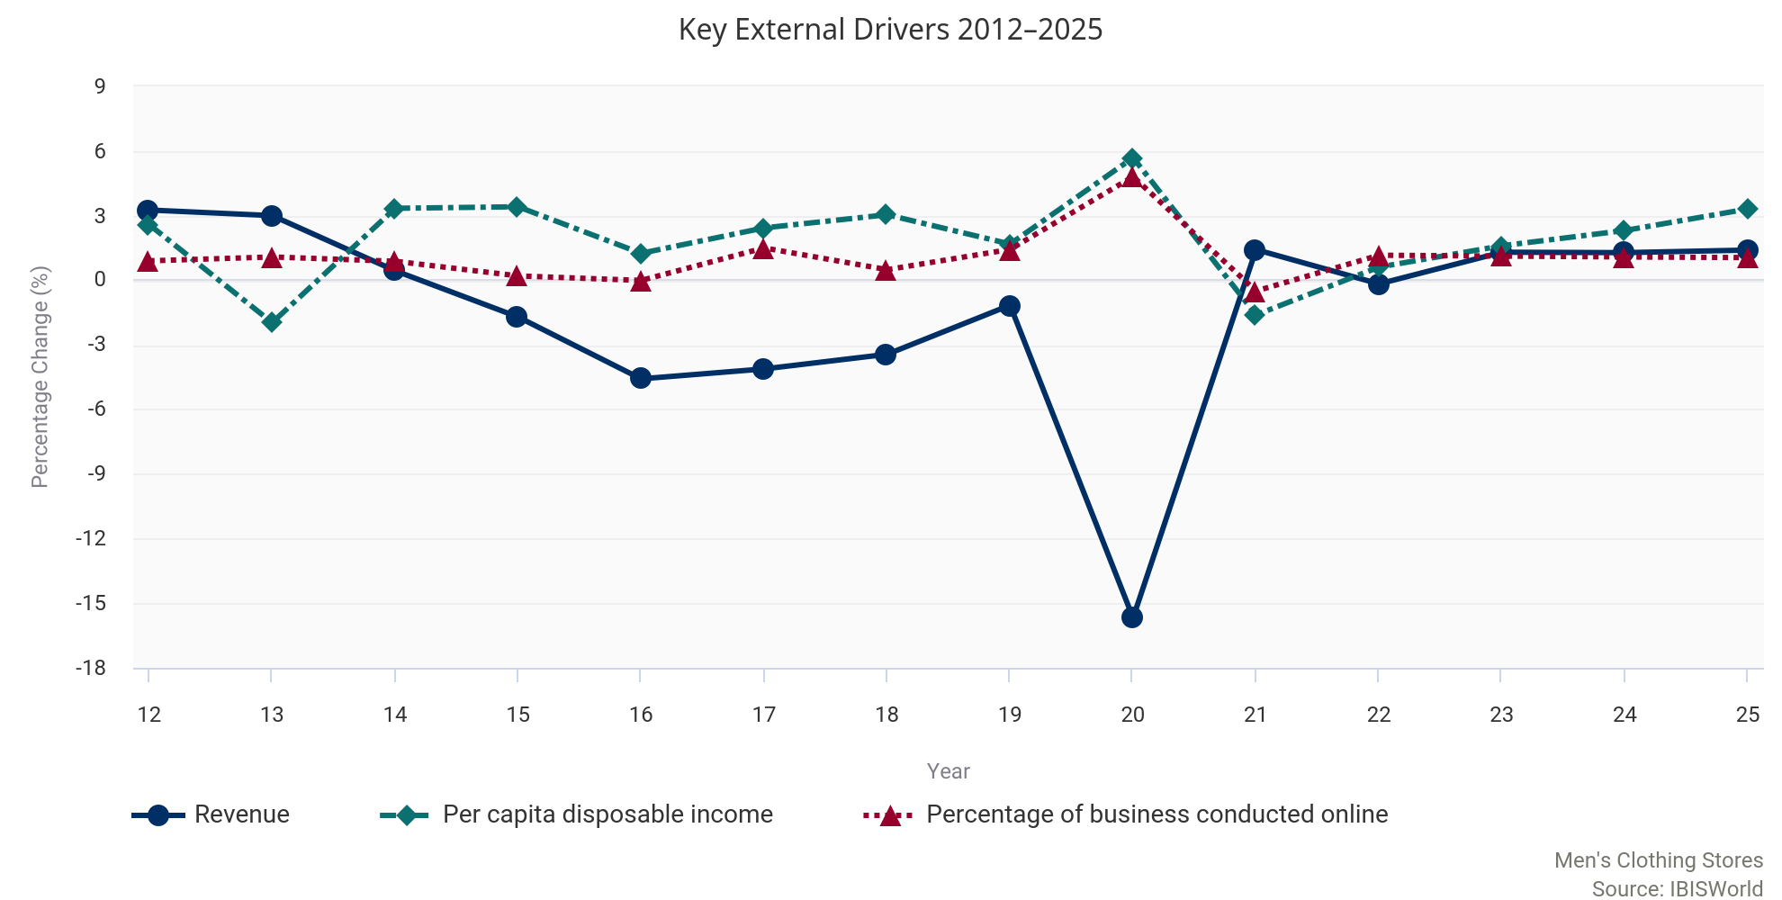

Key External  Drivers | Per capita disposable income  Growth in per capita disposable income affects demand for men's clothing. The majority of industry products are highly discretionary items; therefore, when household disposable income is high, consumers have more discretionary funds on hand to purchase items sold in this industry. Per capita disposable income is expected to increase in 2020.  Percentage of business conducted online  Online shopping poses a direct threat to traditional industry retailers. Many online retailers are able to offer products similar to those offered by specialty apparel retailers, but with lower prices, wider inventories and the ease of direct-to-home shipping. An increase in the percentage of services conducted online will likely decrease demand for traditional brick-and-mortar stores, depressing industry revenue. The percentage of services conducted online is expected to rise in 2020, posing a potential threat to the industry.  Consumer Confidence Index  Higher consumer confidence generally leads to an increase in household expenditure, which in turn increases demand for apparel sold in this industry. Falling levels of consumer confidence tend to decrease demand for clothing and related items. The Consumer Confidence Index is expected to decrease in 2020.  National unemployment rate  Business attire, suits and formal wear comprise a notable share of industry sales. Men typically purchase these clothing items for work and related events. As a result, industry demand declines when the unemployment rate is high. Conversely, demand for work-related attire grows when employment increases. The national unemployment rate is expected to increase sharply in 2020.  Households earning more than $100,000  Consumers in a higher-income bracket are more likely to shop at specialized men's clothing stores. Many industry participants design their products for affluent men and have clothing lines with high prices. The number of households earning more than $100,000 is expected to decline slightly in 2020. However, compared to other drivers this decline is subdued, presenting a potential opportunity for industry operators.

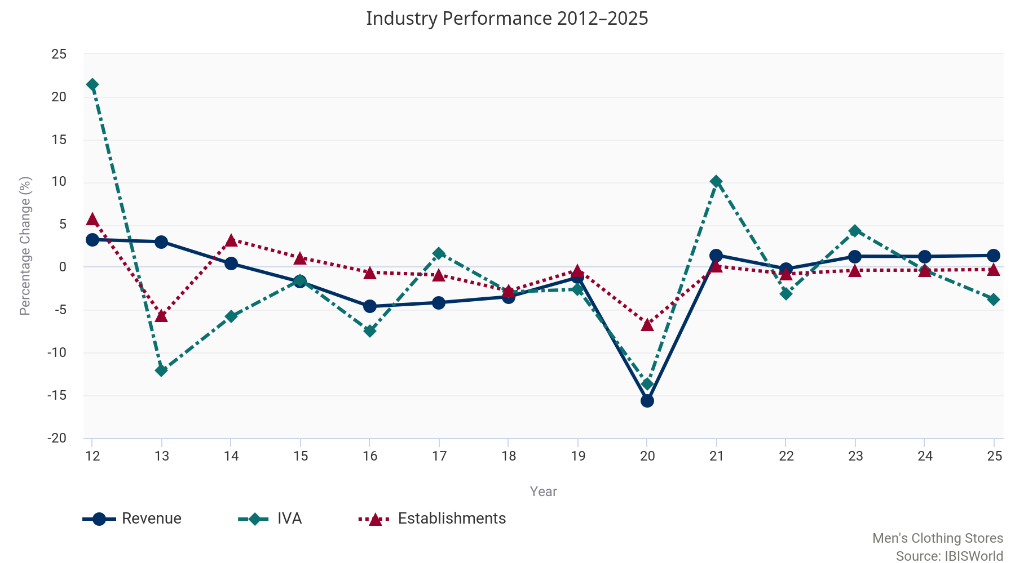

Current  Performance | The Men's Clothing Stores industry comprises retailers that exclusively sell men's clothing, with the majority of sales generated through casual wear, office apparel and formal attire.  Demand for office attire is highly dependent on employment levels. For the majority of the five years to 2020, unemployment has decreased, while high levels of per capita disposable income and consumer confidence have encouraged shoppers to spend more liberally on apparel, including suits for formal events. These positive macroeconomic factors have also enabled shoppers to trade up to luxury and premium-brand apparel.  Nevertheless, demand has been pressured in recent years from high levels of external competition, most notably from e-commerce businesses. As the percentage of business conducted online increased at an annualized rate of 6.7% over the past five years, demand at the brick-and-mortar stores that operate in this industry contracted. Coupled with increasing competition, the outbreak of COVID-19 (coronavirus) has presented a large threat to operators as they were forced to close down their stores beginning in March for the foreseeable future, limiting their ability to generate revenue through in-store operations. As a result, industry revenue slipped into decline over the five years to 2020, falling at an annualized rate of 5.9% to $7.0 billion. This includes an expected 15.7% contraction in 2020 as e-commerce sales rise an estimated 20.0% over the year and the coronavirus pandemic continues to evolve.  Economic trends  The men's clothing purchased at industry establishments are considered highly discretionary because they are typically branded or tailored, which makes them more expensive for consumers.  Therefore, as the economic environment has grown for the majority of the five-year period as a result of climbing disposable income and higher consumer confidence, the Men's Clothing Stores industry has reaped some benefits. Per capita disposable income is expected to grow at an annualized rate of 2.8% over the five years to 2020, which has enabled consumers to splurge on men's apparel. Additionally, the Consumer Confidence Index, which measures consumer perceptions and expectations of economic conditions, has grown considerably during the majority of the five-year period, specifically between 2015 and 2018, and has encouraged consumers to purchase price-premium products. Together, these factors have boosted consumer spending on apparel during the majority of the five-year period.  The unemployment rate in the United States decreased from 5.3% in 2015 to 3.7% in 2019, which further boosted demand for men's apparel. Demand conditions are tied to employment levels because consumers are more likely to demand office attire from industry establishments when they have a steady job. This has encouraged several luxury brands to open men's-only clothing stores to capture a share of the increased demand for office and formal wear. In recent years, brands including Bottega Veneta and Lanvin have opened their first men's-only stores on Madison Avenue in New York City. Increased competition from high-profile brands has encouraged other industry operators to spend more on marketing and relocate to areas with heavy foot traffic where rent is often more expensive. These expenses have hampered industry profit over the past five years. In 2020, IBISWorld estimates the average industry profit margin, measured as earnings before interest and taxes, will account for 0.9% of revenue, down from 2.7% in 2015.  In response to companies such as Lanvin tapping into this industry, incumbent industry operators have increasingly worked to expand their product mixes and market presences to better compete. For example, in 2014, Tailored Brands Inc. (Tailored Brands) acquired Jos. A. Bank Clothiers Inc. in an attempt to tap into a wider range of markets and strengthen the company's influence in the Men's Clothing Stores industry. IBISWorld estimates that the company's market share will stand at 10.1% in 2020, making it the largest player in the Men's Clothing Stores industry.  Additionally, as online competitors have taken market share away from industry operators, companies have ceased expansion efforts and shuttered some locations. Over the five years to 2020, the number of industry locations declined at an annualized rate of 2.3% from 12,084 establishments to an estimated 10,784 establishments. Similarly, employment has declined at an annualized rate of 2.7% to 50,322 workers, as enterprises slimmed down their operations.  Competition from all angles  While major brands such as Joseph Abboud, a previous subsidiary of Tailored Brands that was sold to WHP Global in March 2020, have found their place in the industry by serving a niche high-end market, the majority of men's apparel retailers compete on price and convenience.  External competition from department stores, such as Macy's Inc. (Macy's) and Nordstrom Inc., has been strong in this area. Since department stores offer a variety of clothing options for men and women, they represent an easily accessible one-stop shop. Department stores also offer exclusive brands (e.g. Alfani at Macy's) at generally lower prices for similar items found at men's specialty retailers, such as the Men's Wearhouse, which is a subsidiary of Tailored Brands.  Nonetheless, competition from online-only retailers has pushed industry revenue into a slow decline over the five years to 2020. Internet retailers offer easy price comparison for various products and enable convenience and time savings through shipping services. Online retailers can often sell their products at lower prices while maintaining favorable returns because they do not incur costs associated with retail space and related employees. Some online retailers have opened up brick-and-mortar showrooms, enabling customers to try on products before ordering online. This new retail model attempts to strike the perfect balance between offline and online retail to generate as many sales as possible. As a result, brick-and-mortar men's clothing stores have experienced mounting pressure from all types of online retailers. Even operators that run e-commerce sites must compete with internet giants, such as Amazon.com Inc., that stock or contract highly diverse inventories that cater to a wide range of consumers. Lastly, many online companies are also vertically integrating with the upstream Men's and Boys' Apparel Manufacturing industry (IBISWorld report 31522) to further reduce their costs. Vertically integrated companies that sell directly to customers pose a growing threat to traditional operators that are too small to vertically integrate.  COVID-19  The same macroeconomic conditions that have mitigated further declines in the industry are the same drivers that are presenting a large threat to industry operators during the outbreak of the coronavirus.  In compliance with shelter-in-place and social distancing orders, the majority of nonessential businesses have closed in mid-March. The majority of retail stores, including establishments in the Men's Clothing Stores industry, are considered nonessential, and therefore have been closed, limiting any revenue generation through in-store purchases. Many retail stores have begun re-opening, depending on state-specific legislation, however, they are still operating at strict capacity limits. On top of store closures, the economic uncertainty surrounding the global pandemic has led consumer confidence to drop significantly, causing disposable income and consumer spending to decline in 2020. Therefore, even when stores reopen, consumers will likely continue cutting discretionary spending until confidence in the economy returns. Furthermore, since unemployment is so high as a result of many job cuts across the entire economy, demand for work apparel, including suits, sport coats and office wear, has also decreased. These products account for 39.1% of industry revenue in 2020, and therefore a decrease in demand for this specific segment is detrimental to industry operators. The situation is still ongoing and therefore the full effect of the coronavirus pandemic on industry operators is relatively unknown.

Historical Performance Data
Year | Revenue  ($m) | IVA  ($m) | Establishments  (Units) | Enterprises  (Units) | Employment  (People) | Exports  ($m) | Imports  ($m) | Wages  ($m) | Domestic  Demand  ($m) | Per Capita Disposable Income  ($)
2011 | 9,093 | 2,054 | 11,599 | 8,118 | 56,310 | N/A | N/A | 1,545 | N/A | 38,780
2012 | 9,389 | 2,494 | 12,265 | 8,401 | 63,591 | N/A | N/A | 1,828 | N/A | 39,784
2013 | 9,671 | 2,192 | 11,570 | 8,255 | 58,656 | N/A | N/A | 1,602 | N/A | 39,004
2014 | 9,715 | 2,066 | 11,948 | 8,620 | 61,502 | N/A | N/A | 1,658 | N/A | 40,310
2015 | 9,549 | 2,036 | 12,084 | 8,817 | 57,688 | N/A | N/A | 1,692 | N/A | 41,670
2016 | 9,113 | 1,884 | 12,015 | 8,729 | 57,439 | N/A | N/A | 1,647 | N/A | 42,108
2017 | 8,738 | 1,915 | 11,909 | 8,696 | 60,260 | N/A | N/A | 1,653 | N/A | 43,056
2018 | 8,437 | 1,860 | 11,582 | 8,532 | 56,822 | N/A | N/A | 1,641 | N/A | 44,521
2019 | 8,340 | 1,812 | 11,548 | 8,517 | 56,498 | N/A | N/A | 1,629 | N/A | 45,594
2020 | 7,033 | 1,564 | 10,784 | 8,012 | 50,322 | N/A | N/A | 1,436 | N/A | 44,844

Industry Outlook
Outlook | Revenue for the Men's Clothing Stores industry is forecast to rebound over the five years to 2025, increasing slightly at an annualized rate of 1.1% to total $7.4 billion.  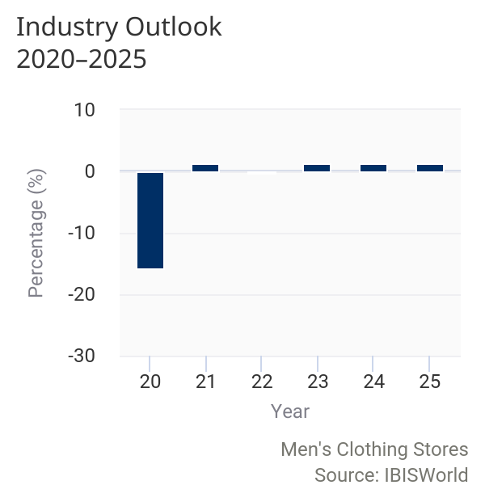  The industry is projected to experience growth during the outlook period as economic trends, such as consumer confidence, increase as the economy rebounds from the outbreak of COVID-19 (coronavirus). However, increased competition from online retailers of men's clothing and discount stores will continue to further pressure industry revenue, limiting further growth. Overall, the upward trajectory of the overall economy and resulting improvements in per capita disposable income will help boost industry revenue.  Operating landscape  Similar to the five years to 2020, companies are anticipated to continue merger and acquisition (M&A) activity over the five years to 2025.  Large powerful players, such as Tailored Brands Inc., will likely expand their brand portfolios and gain market share by acquiring smaller operators that fit within the aesthetic of their existing brands. By operating more locations and offering a wider range of products, companies in the industry are expected to expand their reach. This M&A activity will likely lead to a steady decline in the number of companies operating in the industry. Over the five years to 2025, IBISWorld anticipates that the number of industry enterprises will decline at an annualized rate of 0.4%, totaling 7,864 operators.  As the industry consolidates and companies streamline their operations, growth in the number of industry employees is also expected to be limited. Over the five years to 2025, IBISWorld estimates that the number of industry workers will increase slightly at an annualized rate of 0.3%, totaling 50,974 employees. This growth is mainly a result of the likely influx of part time workers as operators attempt to cut costs and make up for profit losses in 2020.  Competitive environment  Consistently increasing external competition from online retailers will likely suppress value-based industry retailer performance over the five years to 2025, which will subsequently pressure profit.  Online retailers can competitively price their products due to lower overhead costs, pulling demand away from operators that sell low- to mid-priced menswear and compete predominantly on the basis of price. This dichotomy is expected to pressure profit. Industry profit, defined as earnings before interest and taxes, is expected to account for 1.7% of revenue in 2025. While this is still low, profit margin is anticipated to increase over the next five years as demand, especially for higher price point items, increases in line with growing disposable income levels and consumer confidence. Additionally, a decline in the national unemployment rate will lead to increased demand for formal and office wear, as well as suits and sport coats, which are typically pricier items.  Demographic changes  Over the next five years, a large portion of the baby-boomer generation is expected to retire, limiting demand for men's attire from this market segment.  Much of the workforce will likely be part of Generation X. Meanwhile, the majority of Generation Y will enter the workforce for the first time, largely offsetting the retirement rate. These demographic trends will likely change men's clothing stores' major markets. Demand from baby boomers will likely wane, while the industry's Generation X and Y market segments will have higher purchasing power, and thus, grow as a percentage of total revenue.  This demographic shift will also likely lead to a slight alteration of the product mix this industry offers. Although many white-collar jobs currently require formal or casual business attire for the office, a growing number of companies are permitting their employees to dress casually. Many Generation Y career fields will continue to alter their dress codes to reflect a more casual work environment, spurring the casual attire product segment of this industry to expand as a share of revenue. Companies may also offer services such as custom tailoring to differentiate their casual attire from that of competitively priced department stores.
Performance Outlook Data
Year | Revenue  ($m) | IVA  ($m) | Establishments  (Units) | Enterprises  (Units) | Employment  (People) | Exports  ($m) | Imports  ($m) | Wages  ($m) | Domestic  Demand  ($m) | Per Capita Disposable Income ($)
2020 | 7,033 | 1,564 | 10,784 | 8,012 | 50,322 | N/A | N/A | 1,436 | N/A | 44,844
2021 | 7,133 | 1,722 | 10,799 | 8,020 | 50,619 | N/A | N/A | 1,447 | N/A | 45,088
2022 | 7,121 | 1,670 | 10,717 | 7,958 | 50,282 | N/A | N/A | 1,438 | N/A | 45,784
2023 | 7,215 | 1,742 | 10,681 | 7,923 | 50,514 | N/A | N/A | 1,447 | N/A | 47,111
2024 | 7,307 | 1,736 | 10,646 | 7,890 | 50,753 | N/A | N/A | 1,457 | N/A | 48,575
2025 | 7,410 | 1,671 | 10,621 | 7,864 | 50,974 | N/A | N/A | 1,466 | N/A | 50,187
2026 | 7,542 | 1,654 | 10,621 | 7,854 | 51,371 | N/A | N/A | 1,480 | N/A | 51,759

Industry Life Cycle | The life cycle stage of this industry is Mature  LIFE CYCLE REASONS  The industry has wholehearted market acceptance  Fashion trends do not change quickly in men's apparel, making for a static product mix  Men's clothing stores are a staple in the retail sector

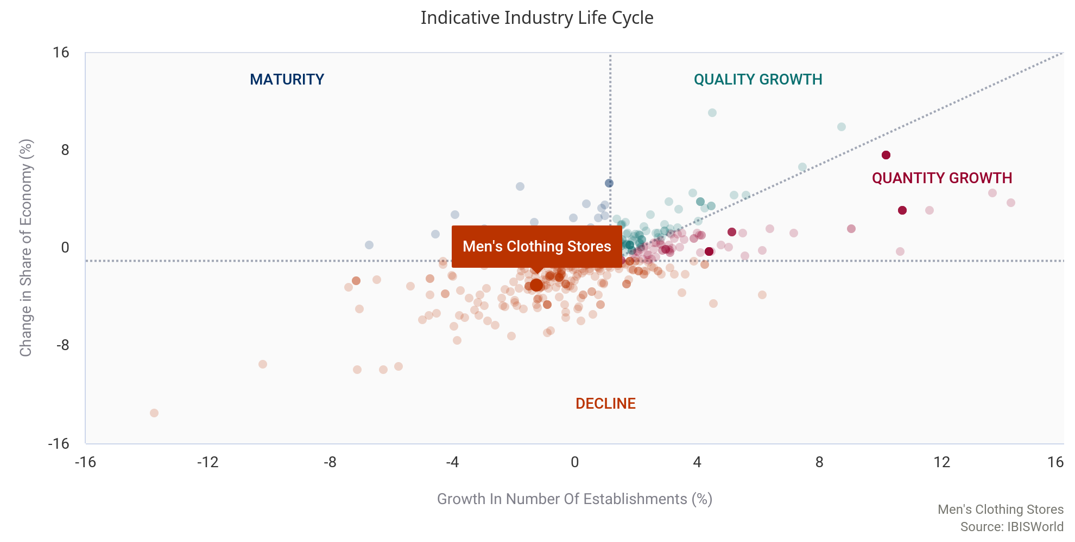

Industry value added (IVA), which measures an industry's contribution to the overall economy, for the Men's Clothing Stores industry, is expected to decline at an annualized rate of 2.0% over the 10 years to 2025. Meanwhile, US GDP is anticipated to increase an annualized 1.9% during the same period. Although IVA is declining, the industry is considered mature because it has wholehearted market acceptance and is a staple in the retail sector. Furthermore, much of the IVA decline is the result of merger and acquisition (M&A) activity within the industry. For example, Tailored Brands Inc. (Tailored Brands), the industry's largest player, acquired Jos. A. Bank. in 2014. Additionally, over the five years to 2020, Tailored Brands sold its corporate apparel operations and its subsidiary, Joseph Abboud, to WHP Global in early 2020. M&A activity is highly indicative of a mature industry and further reflects the industry's life cycle stage.
The industry's product mix is also well-defined, with formal wear, casual wear, coats and sporting apparel holding steady ground. While office attire has declined as a share of total revenue, it still represents a notable share of the market, indicating that demand for more formal attire has not declined drastically. Even with changing preferences and dress codes, the types of products offered in this industry are unlikely to change. Product innovation in men's clothing is very slow; fashion trends do not affect the male population as much as they do the female population, making men's apparel more static. Demographics are expected to shift slightly as generations age and enter the workforce at faster rates, but dramatic shifts in purchasing power are not likely to occur over the five years to 2025.
Technology within the industry is slow to change. Most automation has already taken place, with the majority of locations using electronic cash registers, scanners and inventory tracking. IBISWorld expects only slight cosmetic upgrades to take place over the next five years. Low technological change further establishes the Men's Clothing Stores industry in its mature life cycle stage.

Products & Markets
Supply Chain
  Key Buying Industries
  1st Tier
  Consumers in the US
  Key Selling Industries
  1st Tier
  Men's & Boys' Apparel Wholesaling in the US
  Men's & Boys' Apparel Manufacturing in the US
  Computer & Packaged Software Wholesaling in the US
  2nd Tier
  Cut and Sew Manufacturers in the US
  Textile Mills in the US

Products & Services | 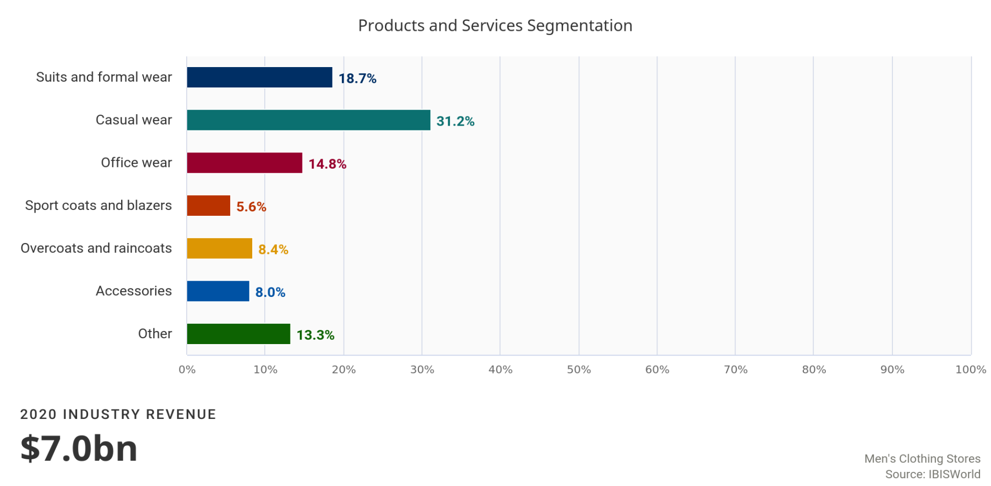
Casual wear
Casual wear is the largest product segment in the Men's Clothing Stores industry, representing 31.2% of total revenue in 2020.

Casual wear has increased as a share of total demand over the five years to 2020 due to a shift in work place dress codes; while office attire was previously formal and generally required a suit, some employers have relaxed the formal dress code during work hours. This has facilitated a shift in the product mix for men's clothing stores, moving away from conservative and toward casual wear. Moreover, the emergence of premium denim (i.e. branded denim that carries a promise of high quality and aesthetics) has helped this segment gain popularity, especially among Generation Y consumers that value high-end casual wear. T-shirts are extremely competitive in style, fit and brand. Generation X and Generation Y consumers will often spend more on a particular brand, while baby boomers will demand a wide variety of shirts for casual and work purposes, focusing on fit and comfort. Due to the outbreak of COVID-19, the majority of corporate America transitioned to working from home, contributing to a further increase in demand for casual wear compared to office and formal wear.
Office and formal wear
The office and formal wear segment primarily includes suits, tailored pants and dress slacks.

White-collar employment rates and business sentiment provide demand patterns for office suits. For example, poor business sentiment has a negative effect on demand for new office attire; conversely, positive macroeconomic factors typically boost demand for office attire. Consumers are likely to postpone new suit purchases as unemployment rises and disposable income contracts. While casual wear has continued to outpace other industry product segments, strong employment levels and economic conditions have expanded demand for office and formal wear. In 2020, IBISWorld estimates that suits and formal wear represent 18.7% of total demand, sport coats and blazers represent 5.6% of demand and office wear represents 14.8% of total industry demand. Demand for office and formal wear is anticipated to decrease in 2020 as a result of high unemployment due to the implications of COVID-19 (coronavirus).
Overcoats and raincoats
Overcoats and raincoats are estimated to account for 8.4% of industry revenue in 2020 and have remained relatively static over the past five years.

Accessories, which include belts, socks and underwear, are expected to represent 8.0% of industry revenue. Other items are anticipated to account for the remaining 13.3% of industry revenue. This segment includes pajamas, robes, underwear, sports and exercise apparel, luggage and children's apparel.
Major Markets | 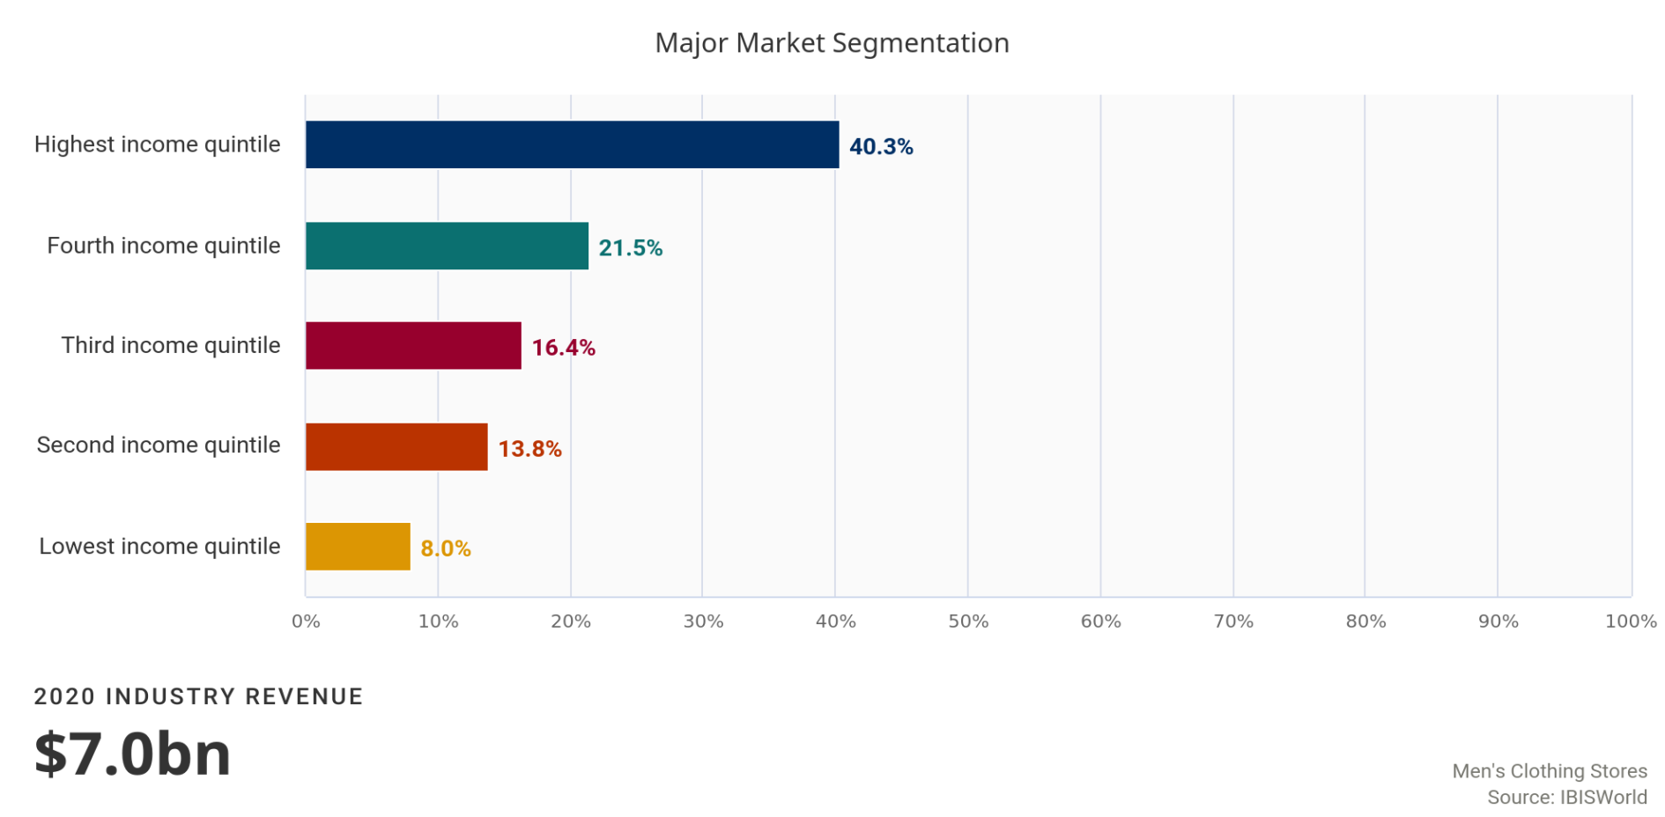
Lowest and second income quintile
The lowest and second-lowest income quintiles are expected to account for a respective 8.0% and 13.8% of revenue for the Men's Clothing Stores industry.

Consumers in low income quintiles have limited disposable incomes and are more likely to buy their clothing at discount stores and other retail outlets that competitively price their products. Moreover, men's clothing stores typically specialize in fine suits, and consumers with low-paying jobs usually wear uniforms or casual wear to work.
Third and fourth income quintile
The third- and fourth-lowest income quintiles are anticipated to comprise a respective 16.4% and 21.5% of industry revenue, respectively.

Such consumers benefit from higher disposable income, leading to stronger demand. Revenue from these segments has slightly decreased over the five years to 2020, as the wealthiest and least wealthy income quantiles have increased their shares of revenue.
Highest income quintile
Consumers in the highest income quintile are estimated to account for 40.3% of industry revenue.

Consumers in this income quintile benefit from high disposable income levels and are more likely to attend formal events that require suits. Moreover, consumers in this segment are most likely to purchase luxury items, translating to a higher spend per suit. Over the past five years, this consumer segment has increased as a share of total industry revenue as disposable income levels increased from 2015 to 2019.
Exports in this industry are Low and Steady
Imports in this industry are Low and Steady
Although some of the products sold by establishments in the Men's Clothing Stores industry are imported into the United States, the trade of these items is accounted for at the manufacturing level. For more information on trade figures for the industry's products, see the Men's and Boys' Apparel Manufacturing industry report (IBISWorld report 31522).

Business Locations | 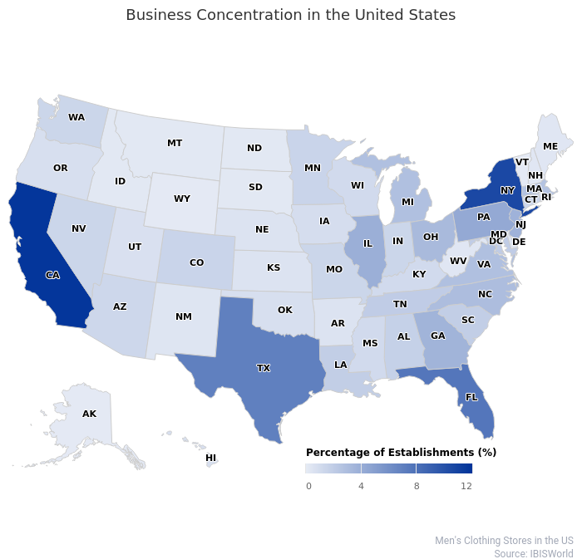
Since exposure is important in gaining customers, location is a key performance factor for operators in the Men's Clothing Stores industry. For this reason, stores are located largely in line with the spread of population in the United States. The Southeast region accounts for 27.6% of establishments in the industry and 25.8% of the total American population in 2020. Likewise, the Mid-Atlantic and West regions represent popular areas for industry establishments and are densely populated; the Mid-Atlantic houses 21.5% of establishments and 15.0% of the population, while the West holds 16.3% of industry locations and 17.2% of the US population.
The Mid-Atlantic region differs from other US regions, as its share of industry establishments significantly outweighs its share of the population. This indicates that there is a higher concentration of wealth in this region. The Mid-Atlantic, and New York in particular, is a hotspot for corporate offices, which boosts demand for men's office wear and formal attire. The Mid-Atlantic region is also home to many wholesalers and domestic manufacturers of men's and boys' clothing. Retailers often choose to open up shop near upstream operators in the supply chain to minimize transportation costs and cut out other expenses such as warehousing. In 2020, IBISWorld estimates that New York and Pennsylvania, which are both located in the Mid-Atlantic region, will hold 10.6% and 4.3% of industry establishments, respectively.
 | 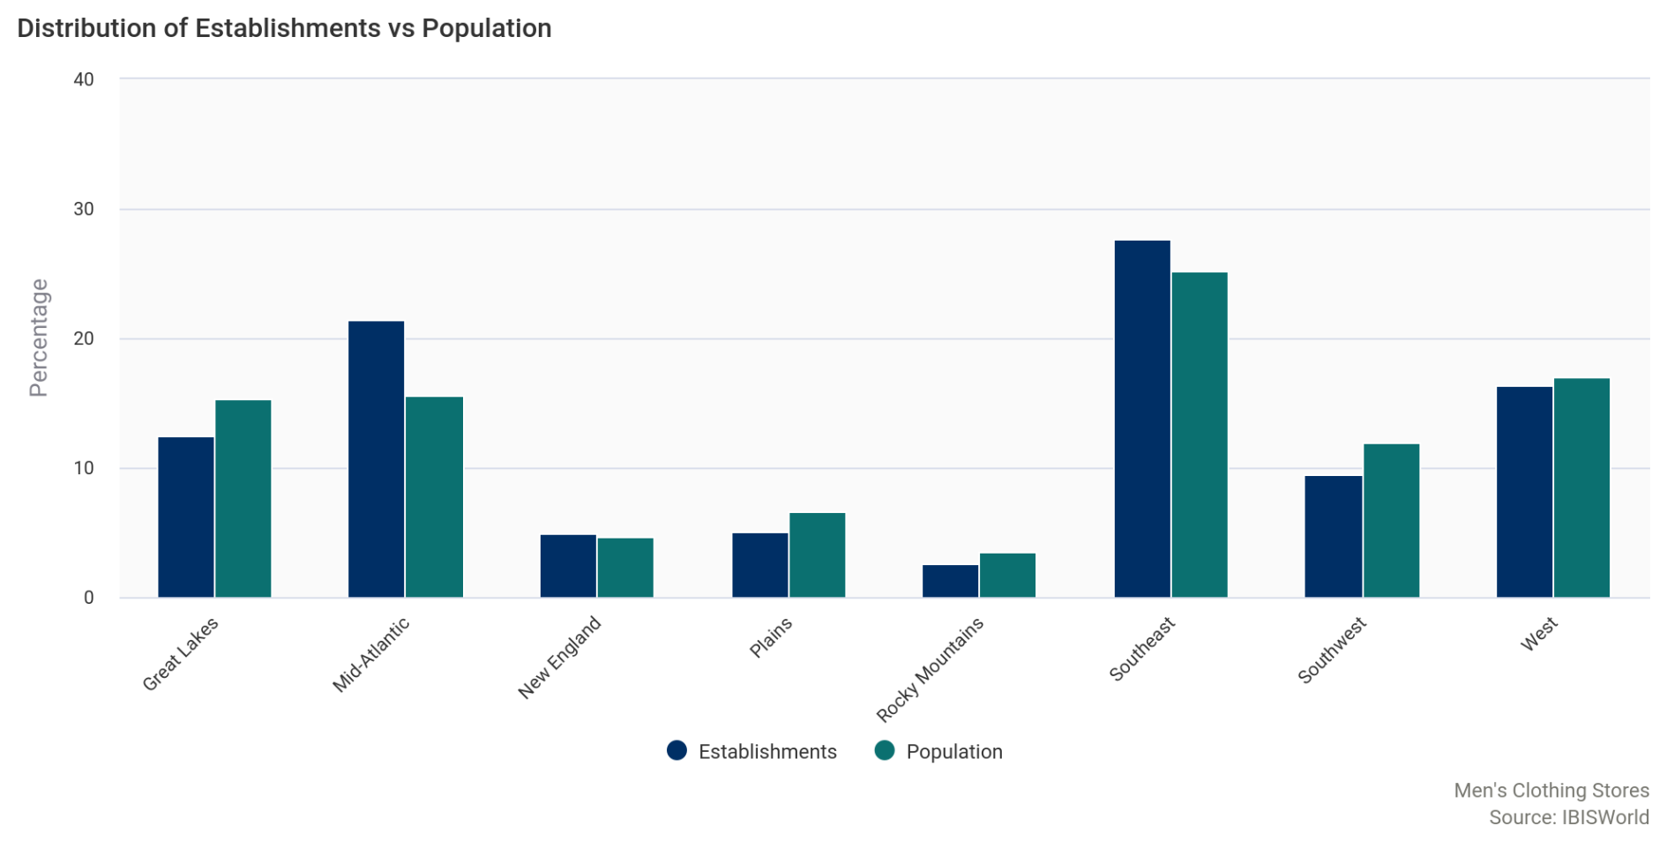

Competitive Landscape
Market Share Concentration | Concentration in this industry is Low  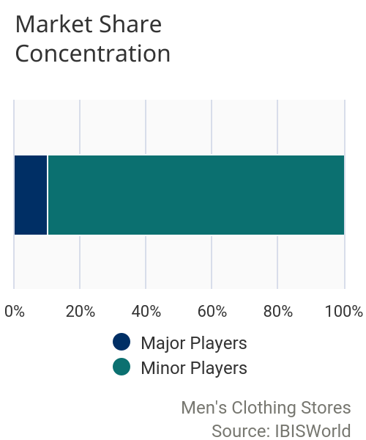  The Men's Clothing Stores industry exhibits a low level of market share concentration, with the top two players accounting for 13.0% of total industry revenue in 2020. Major player concentration has increased over the majority of the five-year period, with acquisitions and mergers facilitating such conditions. For example, Tailored Brands Inc. acquired Jos. A. Bank in 2014, significantly increasing its share of the market and making it the only major player within the industry. However, market share dropped significantly in 2020 as the industry's largest players are anticipated to perform worse than the average industry operator, mainly due to their reliance on demand for formalwear and suits. However, expansion for this industry is traditionally limited because most major retailers will expand to offer clothing for women and children, which effectively removes them from the industry.
Key Success  Factors | IBISWorld identifies 250 Key Success Factors for a business. The most important for this industry are:  Ability to control stock on hand:  Stock control is important for operators to avoid oversupply and shortages in inventory.  Having a clear market position:  Market positioning projects a clear and consistent image of the company and attracts consumers.  Establishment of brand names:  Men's clothing retailers that supply brand names and establish recognition from consumers often benefit from higher demand.  Production of goods currently favored by the market:  Stores that stock clothing items in line with current fashion trends are more likely to entice consumer spending.  Experienced work force:  Quality customer service is an important factor in a consumer’s shopping experience and can influence purchasing decisions.  Attractive product presentation:  The store layout and product display must encourage consumers to purchase goods and reinforce the company image.  Adaptability of operations to comply with social distancing protocols:  As industry operators begin to reopen their establishments they need to ensure that they are able to comply with state-specific protocols related to COVID-19, such as capacity limits, social distancing and face mask requirements.
Cost Structure  Benchmarks | 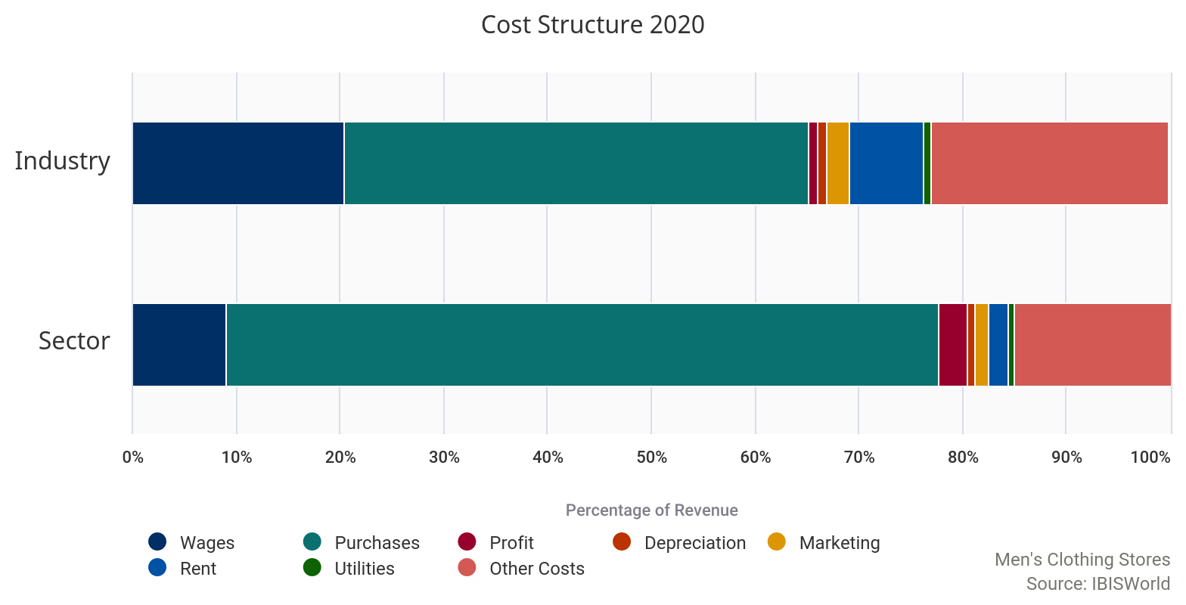
 | Profit  In 2020, profit, measured as earnings before interest and taxes, for the Men's Clothing Stores industry is expected to make up 0.9% of industry revenue. Profit has declined over the past five years, falling from 2.7% in 2015, as operators have increased marketing budgets and slashed prices in response to heightened competition. As industry operators have experienced increased competition, particularly from online-based businesses that incur lower overhead costs, they have been pushed to invest in advertising or lower selling prices to remain competitive. Furthermore, average rent costs have increased for industry operators, as many businesses have been setting up stores in high foot-traffic areas to increase visibility. These central locations command a higher price tag, and this factor has eaten into profit. Additionally, the outbreak of COVID-19 (coronavirus) has caused further declines in margins as operators had to temorarily close retail locations, limiting their ability to generate in-store revenue. As a result, many operators were unable to cover or adjust overhead costs, such as rent and purchases, leading to further shrinking in profit margins. | 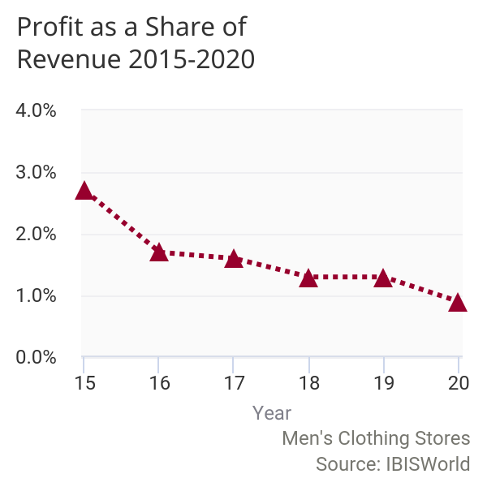

 | Wages  Retailing industries are fairly labor intensive because employees are needed to carry out customer service and general front-of-house operations. Wage costs in this industry are expected to account for 20.4% of industry revenue in 2020. A large portion of labor in the retailing industry is casual and part-time, a common characteristic across the entire clothing retail sector. Retailers undertake administrative activities such as customer service, product merchandising, inventory control and cash handling. Over the five years to 2020, wages as a percentage of revenue have increased since revenue has declined at a faster rate than wages. | 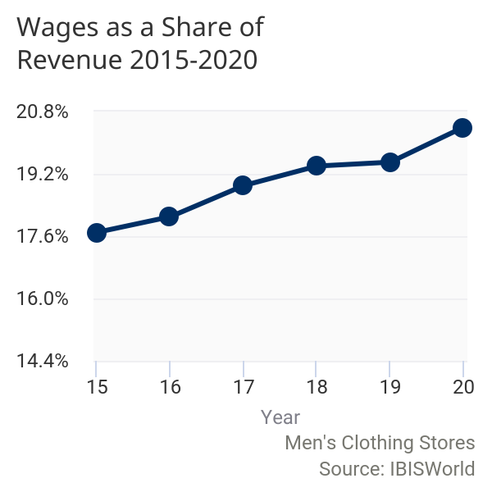

 | 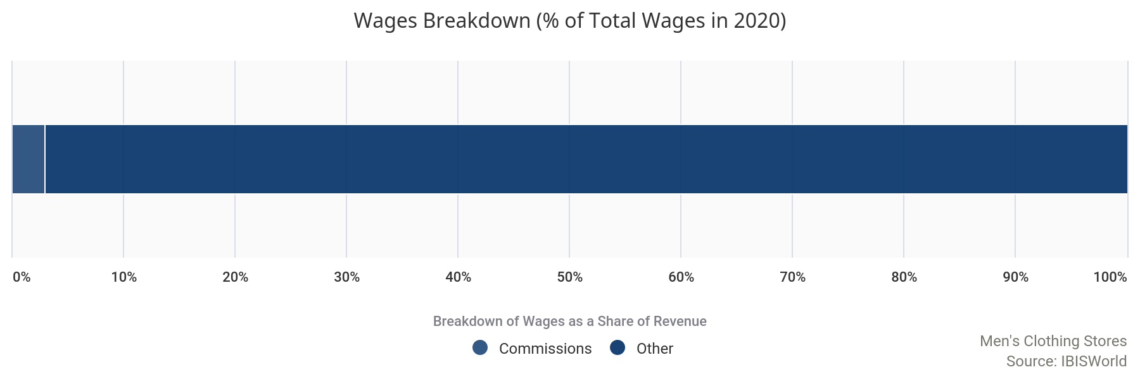
 | Purchases  Purchases are the largest cost for industry players, accounting for an estimated 44.7% of industry revenue. High purchasing costs are typical for industries within the retail sector, as operators must originally purchase a sizable inventory. Purchase costs have remained the largest expense for industry operators over the past five years. Increased import penetration from low-cost countries, such as China, will likely decrease purchase costs for industry operators in the future. Clothing manufactured in China is relatively inexpensive compared with US-produced apparel; therefore, as import penetration increased, purchasing foreign-produced goods became more accessible and decreased the cost of industry purchases. However, due to the uncertainty regarding the relationship between the United States and China, operators may have to search elsewhere for manufacturing facilities. Additionally, due to supply chain disruptions as a result of COVID-19 (coronavirus), purchase costs are anticipated to fluctuate in 2020. | 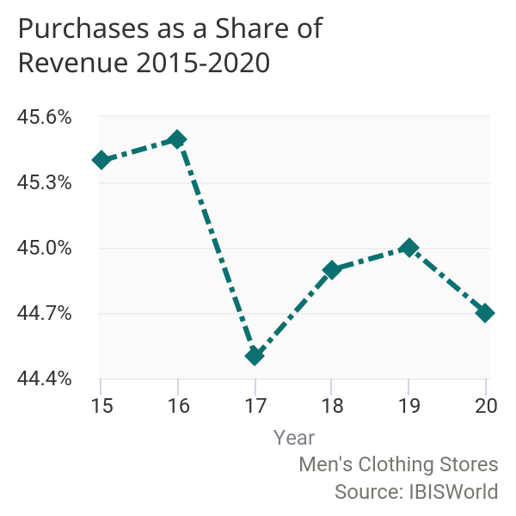

 | 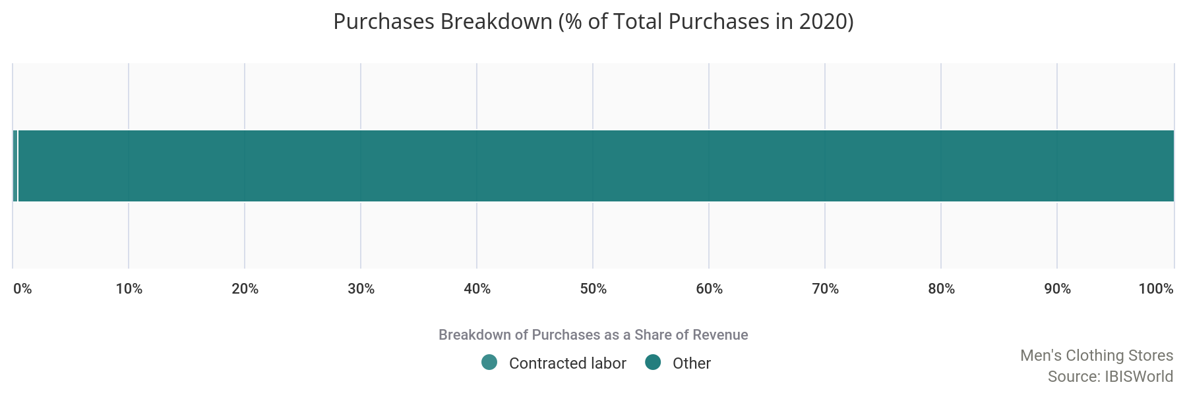
 | Marketing  Marketing expenditures are expected to account for 2.2% of revenue in 2020. This figure has dropped slightly compared to 2019 as operators look to cut discretionary expenditures to mitigate losses from the effects of the coronavirus and subsequent economic recession. | 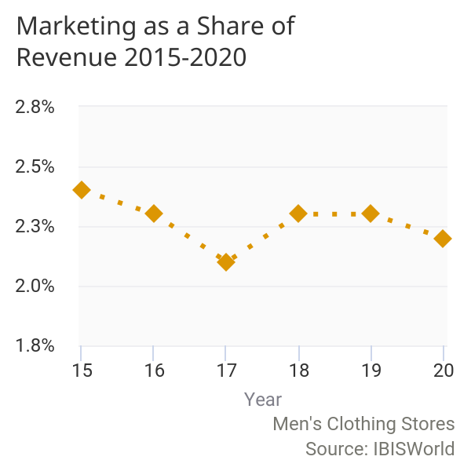

 | Depreciation  Depreciation is low because the industry relies predominantly on labor for operations. As a result, depreciation comprises a mere 0.9% of industry revenue. | 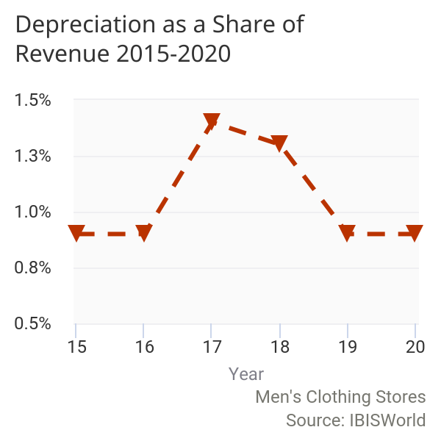

 | Rent  Much like other industries within the retail sector, rent costs are relatively high. Since many retailers are located in prime locations such as malls or large retail spaces, the cost of renting stores can be significant. Store exposure is a key factor in running a successful retail establishment and retailers require premium storefront space in high-traffic areas to boost demand. Challenged by heightened competition from online retailers over the past five years, industry operators have made an effort to increase exposure, which has increased rent costs. Rent is anticipated to account for 7.1% of industry revenue in 2020. | 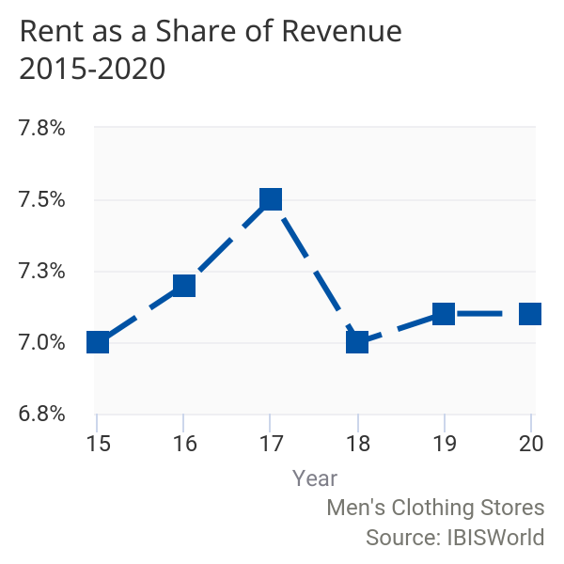

 | 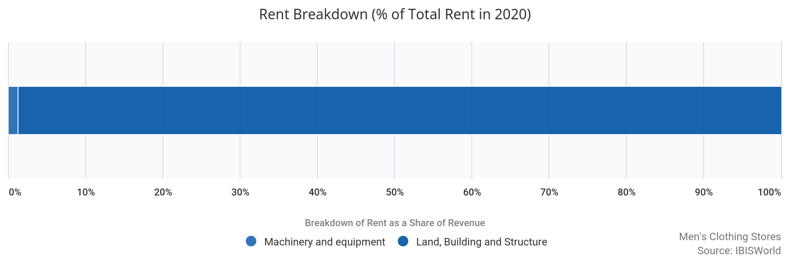
 | Utilities  Utilities are anticipated to account for 0.8% of industry revenue in 2020. Utility costs depend on the number of locations a company has, but is typically high since it costs a lot to keep a storefront up and running. | 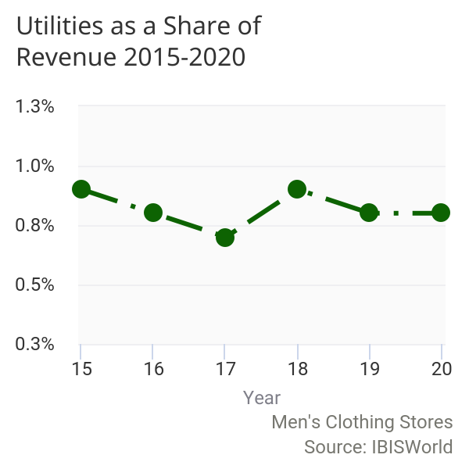

 | Other Costs  Other expenses include legal services and other office administrative costs. Together, these items make up the remaining 22.9% of industry revenue. | 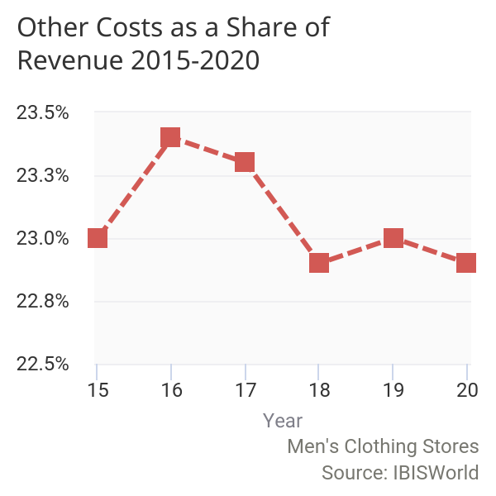

 | 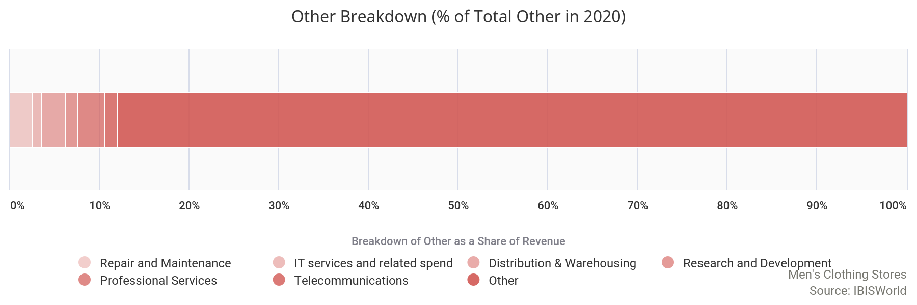
Basis of  Competition | Competition in this industry is High and the trend is Steady
Internal competition
Internal competition reflects competition between operators in the Men's Clothing Stores industry.

Price remains a major basis of competition for the majority of industry participants, particularly those that target low- to middle-income earners; consumers in this space are often sensitive to price changes. Style, variety and comfort are also important factors in regard to gaining a competitive edge.
Retailers that target affluent consumers do not compete as much on price as they do on brand, quality of clothing, style and service. Often, retailers will target a particular segment, such as casual wear, formal wear or even clothing in bigger sizes, such as industry player Destination XL. Given the wide variety of factors and market and product segments, retailers can differentiate themselves from other competing stores within proximity. Men's clothing stores also typically compete with similar stores that are located within their prime market area. Consumers will typically favor stores that are conveniently located closer to their homes. Furthermore, operators are now competing on the basis of safety precautions and procedures in-store due to the ongoing health crisis. In order to appeal to as many customers as possible, operators need to implement safety measures such as social distancing, store capacity limits and face mask requirements. If consumers do not feel comfortable shopping in-store at a specific company, they will likely visit another operator.
External competition
External competition primarily comes from apparel stores that sell products in addition to men's clothing.

Family clothing stores such as the Gap, department stores such as Macy's and discount retailers such as Walmart are all competitors for men's clothing stores. Since clothing from these retailers can be substituted for brand-name or store-specific items from the Men's Clothing Stores industry, price-conscious consumers may choose to make purchases at these alternative retailers. As a one-stop shop for the entire family, these stores also offer an added convenience that is not available at men's-only stores. Similarly, the proximity of these stores to consumers' homes can also be a determining factor in where consumers purchase their clothes.
Likewise, the presence of online retailers can also steal sales away from men's clothing stores. Online retailers offer the convenience of shopping from home, especially when a customer already knows the size they need. Moreover, many men prefer the convenience of online shopping relative to going to the store. Furthermore, operators that offer showrooms that let customers try on their products, but ship directly to the consumer are increasingly eating away foot traffic and market share from traditional brick-and-mortar retailers. Competition from online retailers increased dramatically in 2020 as consumers were limited to shopping online as retail stores across the US were temporarily closed to mitigate the spread of COVID-19 (coronavirus).

Barriers to  Entry | Barriers to Entry in this industry are Medium and the trend is Steady
 | Although barriers to entry vary from operator to operator, they are typically moderate and steady throughout the Men's Clothing Stores industry. Initial hurdles for new entrants primarily include securing the capital to lease a space, purchase inventory and hire employees, as well as building a customer base of loyal shoppers.  Since operators need to be accessible to consumers, industry entrants benefit from setting up shop in highly visible areas with heavy foot traffic; however, these locations often come with higher price tags and require a significant amount of upfront capital. Furthermore, staffing knowledgeable employees often helps boost sales, though higher-skilled employees typically command higher salaries. Competing directly with major players and established brands can be difficult for new industry entrants. Consumer loyalty is important in this competitive industry, and companies that stock well-known and respected brands often fare well; however, stocking a store with high-value brands requires upfront capital, and serves as a barrier to entry in this industry.  There are no major regulatory or license requirements to compete in this industry. A considerable number of establishments are nonemploying companies and the wide variety of product and market segments enables new entrants to target a niche market that may be underserved.
  Barriers to Entry Checklist
  Competition | High
  Concentration | Low
  Life Cycle Stage | Mature
  Technology Change | Medium
  Regulation & Policy | Medium
  Industry Assistance | Low

Industry Globalization | Globalization in this industry is Low and the trend is Increasing
The Men's Clothing Stores industry is predominantly domestic and few players operate internationally. Imports, however, play a large part in this industry, as many operators source their goods from low-labor-cost countries, such as China. While international trade balances are recorded at the manufacturing level rather than the retail level, the infiltration of imports is significant to this industry's costs and revenue.
The industry is further globalized through international operations of major players. For example, major player Tailored Brands Inc. operates internationally through its Moore's stores, which are located in Canada. Furthermore, Destination XL Group has Casual Male retail and direct business operations in England and Kuwait and ship to over 200 countries through their e-commerce website. Globalization is anticipated to rise over the five years to 2025 as more luxury brands from countries such as Italy launch men's-only clothing stores in the United States.

Major Companies
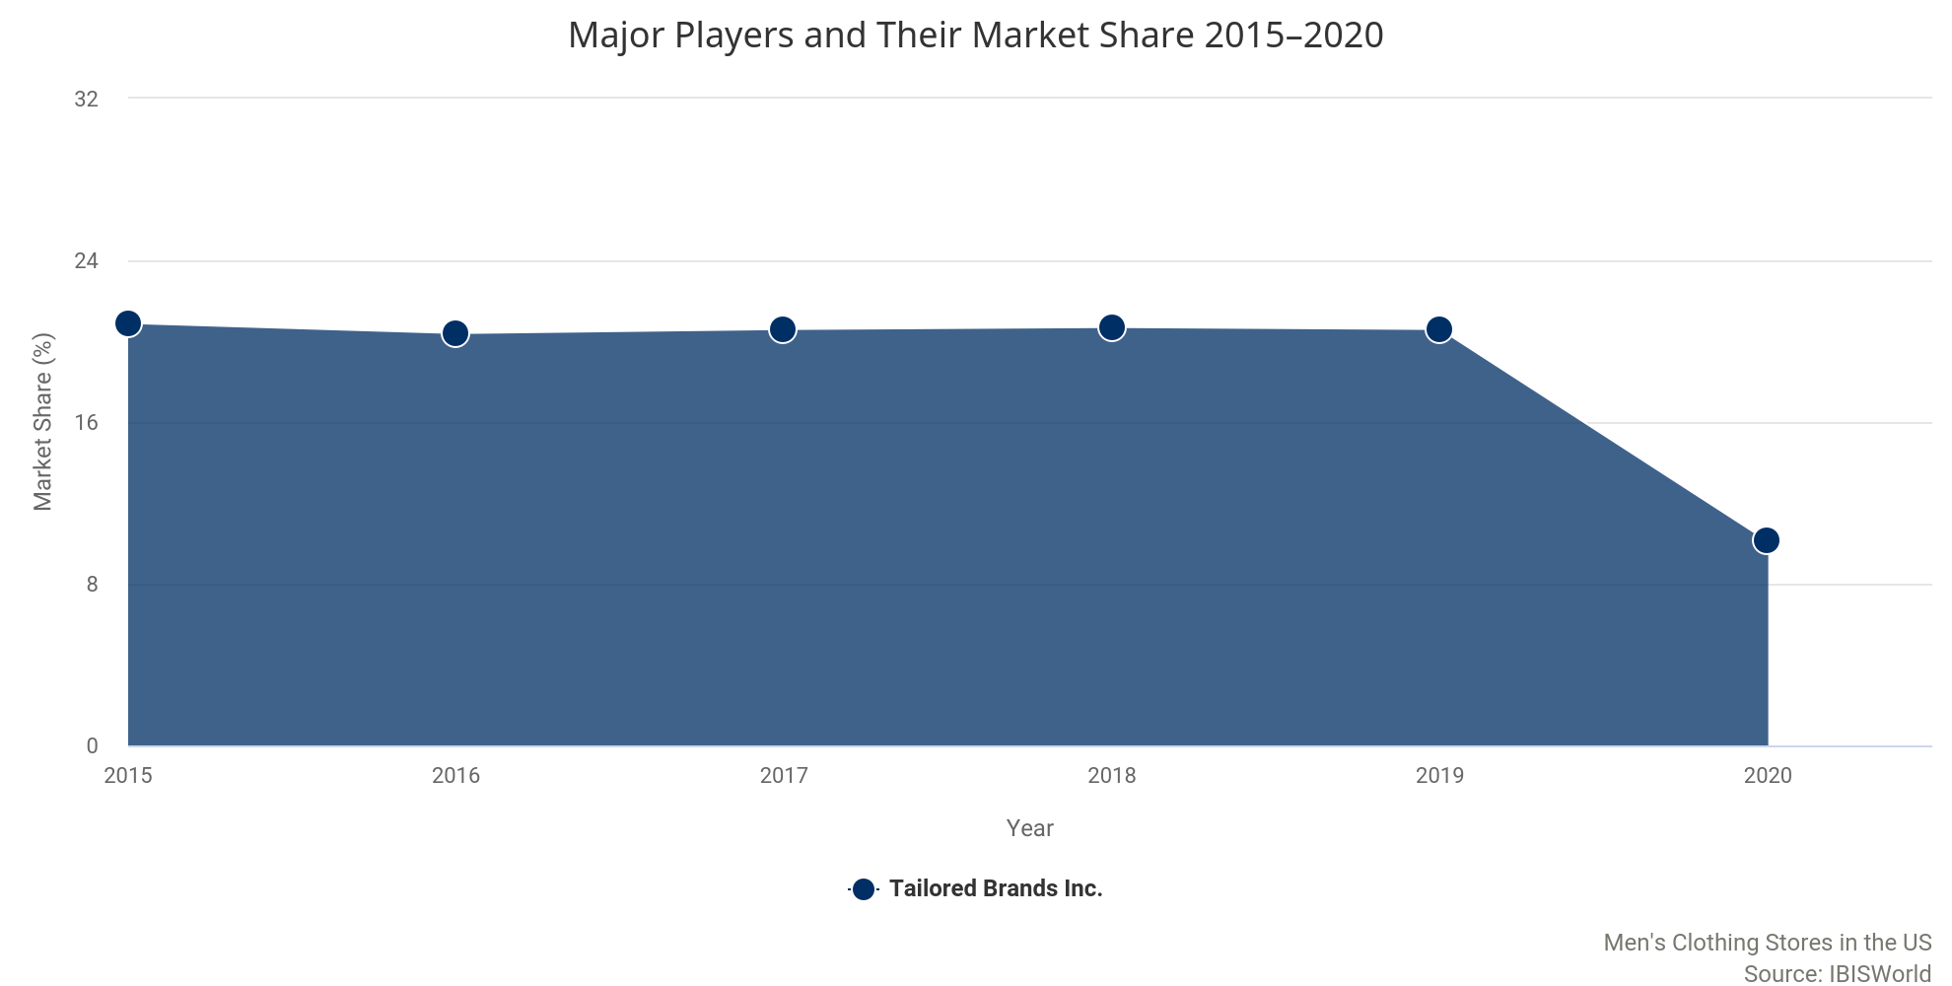

Major Players | 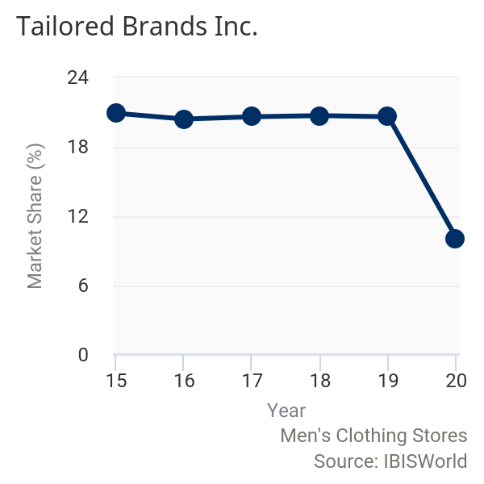  Tailored Brands Inc.  Market Share: 10.1%  Brand Names Moore's, Men's Wearhouse, K&G, Jos. A. Bank  Tailored Brands Inc. (Tailored Brands) is a men's clothing and accessory retailer headquartered in Houston, employing an estimated 19,300 people globally. Originally founded as Men's Wearhouse Inc. in 1973, the company launched a new holding company on a one-for-one basis as Tailored Brands Inc. in January 2016. The company generates most of its revenue through more than 1,400 retail stores, the majority of which specialize in men's suit sales and tuxedo rentals. Other revenue is generated through the company's corporate apparel provider business. While US sales comprise the majority of company revenue, Tailored Brands also has operations in Canada. In fiscal 2020 (year-end February, latest data available), the company reported $2.9 billion in total sales.  Through its several brands, including its formerly eponymous Men's Wearhouse brand, the company specializes in formal wear, such as suits and tuxedos, and targets middle and upper-middle class males. The company's strategy and brand are focused on customer service, quality merchandise and a well-stocked inventory of branded and designer apparel. Tailored Brands' Big & Tall product line is particularly popular among large males that do not fit traditional retail sizes.  Tailored Brands has acquired and created partnerships with several companies over the five years to fiscal 2021. It has also expanded its portfolio of luxury brands to boost profit. For instance, in June 2014, Tailored Brands acquired Jos. A. Bank Clothiers Inc. (Jos. A. Bank) for $1.8 billion; these stores now make up more than 35.0% of the company's total US establishments. Then, in 2015, Tailored Brands opened a flagship store for Joseph Abboud, an upscale US-based clothing brand that the company acquired in 2013 and launched an exclusive men's clothing line with Kenneth Cole. However, in August 2019, the company completed the sale of MWUK Limited, its UK corporate apparel operations, and completed the sale of Twin Hill Acquisition Company Inc., its US corporate apparel operations. The sale of these corporate apparel operations, both domestically and internationally, were done as part of a strategic shift. Additionally, in March 2020, the company closed on the previously announced transaction to sell Joseph Abboud trademarks to WHP Global for $115.0 million.  Financial performance  IBISWorld expects that Tailored Brands' industry-specific revenue will decline at an annualized rate of 17.3% over the five years to fiscal 2021, totaling $713.0 million. Store closures and subdued comparable store sales have led to declining revenue during the five-year period. Additionally, the company cited that the COVID-19 (coronavirus) pandemic has adversely affected operations in various ways, including falling store traffic, supply chain disruptions, temporary store closures and disruptions to employees working in stores, distribution centers and offices. Tailored Brands announced all retail stores were going to remain temporarily closed starting in mid-March and by the end of May the company announced they were going to begin open stores depending on specific legislation within the given state. On top of temporary stores closures, which mitigated in-store sales completely, demand for many industry products have fallen as the majority of corporate America transitioned to working from home. Therefore, demand for suits, formal wear and business casual products fell dramatically and the increase in demand for casual wear was not able to cover the loss.
Tailored Brands Inc. (US industry-specific segment) - financial performance*
Year** | Revenue  ($m) | Growth  (% change) | Operating Income  ($m) | Growth  (% change)
2015-16 | 1,838.1 | N/A | -613.8 | N/A
2016-17 | 1,731.0 | -5.8 | 59.3 | 109.7
2017-18 | 1,712.5 | -1.1 | 121.2 | 104.3
2018-19 | 1,703.1 | -0.6 | 127.9 | 5.5
2019-20 | 1,702.3 | 0.0 | 57.8 | -54.8
2020-21 | 713.0 | -58.1 | -515.6 | -992.1
Source: Annual report and IBISWorld
Note: *Estimates; **Year-end February

Other Companies | Destination XL Group Inc.
 | Market Share: 2.9%
Destination XL Group Inc. (DXL) was incorporated in 1976 and is headquartered in Canton, MA. The company is a leading retailer of men's big-and-tall apparel and stocks branded and private-label suits and casual wear throughout its 228 locations across the United States and two stores in Canada. DXL also offers clothing across the rest of Canada through its online store. The company employs 2,353 associates throughout the year, and then hires extra temporary employees during peak seasons.
DXL operates through several sales channels, including its variety of retail stores, as well as its direct business through its catalogs and e-commerce sites. Furthermore, in fiscal 2019 (year-end February), the company launched its own wholesale business unit that focuses on product development and distribution relationships. The company targets a diverse group of men as its target market, which is one of the main reasons for the varying store and website formats. For example, the company's Casual MaleXL store format caters to moderate price seeking customers. However, in fiscal 2020, more than 20.0% of DXL sales were generated through its e-commerce platform, which is not considered industry relevant. In fiscal 2021, IBISWorld estimates that DXL's industry-relevant revenue will total $203.8 million, a decline of 43.4% from the previous year. The store closures and supply chain disruptions caused by COVID-19 (coronavirus) are anticipated to have negative effects on DXL's industry-relevant revenue in 2020.
 | Bonobos
 | Bonobos launched in 2007 selling only men's pants, but subsequently expanded its product line to include shirts, sweaters, lounge wear, swimwear, formal wear, technical sporting wear and accessories. The company has grown to more than 60 brick-and-mortar locations and is the largest clothing brand ever built online in the United States. In 2017, Walmart Inc. acquired the company for $310.0 million. Bonobos's 60 retail stores display the company's entire inventory in all of the sizes available, enabling customers to try on and find their perfect size. However, no transactions are made in store and products are delivered to customers free of charge. At the onset of the pandemic, all Bonobos locations were temporarily closed, but they began opening up based on state-specific regulations. The company is currently operating stores at reduced capacities and following state guidelines regarding face masks. However, revenue generated by Bonobos is accounted for in the Online Men's Clothing Sales industry (OD5095). Similar to Indochino, Bonobos is an example of a company that is disrupting the traditional brick-and-mortar retail model as well as the online retail model.
 | Indochino
 | Indochino was founded in 2007 as a completely online company that enabled customers to take their measurements at home and order custom suits online. However, starting in 2015, the company launched brick-and-mortar showrooms, giving customers the opportunity to be measured by a professional. Indochino has expanded to 42 showrooms across North America, however, all showrooms were temporarily closed at the onset of the pandemic. However, as states have begun opening up, Indochino showrooms have also re-opened with capacity limits and other precautions. Currently, the company employs more than 600 individuals globally even though all of the suits are still ordered online and delivered to the customer within weeks. Recently, Indochino has expanded its product line to casual wear with the launch of INDOchinos, a line of casual khaki pants. Indochino is part of the Online Men's Clothing Sales industry (IBISWorld report OD5095). Nonetheless, the retail model used by Indochino is part of a growing trend within the broader retail industry and highlights how companies are trying to strike the balance between online and offline.

Operating Conditions
 | 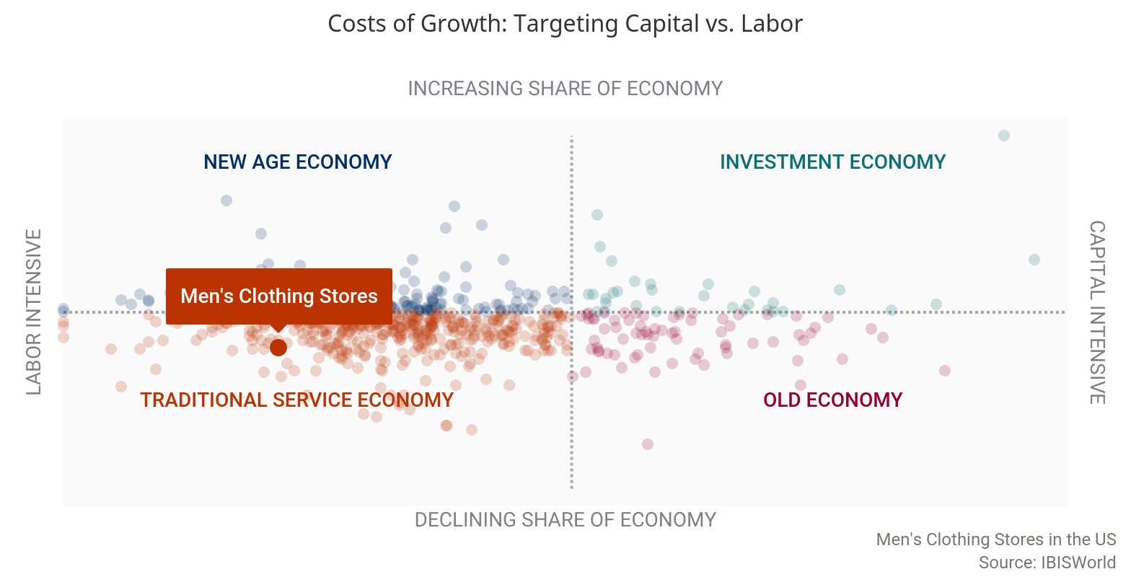
Capital Intensity | The level of capital intensity is Low
  As is typical of the retail sector, operators within the Men's Clothing Stores industry generally incur much higher labor costs than capital costs. In 2020, for every $1.00 spent on labor, the typical operator is expected to spend $0.04 on capital investments. Labor costs are required for workers on the sales floor, in stocking rooms and in management positions. Capital expenditure comes in the form of display shelves and cash registers. An increase in the use of point-of-sale (POS) systems, which monitor inventory levels, sales and taxes collected, is slowly increasing the capital expenditure of some operators within this industry. | 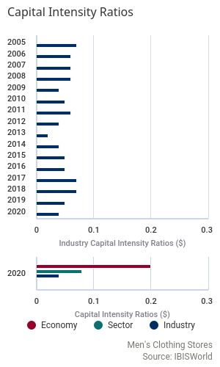
Technology & Systems | Potential Disruptive Innovation: Factors Driving Threat of Change
Level |  | Factor | Disruptive Effect | Description
 | Very Low | Rate of Innovation | Very Unlikely | A ranked measure for the number of patents assigned to an industry. A faster rate of new patent additions to the industry increases the likelihood of a disruptive innovation occurring.
 | High | Innovation Concentration | Likely | A measure for the mix of patent classes assigned to the industry. A greater concentration of patents in one area increases the likelihood of technological disruption of incumbent operators.
 | Medium | Ease of Entry | Potential | A qualitative measure of barriers to entry. Fewer barriers to entry increases the likelihood that new entrants can disrupt incumbents by putting new technologies to use.
 | Low | Rate of Entry | Unlikely | Annualized growth in the number of enterprises in the industry, ranked against all other industries. A greater intensity of companies entering an industry increases the pool of potential disruptors.
 | Medium | Market Concentration | Potential | A ranked measure of the largest core market for the industry. Concentrated core markets present a low-end market or new market entry point for disruptive technologies to capture market share.

The rate of new patent technologies entering the industry is low, which limits the potential for innovations. A low rate does not mean that innovations cannot occur, just that the likelihood of some innovation materializing as a threat is lower. However, the concentration of technologies is high in this industry. This suggests that industry operators have exposure to potentially unforeseen areas of innovation.
Industry operators are exposed to a low rate of new entrants and a moderate level of entry barriers. This combination of factors creates an environment where entry trends are not a key threat of disruption.
There are several relevant disruptive forces in the Men's Clothing Stores industry, including subscription boxes and direct-to-consumer retail operators.

Companies such as Bonobos and Indochino have brick-and-mortar stores that act more as showrooms. They have clothing on display in all of the sizes offered; however, rather than purchasing in-store, all clothing is ordered online and sent directly to the consumer. This gives the consumer the opportunity to physically try on products before buying, and enables the operator to not waste money on excess backstock and storage. Additionally, subscription box services, such as Stitch Fix, send customers a personalized box every month based off of survey responses and style preferences. Both of these business models have been acting in the industry for several years and current operators have been unable to successfully mimic these models. As a result, there is potential that the innovation with result in a shift in industry landscape and market structure.
The level of technology change is Medium
Technological advances relevant to the Men's Clothing Stores industry include the use of electronic cash registers, electronic scanning devices and automated warehouse equipment.

Electronic barcode scanning systems enable efficient customer checkout and returns, store-based inventory management and rapid order replenishment. The introduction of scanning and electronic data interchange has improved the industry's management and distribution of stock.
With stock loss and theft negatively affecting industry profitability, retailers continually invest in systems and procedures that aim to limit these losses. This technology includes closed-circuit TV cameras, source tagging, signature-capture technology and fingerprint scanning systems that verify customer identities. Technology such as radio-frequency identification (RFID) is also used to reduce theft. This technology tracks products from the time they leave the assembly line to the time they leave the store by releasing continuous signals from a chip inserted in the product at the manufacturing stage. The penetration of this technology remains low, as costs are fairly high, but with the RFID industry achieving rapid growth in recent years, the costs associated with this technology are expected to fall as its acceptance increases. Overall, the use of this technology will help the industry participants that use it, giving them a competitive edge over those that choose not to use it.
Revenue Volatility | The level of volatility is Medium
 | 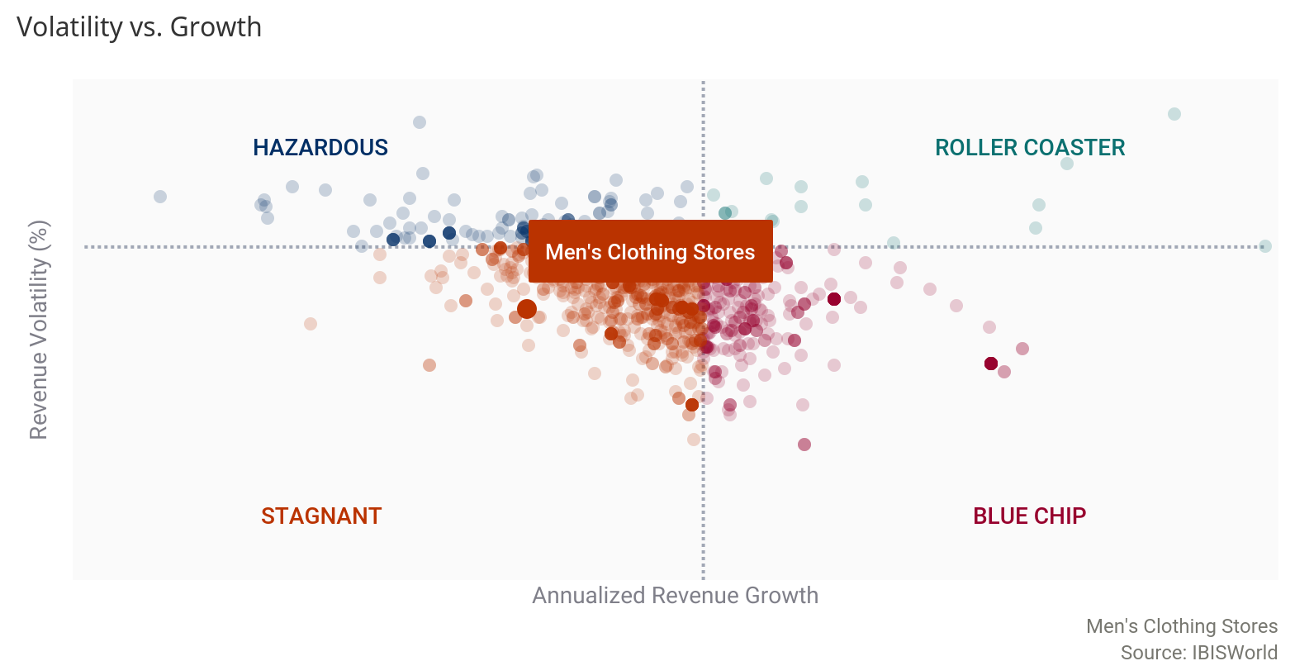
The Men's Clothing Stores industry experiences a low to moderate level of revenue volatility and there are several factors that affect the rate of growth in any given year.

Changes in per capita disposable income affect discretionary power and the relative affordability of clothing. Likewise, consumer confidence causes fluctuations in demand through consumer perceptions of overall economic security. Additionally, clothing prices will affect demand in any given year, changing total sales by retailers. Other factors such as competition from supercenters and online retailers affect industry revenue, as brick-and-mortar industry operators often have to lower prices to remain competitive. Industry revenue decreased as little as 1.7% in 2015 and as much as 15.7% in 2020 as a result of the negative impacts of the outbreak of COVID-19 (coronavirus). Revenue volatility is likely to remain relatively low in the coming years, as per capita disposable income increases and competition from online retailers heightens.
Regulation & Policy | The level of regulation is Medium and the trend is Steady  Regulations relevant to men's clothing stores vary by state.  Congress and individual states enact trade regulations with the aim of maintaining a free and competitive economy. No industry-specific regulation, however, currently exists for the Men's Clothing Stores industry. The majority of industry regulation relates to wages and antitrust laws.  Congress has passed the Sherman Act, the Wilson Act, the Clayton Act and the Robinson-Patman Act regarding unfair competition. Together these make up US federal antitrust law. The Sherman Act (1890) prohibits the formation of monopolies that hinder competition. The Wilson Act (1895) prohibits conspiracies that restrain import trade. The Clayton Act (1914) bans certain forms of price discrimination. Finally, the Robinson-Patman Act (1936) provides some protection to small independent retailers and their suppliers from unfair competition from vertically integrated, multilocation chain stores. States have enacted their own antitrust laws to ensure that the public is provided with the best prices, quality and competition among businesses, including men's clothing stores.  COVID-19  Due to the outbreak of COVID-19 (coronavirus) in late 2019 and early 2020, social distancing measures and nonessential business closures were enacted by all states to varying degrees.  Industry operators are considered non-essential and therefore, the majority of establishments were temporarily closed at the onset of the pandemic. However, most states have begun to re-open businesses and therefore, operators must ensure social distancing guidelines are maintained within their establishments by ensuring consumers and employees have ample space to maintain social distancing protocols (six feet apart). While the extent of these regulations varies depending on the state, with many easing restrictions in mid-2020, all operators have been affected. Adapting has involved delineating six-foot markers near registers in establishments, enforcing a face mask policy for customers and employees while in the establishment or limiting consumer counts for smaller or more heavily trafficked establishments.
Industry Assistance | The level of industry assistance is Low and the trend is Steady  The Men's Clothing Stores industry does not receive any special government assistance.  Import quotas and tariffs are also not applicable to this industry, as they are imposed at the manufacturing level. There are several industry associations set up to aid growth and education within the retail sector. The National Retail Federation is the world's largest retail trade association and conducts programs and services in research, education, training, information technology and government affairs to protect and advance the interests of the retail industry.  Several other associations exist that specialize in specific retail operations. For example, the American Apparel and Footwear Association (AAFA) is the national trade association representing apparel, footwear and other sewn products companies. AAFA's mission is to promote and enhance its members' competitiveness, productivity and profitability in the global market by minimizing trade restraints.  Additionally, due to the outbreak of COVID-19 (coronavirus) and the negative effects for many individuals and businesses as a result of the pandemic, the federal government passed the Coronavirus Aid, Relief and Economic Security Act (CARES). Part of the $2.0 trillion stimulus package is the Paycheck Protection Program (PPP), which provides funding for eligible businesses that employ fewer than 500 individuals to receive funding in order to pay for rent and utilities, as well as keep employees on the payroll. As of August 8, 2020, the Retail Trade sector accounted for just over 7.7% of all approved PPP loans. Industry operators are part of the Retail Trade sector and therefore it is likely, especially among smaller operators, that the industry will benefit from increased federal funding in 2020.

Key Statistics

Industry Data
Year | Revenue  ($m) | IVA  ($m) | Establishments  (Units) | Enterprises  (Units) | Employment  (People) | Exports  ($m) | Imports  ($m) | Wages  ($m) | Domestic  Demand  ($m) | Per Capita Disposable Income ($)
2011 | 9,093 | 2,054 | 11,599 | 8,118 | 56,310 | N/A | N/A | 1,545 | N/A | 38,780
2012 | 9,389 | 2,494 | 12,265 | 8,401 | 63,591 | N/A | N/A | 1,828 | N/A | 39,784
2013 | 9,671 | 2,192 | 11,570 | 8,255 | 58,656 | N/A | N/A | 1,602 | N/A | 39,004
2014 | 9,715 | 2,066 | 11,948 | 8,620 | 61,502 | N/A | N/A | 1,658 | N/A | 40,310
2015 | 9,549 | 2,036 | 12,084 | 8,817 | 57,688 | N/A | N/A | 1,692 | N/A | 41,670
2016 | 9,113 | 1,884 | 12,015 | 8,729 | 57,439 | N/A | N/A | 1,647 | N/A | 42,108
2017 | 8,738 | 1,915 | 11,909 | 8,696 | 60,260 | N/A | N/A | 1,653 | N/A | 43,056
2018 | 8,437 | 1,860 | 11,582 | 8,532 | 56,822 | N/A | N/A | 1,641 | N/A | 44,521
2019 | 8,340 | 1,812 | 11,548 | 8,517 | 56,498 | N/A | N/A | 1,629 | N/A | 45,594
2020 | 7,033 | 1,564 | 10,784 | 8,012 | 50,322 | N/A | N/A | 1,436 | N/A | 44,844
2021 | 7,133 | 1,722 | 10,799 | 8,020 | 50,619 | N/A | N/A | 1,447 | N/A | 45,088
2022 | 7,121 | 1,670 | 10,717 | 7,958 | 50,282 | N/A | N/A | 1,438 | N/A | 45,784
2023 | 7,215 | 1,742 | 10,681 | 7,923 | 50,514 | N/A | N/A | 1,447 | N/A | 47,111
2024 | 7,307 | 1,736 | 10,646 | 7,890 | 50,753 | N/A | N/A | 1,457 | N/A | 48,575
2025 | 7,410 | 1,671 | 10,621 | 7,864 | 50,974 | N/A | N/A | 1,466 | N/A | 50,187

Annual Change
Year | Revenue  (%) | IVA  (%) | Establishments  (%) | Enterprises  (%) | Employment  (%) | Exports  (%) | Imports  (%) | Wages  (%) | Domestic  Demand  (%) | Per Capita Disposable Income (%)
2011 | 5.68 | -0.94 | 0.77 | -2.56 | 4.02 | N/A | N/A | 4.39 | N/A | 1.61
2012 | 3.26 | 21.4 | 5.74 | 3.48 | 12.9 | N/A | N/A | 18.3 | N/A | 2.58
2013 | 3.00 | -12.1 | -5.67 | -1.74 | -7.77 | N/A | N/A | -12.4 | N/A | -1.97
2014 | 0.44 | -5.75 | 3.26 | 4.42 | 4.85 | N/A | N/A | 3.50 | N/A | 3.34
2015 | -1.71 | -1.46 | 1.13 | 2.28 | -6.21 | N/A | N/A | 2.06 | N/A | 3.37
2016 | -4.58 | -7.48 | -0.58 | -1.00 | -0.44 | N/A | N/A | -2.68 | N/A | 1.05
2017 | -4.12 | 1.66 | -0.89 | -0.38 | 4.91 | N/A | N/A | 0.37 | N/A | 2.25
2018 | -3.44 | -2.88 | -2.75 | -1.89 | -5.71 | N/A | N/A | -0.75 | N/A | 3.40
2019 | -1.16 | -2.57 | -0.30 | -0.18 | -0.58 | N/A | N/A | -0.69 | N/A | 2.40
2020 | -15.7 | -13.7 | -6.62 | -5.93 | -10.9 | N/A | N/A | -11.9 | N/A | -1.65
2021 | 1.42 | 10.1 | 0.13 | 0.09 | 0.59 | N/A | N/A | 0.75 | N/A | 0.54
2022 | -0.17 | -3.05 | -0.76 | -0.78 | -0.67 | N/A | N/A | -0.57 | N/A | 1.54
2023 | 1.30 | 4.33 | -0.34 | -0.44 | 0.46 | N/A | N/A | 0.62 | N/A | 2.89
2024 | 1.28 | -0.37 | -0.33 | -0.42 | 0.47 | N/A | N/A | 0.64 | N/A | 3.10
2025 | 1.40 | -3.74 | -0.24 | -0.33 | 0.43 | N/A | N/A | 0.62 | N/A | 3.31

Key Ratios
Year | IVA/Revenue  (%) | Imports/  Demand  (%) | Exports/  Revenue  (%) | Revenue per  Employee  ($'000) | Wages/  Revenue  (%) | Employees per  estab.  (Units) | Average Wage ($)
2011 | 22.6 | N/A | N/A | 161 | 17.0 | 4.85 | 27,439
2012 | 26.6 | N/A | N/A | 148 | 19.5 | 5.18 | 28,738
2013 | 22.7 | N/A | N/A | 165 | 16.6 | 5.07 | 27,305
2014 | 21.3 | N/A | N/A | 158 | 17.1 | 5.15 | 26,954
2015 | 21.3 | N/A | N/A | 166 | 17.7 | 4.77 | 29,328
2016 | 20.7 | N/A | N/A | 159 | 18.1 | 4.78 | 28,667
2017 | 21.9 | N/A | N/A | 145 | 18.9 | 5.06 | 27,428
2018 | 22.0 | N/A | N/A | 148 | 19.4 | 4.91 | 28,871
2019 | 21.7 | N/A | N/A | 148 | 19.5 | 4.89 | 28,836
2020 | 22.2 | N/A | N/A | 140 | 20.4 | 4.67 | 28,530
2021 | 24.1 | N/A | N/A | 141 | 20.3 | 4.69 | 28,578
2022 | 23.4 | N/A | N/A | 142 | 20.2 | 4.69 | 28,607
2023 | 24.1 | N/A | N/A | 143 | 20.1 | 4.73 | 28,653
2024 | 23.8 | N/A | N/A | 144 | 19.9 | 4.77 | 28,702
2025 | 22.6 | N/A | N/A | 145 | 19.8 | 4.80 | 28,756

Industry Financial Ratios
April 2019 - March 2020
by company revenue
Liquidity Ratios | Apr 16 -  Mar 17 | Apr 17 -  Mar 18 | Apr 18 -  Mar 19 | Apr 19 -  Mar 20 | Small  (<$10m) | Medium  ($10-$50m) | Large  (>$50m)
Current Ratio | 1.4 | 1.3 | 1.6 | 1.7 | 1.9 | N/A | N/A
Quick Ratio | 0.3 | 0.3 | 0.4 | 0.3 | 0.3 | N/A | N/A
Sales / Receivables (Trade Receivables Turnover) | 68.0 | 410.0 | 237.2 | 421.4 | N/C | N/A | N/A
Days' Receivables | 5.4 | 0.9 | 1.5 | 0.9 | N/A | N/A | N/A
Cost of Sales / Inventory (Inventory Turnover) | 3.0 | 2.5 | 3.1 | 2.6 | 2.2 | N/A | N/A
Days' Inventory | 121.7 | 146.0 | 117.7 | 140.4 | 165.9 | N/A | N/A
Cost of Sales / Payables (Payables Turnover) | 9.3 | 10.5 | 9.1 | 8.8 | 8.8 | N/A | N/A
Days' Payables | 39.2 | 34.8 | 40.1 | 41.5 | 41.5 | N/A | N/A
Sales / Working Capital | 12.6 | 15.9 | 14.0 | 8.7 | 8.4 | N/A | N/A

Coverage Ratios
Earnings Before Interest & Taxes (EBIT) / Interest | 3.2 | 2.6 | 4.7 | 1.9 | 1.8 | N/A | N/A
Net Profit + Dep., Depletion, Amort. / Current Maturities LT Debt | N/A | N/A | N/A | N/A | N/A | N/A | N/A

Leverage Ratios
Fixed Assets / Net Worth | 0.6 | 0.5 | 0.3 | 0.1 | 0.1 | N/A | N/A
Debt / Net Worth | 2.5 | 1.8 | 1.7 | 2.8 | 2.8 | N/A | N/A
Tangible Net Worth | 7.5 | 25.8 | 21.0 | 27.1 | 33.5 | N/A | N/A

Operating Ratios
Profit before Taxes / Net Worth, % | 28.8 | 10.4 | 6.5 | 10.1 | 7.7 | N/A | N/A
Profit before Taxes / Total Assets, % | 6.3 | 3.2 | 2.5 | 2.6 | 2.3 | N/A | N/A
Sales / Net Fixed Assets | 20.6 | 23.2 | 24.1 | 35.3 | 60.6 | N/A | N/A
Sales / Total Assets (Asset Turnover) | 2.7 | 2.2 | 2.1 | 2.3 | 2.6 | N/A | N/A

Cash Flow & Debt Service Ratios (% of sales)
Cash from Trading | 49.8 | 50.7 | 47.8 | 47.4 | 49.3 | N/A | N/A
Cash after Operations | 3.3 | 1.1 | 2.1 | 3.1 | 3.0 | N/A | N/A
Net Cash after Operations | 4.2 | 3.0 | 3.7 | 3.4 | 3.0 | N/A | N/A
Cash after Debt Amortization | 1.0 | 0.0 | 1.0 | 0.2 | -0.6 | N/A | N/A
Debt Service P&I Coverage | 2.0 | 1.8 | 3.5 | 3.1 | 0.6 | N/A | N/A
Interest Coverage (Operating Cash) | 3.6 | 5.7 | 8.4 | 3.1 | 0.6 | N/A | N/A

Assets, %
Cash & Equivalents | 15.6 | 13.6 | 15.4 | 18.0 | 18.2 | N/A | N/A
Trade Receivables (net) | 9.4 | 7.2 | 11.5 | 7.3 | 8.4 | N/A | N/A
Inventory | 44.5 | 46.4 | 43.1 | 49.3 | 54.7 | N/A | N/A
All Other Current Assets | 2.2 | 3.2 | 2.1 | 3.0 | 3.3 | N/A | N/A
Total Current Assets | 71.6 | 70.4 | 72.2 | 77.6 | 84.7 | N/A | N/A
Fixed Assets (net) | 16.5 | 17.4 | 15.4 | 8.0 | 5.3 | N/A | N/A
Intangibles (net) | 3.5 | 3.0 | 5.0 | 7.0 | 3.5 | N/A | N/A
All Other Non-Current Assets | 8.4 | 9.2 | 7.4 | 7.5 | 6.5 | N/A | N/A
Total Assets | 100.0 | 100.0 | 100.0 | 100.0 | 100.0 | N/A | N/A
Total Assets ($m) | 780.2 | 590.3 | 1,315.4 | 357.2 | 22.4 | 46.6 | 288.2

Liabilities, %
Notes Payable-Short Term | 17.3 | 15.2 | 18.6 | 16.4 | 17.5 | N/A | N/A
Current Maturities L/T/D | 2.8 | 3.5 | 1.4 | 0.7 | 0.3 | N/A | N/A
Trade Payables | 24.5 | 19.7 | 18.1 | 15.7 | 17.2 | N/A | N/A
Income Taxes Payable | 0.1 | 0.1 | 0.0 | 0.0 | 0.0 | N/A | N/A
All Other Current Liabilities | 16.1 | 21.4 | 14.8 | 14.4 | 13.5 | N/A | N/A
Total Current Liabilities | 60.8 | 59.9 | 52.9 | 47.1 | 48.5 | N/A | N/A
Long Term Debt | 23.7 | 8.1 | 9.1 | 9.5 | 9.4 | N/A | N/A
Deferred Taxes | 0.5 | 0.0 | 0.0 | 0.0 | 0.0 | N/A | N/A
All Other Non-Current Liabilities | 4.0 | 3.2 | 12.0 | 9.3 | 5.2 | N/A | N/A
Net Worth | 11.0 | 28.8 | 26.0 | 34.1 | 37.0 | N/A | N/A
Total Liabilities & Net Worth ($m) | 780.2 | 590.3 | 1,315.4 | 357.2 | 22.4 | 46.6 | 288.2

Maximum No. of Statements Used | 35.0 | 41.0 | 35.0 | 27.0 | 21.0 | 4.0 | 2.0
Source: RMA Annual Statement Studies, rmahq.org.  RMA data for all industries is derived directly from more than 260,000 statements of member financial institution's borrowers and prospects |  |  |  |  | 

Additional Resources
Additional Resources | National Retail Federation  http://www.nrf.com  American Apparel & Footwear Association  http://www.aafaglobal.org  US Census Bureau  http://www.census.gov

Industry Jargon | BABY BOOMERS  The demographic of Americans born between 1946 and 1964, accounting for a major proportion of the population.  GENERATION X  The demographic of Americans aged 30 to 45, which follows the baby boomer generation.  GENERATION Y  The demographic of Americans aged between 10 and 30, which are born to baby boomers and follow Generation X.  OFFSHORING  The relocation of a company's business process, such as manufacturing or accounting, from one country to another, whether the work is outsourced or stays within the company.  OUTSOURCE  To procure goods or services under contract with an outside supplier.  POINT-OF-SALE (POS)  A system used at checkout in retail stores using computers and cash registers to capture transaction data at the time and place of sale.

Glossary | BARRIERS TO ENTRY  High barriers to entry mean that new companies struggle to enter an industry, while low barriers mean it is easy for new companies to enter an industry.  CAPITAL INTENSITY  Compares the amount of money spent on capital (plant, machinery and equipment) with that spent on labor. IBISWorld uses the ratio of depreciation to wages as a proxy for capital intensity. High capital intensity is more than $0.333 of capital to $1 of labor; medium is $0.125 to $0.333 of capital to $1 of labor; low is less than $0.125 of capital for every $1 of labor.  CONSTANT PRICES  The dollar figures in the Key Statistics table, including forecasts, are adjusted for inflation using the current year (i.e. year published) as the base year. This removes the impact of changes in the purchasing power of the dollar, leaving only the "real" growth or decline in industry metrics. The inflation adjustments in IBISWorld’s reports are made using the US Bureau of Economic Analysis’ implicit GDP price deflator.  DOMESTIC DEMAND  Spending on industry goods and services within the United States, regardless of their country of origin. It is derived by adding imports to industry revenue, and then subtracting exports.  EMPLOYMENT  The number of permanent, part-time, temporary and seasonal employees, working proprietors, partners, managers and executives within the industry.  ENTERPRISE  A division that is separately managed and keeps management accounts. Each enterprise consists of one or more establishments that are under common ownership or control.  ESTABLISHMENT  The smallest type of accounting unit within an enterprise, an establishment is a single physical location where business is conducted or where services or industrial operations are performed. Multiple establishments under common control make up an enterprise.  EXPORTS  Total value of industry goods and services sold by US companies to customers abroad.  IMPORTS  Total value of industry goods and services brought in from foreign countries to be sold in the United States.  INDUSTRY CONCENTRATION  An indicator of the dominance of the top four players in an industry. Concentration is considered high if the top players account for more than 70% of industry revenue. Medium is 40% to 70% of industry revenue. Low is less than 40%.  INDUSTRY REVENUE  The total sales of industry goods and services (exclusive of excise and sales tax); subsidies on production; all other operating income from outside the firm (such as commission income, repair and service income, and rent, leasing and hiring income); and capital work done by rental or lease. Receipts from interest royalties, dividends and the sale of fixed tangible assets are excluded.  INDUSTRY VALUE ADDED (IVA)  The market value of goods and services produced by the industry minus the cost of goods and services used in production. IVA is also described as the industry's contribution to GDP, or profit plus wages and depreciation.  INTERNATIONAL TRADE  The level of international trade is determined by ratios of exports to revenue and imports to domestic demand. For exports/revenue: low is less than 5%, medium is 5% to 20%, and high is more than 20%. Imports/domestic demand: low is less than 5%, medium is 5% to 35%, and high is more than 35%.  LIFE CYCLE  All industries go through periods of growth, maturity and decline. IBISWorld determines an industry's life cycle by considering its growth rate (measured by IVA) compared with GDP; the growth rate of the number of establishments; the amount of change the industry's products are undergoing; the rate of technological change; and the level of customer acceptance of industry products and services.  NONEMPLOYING ESTABLISHMENT  Businesses with no paid employment or payroll, also known as nonemployers. These are mostly set up by self-employed individuals.  PROFIT  IBISWorld uses earnings before interest and tax (EBIT) as an indicator of a company’s profitability. It is calculated as revenue minus expenses, excluding interest and tax.  REGIONS  West | CA, NV, OR, WA, HI, AK  Great Lakes | OH, IN, IL, WI, MI  Mid-Atlantic | NY, NJ, PA, DE, MD  New England | ME, NH, VT, MA, CT, RI  Plains | MN, IA, MO, KS, NE, SD, ND  Rocky Mountains | CO, UT, WY, ID, MT  Southeast | VA, WV, KY, TN, AR, LA, MS, AL, GA, FL, SC, NC  Southwest | OK, TX, NM, AZ  VOLATILITY  The level of volatility is determined by averaging the absolute change in revenue in each of the past five years. Volatility levels: very high is more than ±20%; high volatility is ±10% to ±20%; moderate volatility is ±3% to ±10%; and low volatility is less than ±3%.  WAGES  The gross total wages and salaries of all employees in the industry.

IBISWorld helps you find the industry information you need – fast.
With our trusted research covering thousands of global industries, you’ll get a quick and intelligent overview of any industry so you can get up to speed in minutes. In every report, you’ll find actionable insights, comprehensive data and in-depth analysis to help you make smarter, faster business decisions. If you’re not yet a member of IBISWorld, contact us at 1-800-330-3772 or info@ibisworld.com to learn more.
DISCLAIMER
This product has been supplied by IBISWorld Inc. (‘IBISWorld’) solely for use by its authorized licenses strictly in accordance with their license agreements with IBISWorld. IBISWorld makes no representation to any other person with regard to the completeness or accuracy of the data or information contained herein, and it accepts no responsibility and disclaims all liability (save for liability which cannot be lawfully disclaimed) for loss or damage whatsoever suffered or incurred by any other person resulting from the use of, or reliance upon, the data or information contained herein. Copyright in this publication is owned by IBISWorld Inc. The publication is sold on the basis that the purchaser agrees not to copy the material contained within it for other than the purchasers own purposes. In the event that the purchaser uses or quotes from the material in this publication – in papers, reports, or opinions prepared for any other person – it is agreed that it will be sourced to: IBISWorld Inc.

Copyright 2020 IBISWorld Inc.



